Highlight of the Week: UKRI’s Smart Sustainable Plastic Packaging Fund
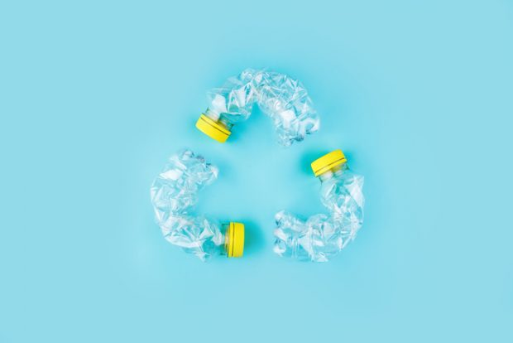
The United Kingdom recognizes the need to address growing concerns around the environmental, social and economic impact of plastic packaging. In addition to revolutionizing how societies interact with consumer goods, plastic packaging has also proven to be a threat to wildlife and human health and is a major contributor to pollution and resource depletion.
In an effort to curb leakages of plastic waste into the environment and aquatic ecosystems, the United Kingdom Research and Innovation, a non-departmental public body, launched the Smart Sustainable Plastic Packaging Challenge in 2019.
To enable clean growth and industrial decarbonization, UKRI funds ground-breaking research and innovation to make plastic packaging fit for a sustainable future.
The solutions for addressable challenges will:
- deliver a reduction in unnecessary and single-use plastic packaging
- increase the viability and uptake of reuse and refill systems
- support new and improved recycling technologies and systems
The Challenge is intended to directly support the 2025 targets in the UK Plastics Pact.
The £60 million funding has, to date, secured over £149 million in match funding from industry and, in total, is expected to leverage in excess of £220 million in co-investment.
As of today, eight funding competitions have been completed and the Challenge has a balanced portfolio of over 80 projects, encompassing:
- projects funded through a competitive process, including feasibility studies, academic and business-led research, and late-stage large-scale demonstrator plants
- direct funding awards, including the funding of an agenda-setting Fellowship in partnership with the Natural Environment Research Council to support the achievement of the objectives of the UN Treaty to end plastic pollution
Key priorities for the Challenge in 2023 to 2024 include reuse and refill technologies, food-grade recycling and sustainable films and flexibles.
The total budget of the fund is £60 million is to be disbursed between 2019 and 2025.

To learn more, read: https://www.ukri.org/what-we-do/our-main-funds-and-areas-of-support/browse-our-areas-of-investment-and-support/smart-sustainable-plastic-packaging/

