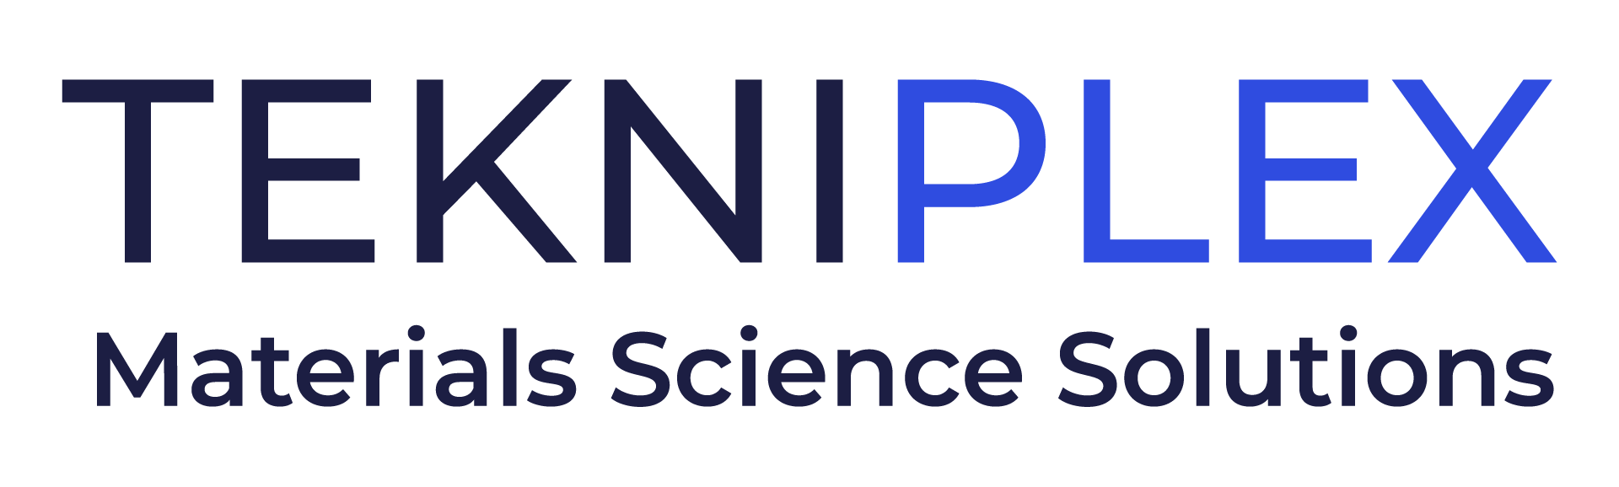
Press release

Media Contact: Peter Gavigan
TekniPlex
+1 (908) 720-5391
Peter.Gavigan@tekni-plex.com

Christopher Dale
Turchette Agency
+1 (973) 227-8080 ext. 116
cdale@turchette.com

At Pharmapack Paris, TekniPlex to Showcase
Cleanroom-produced COC Films, Among Other Solutions

Materials science company also highlighting recyclable polyolefin blister packaging with barrier PP lidding – a healthcare industry first.

Wayne, PA – At Pharmapack Paris, February 1-2, TekniPlex, a globally integrated provider of innovative solutions through materials science and manufacturing technologies, will showcase samples from a range of cyclic olefin copolymer (COC) diagnostics films whose cleanroom production is a differentiator in the healthcare space. At booth B96-98, the company also will highlight another recently introduced innovation: the world’s first fully transparent recyclable mid-barrier blister package

Manufactured in an ISO Class 8 cleanroom environment for significantly reduced risk of contamination, TekniPlex’s COC films can be nimbly customized to suit the dynamic needs of the diagnostics market. Its standard, crystal-clear 140 µm film offers excellent sealing properties combined with a low background UV autofluorescence required for multiplexing in PCR diagnostics. In addition, the film has a glass transition temperature (Tg) of 78°C and an ultra-flat surface enabling nano-structuring through hot embossing and nano-imprint lithography. This allows ultra-small-sized structures to be replicated in the polymer structure, needed for microfluidic and for diffraction gratings that give the resulting film a shiny, colorful appearance.

“Manufactured in a cleanroom setting, our customizable film technology is enabling new diagnostics capabilities to enter the market, helping patients get diagnosed and on the road to recovery more expediently,” said Michiel van den Berg, Global Product Manager for TekniPlex “This exemplifies TekniPlex’s commitment to developing materials science solutions that make our customers’ products more effective and, ultimately, helps improve outcomes.”

At Pharmapack Paris, TekniPlex also will feature its groundbreaking sustainable blister system, whose mechanical recyclability has been certified by third-party testing. Recyclable in geographies where the #5 (polypropylene) recycling stream is available, the mid-barrier blisters feature a polyolefin blister film paired with a barrier PP lidding film. This marks the first time a formed blister + lidding combination is certified as recyclable – a significant milestone in the evolving push to make healthcare packaging more sustainable.

Rounding out TekniPlex’s offerings at Pharmapack Paris will be a selection of films and components for healthcare and pharmaceutical applications. For example, the company’s range of punched rubber gaskets for aerosol valves improve functionality for metered dose inhaler valves, while its punched plastic gaskets perform well with nasal spray applications. Other solutions, such as the company’s PVC super barrier polyvinylidene chloride (PVDC) coated structures and Aclar® laminates, are designed to protect drugs with demanding environmental protection requirements.

# # #

About TekniPlex
TekniPlex is a globally integrated company that provides innovative solutions through materials science and manufacturing technologies. A global leader in the healthcare and consumer product markets, TekniPlex provides medical device components and a multitude of materials science solutions that lead to a healthier and more sustainable world. Its solutions are found in some of the most well-known names in the healthcare, pharmaceutical, personal care, household, and food & beverage markets.

Headquartered in Wayne, Pa., TekniPlex employs 7,000 team members throughout its operations in Belgium, Brazil, Canada, China, Colombia, Costa Rica, Germany, India, Italy, Mexico, Northern Ireland, and the United States. For more information visit www.tekni-plex.com.

About TekniPlex Healthcare
TekniPlex Healthcare utilizes advanced materials science expertise and technologies to develop and deliver critical solutions for medical and diagnostic devices, drug delivery systems and healthcare packaging applications. With a global reach, the division’s deep understanding of the greater pharmaceuticals and medical landscape helps it produce exemplary barrier properties for drugs and precision medical devices for interventional and therapeutic procedures. TekniPlex Healthcare’s ever-evolving portfolio helps meet demands for high-leverage medicines and mission-critical healthcare products that benefit care providers and patients. For more information visit www.tekni-plex.com/healthcare.

