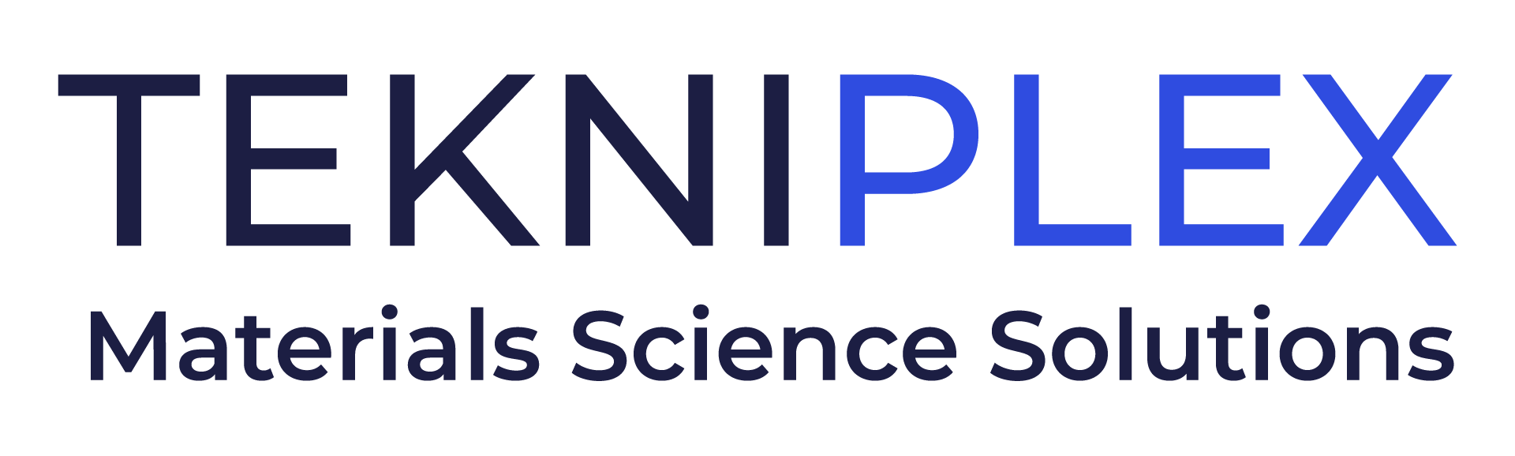
Press release

Media Contact: Peter Gavigan
TekniPlex
+1 (908) 720-5391
Peter.Gavigan@tekni-plex.com

Christopher Dale
Turchette Agency
+1 (973) 227-8080 ext. 116
cdale@turchette.com

TekniPlex Consumer Products Plans Specialty Molded Fiber Facility in Ohio, Bringing Recent Segment Investments to $350 Million

Scheduled to commence operations in 2024, the 200,000-sq-ft plant
follows three major acquisitions in the specialty molded fiber solutions space,
and marks the company’s eighth such manufacturing facility.

Wayne, PA – TekniPlex Consumer Products, a globally integrated provider of innovative solutions through materials science and manufacturing technologies, is continuing its substantial push into the molded fiber solutions sector by announcing plans for a new manufacturing facility in Ohio. Planned to commence operations in early 2024, and with room for future expansion, the 200,000-square-foot dedicated specialty molded fiber solutions facility will further expand the company’s capacity and capabilities in this burgeoning, sustainability-minded niche, with a variety of products including high-performance egg cartons. This new technology allows for stronger, better-quality egg cartons to enhance egg protection.

For TekniPlex, the facility – its eighth in the specialty molded fiber sector alone – is the latest news amid a decisive molded fiber market push, one now comprising some $350 million in investments. The rise to molded fiber prominence has been both broad and rapid. In the span of just 14 months, TekniPlex acquired a trifecta of high-profile specialty molded fiber solutions players: Keyes Packaging Group of Wenatchee, WA; Fibro Corporation of Tacoma, WA; and most recently, EMATEC, which has five fiber manufacturing plants across Mexico.

“The new facility will combine TekniPlex’s fiber capabilities with technology platforms obtained through our recent strategic acquisitions,” said Eldon Schaffer, CEO of TekniPlex Consumer Products. Molded fiber is a renewable bio-based material derived from 100% natural, typically recycled paper and cardboard fibers, making it highly attractive to brands seeking to expand their bio-based packaging offerings. TekniPlex Consumer Products’ growth in this area exemplifies our materials diverse mindset, including capabilities to provide fresh foods companies with a broad range of packing and packaging solutions to help stand out in supermarket perimeters.”

“We are excited to continue to bring new technology with our specialty molded fiber solutions expansion including our high-performance egg carton, which provides superior egg protection to our customers, reducing food waste and cost,” said Jay Arnold, Vice President & General Manager, Fiber business.

The forthcoming Ohio plant signifies TekniPlex’s intentions to continue expanding its portfolio not only in specialty molded fiber but also sustainability-minded materials – especially those comprising significant amounts of post-consumer recycled (PCR) content, or composed of more recyclable resins like PET. Recently, the company exponentially expanded its GeoPack product family, which addresses various combinations of materials science sustainability’s “4 Rs” – reduce, recycle, reuse, and renew – including biodegradable or compostable materials, post-consumer recycled content, recyclability, renewable substrates, and legislation compliance.

# # #

About TekniPlex Consumer Products
TekniPlex Consumer Products specializes in advanced materials science solutions for companies in the food & beverage and CPG industries with a focus on protecting products, strengthening brands, and innovating sustainably. TekniPlex Consumer Products serves companies around the world in sectors including beauty and personal care, household items, and food and beverage.

With an expanding selection of material-diverse solutions – bolstered in recent years, by a series of strategic acquisitions – TekniPlex Consumer Products is leading the way creating next-generation packaging designs that address real-world challenges in the markets it serves. Most notably, the company is focused on developing more sustainable solutions that continue to provide product safety and consumer satisfaction. For more information, visit www.tekni-plex.com/consumer

