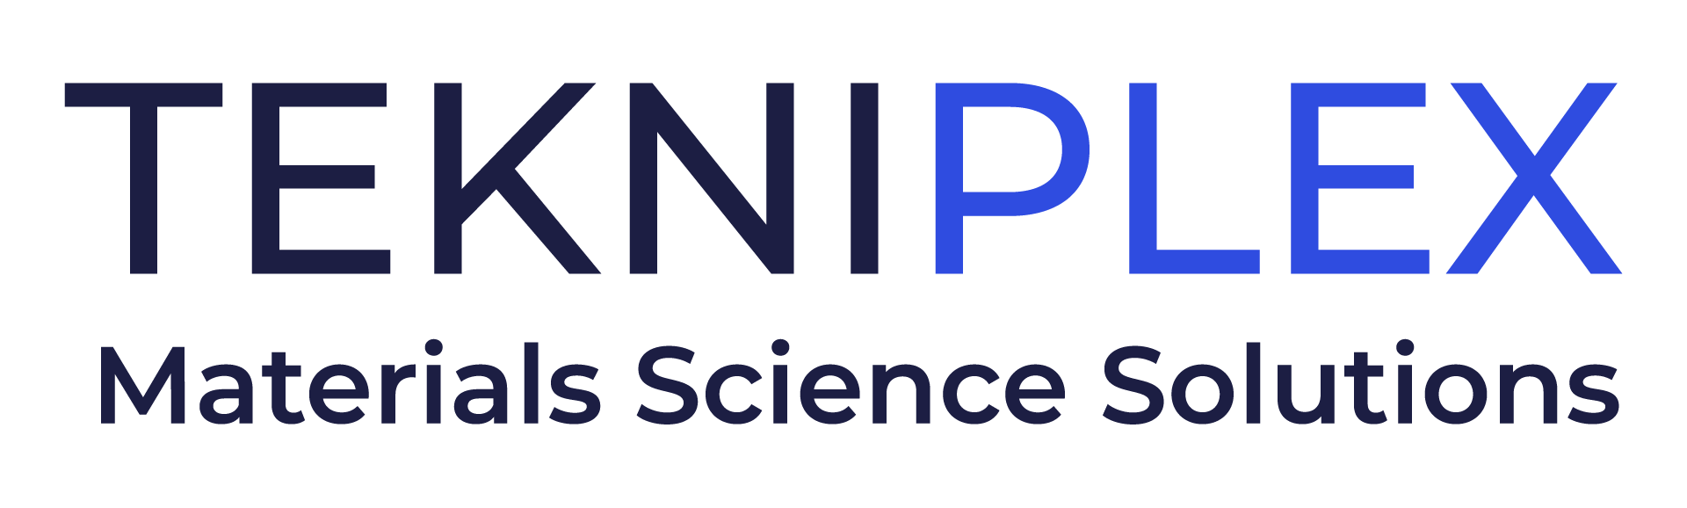
Press release

Media Contact: Melissa Green
TekniPlex Healthcare
+1 (215) 266-4872
Melissa.Green@tekni-plex.com

Christopher Dale
Turchette Agency
+1 (973) 227-8080 ext. 116
cdale@turchette.com

At Pharmapack Europe, TekniPlex Healthcare to Tout Expanded Capacity for Injection Blow Molded Bottles and Five-Layer Blown Film

Company also will showcase sustainability-minded blister packaging, as well as coated PVC structures offering exemplary barrier against oxygen and moisture.

Wayne, PA – TekniPlex Healthcare, which utilizes advanced materials science expertise to help deliver better patient outcomes, will emphasize two recent EU-based capacity and capabilities expansions at Pharmapack Europe, January 22-23 in Paris. At Stand E97, the company will highlight its efforts to meet growing demand for sophisticated vials, bellow bottles and cleanroom-produced multilayer blown films, and also showcase products from its existing portfolio of healthcare packaging solutions.

At its facility in Modena, Italy, TekniPlex Healthcare has added substantial injection blow molding capacity for multidose vial packaging, which support a variety of pharmaceutical liquid applications – including the growing ophthalmic market. Standard bottles range from 5-30 ml, including a 10 ml squeezable container designed specifically for Aptar Pharma‘s Ophthalmic Squeeze Dispenser (OSD) technology platform, which serves preservative-free multidose formulations in eyecare. The bottles are manufactured in ISO 8 cleanrooms.

Meanwhile, TekniPlex Healthcare’s vertical bellow bottles are utilized for surgical powders and other applications, often in wound management. The bottles are available in 3ml or 9ml volumes, and their injection molded cannulas ensure no burrs, flashes or sharp edges for safer dispensing. Tamper-evident cannula caps further enhance safety while eliminating the need for secondary packaging, and customization options include silk screening and color variations.

Elsewhere in Europe, TekniPlex Healthcare is further expanding its cleanroom environment production of multilayer blown film and cleanroom bags at its Puurs, Belgium facility. Building upon a services introduction launched in early 2024, TekniPlex Healthcare is now offering co-extruded blown films and bags with up to five layers, with a particular focus on PE-EVOH-PE constructions providing exemplary oxygen barrier properties.

For TekniPlex Healthcare, the blown film capabilities upgrade reflects a market shift away from conventional food-grade materials towards higher-quality grade pharmaceutical resins. These high-leverage materials are then used for cleanroom-produced films and bags manufactured in accordance with GMP guidelines. Notably, the company’s existing customer set is helping drive demand in this niche, specifically through requests for higher barrier solutions requiring multi-layer protective properties.

Also at Pharmapack Europe, TekniPlex Healthcare will showcase its range of more sustainable blister packaging solutions, all suitable for running on standard blister packaging machines. Most recently, the company introduced a pharma-grade blister film with 30% post-consumer recycled content (PCR) on a mass balance basis. The solution incorporates partner company Alpek Polyester’s Octal rDPET™ Sheet technology and, when combined with TekniPlex’s Teknilid® Push polyester lidding, yields a blister package recyclable wherever the polyester stream exists.

TekniPlex Healthcare also will exhibit the world’s first fully transparent recyclable mid-barrier blister package. Recyclable in geographies where the #5 (polypropylene) recycling stream is available, the mid-barrier blisters feature a polyolefin blister film paired with a barrier PP lidding film. When introduced last year, the solution marked the first time a formed blister + lidding combination with moisture barrier was certified as recyclable – a significant milestone. TekniPlex Healthcare also will exhibit a recyclable polyester mono-material blister + lidding combination, suitable for products that do not require barrier protection.

TekniPlex Healthcare also will exhibit examples of its pharma rubber compounding and manufacturing solutions for healthcare applications, including gaskets and closures. Manufactured to precise dimensional tolerances to ensure proper fit and function within packaging or medical devices, the company’s pharma-grade rubber substantially minimizes the risk of migration-associated impurities like extractables and leachables. In addition, TekniPlex’s modern laboratories enable development and testing of unique rubber solutions for customer-specific applications.

Finally, TekniPlex Healthcare also will showcase its Flexapharm® SBC series of PVDC (polyvinylidene chloride) coated PVC structures, which offer exemplary barrier against oxygen and moisture. Also on display will be an array of Aclar® laminates designed to preserve the efficacy and shelf life of drugs with demanding environmental protection requirements.

# # #

About TekniPlex Healthcare
TekniPlex Healthcare utilizes advanced materials science expertise and technologies to develop and deliver critical solutions for medical and diagnostic devices, drug delivery systems and sterile barriers healthcare packaging applications. With a global reach, the division’s deep understanding of the greater pharmaceuticals and medical landscape helps it produce exemplary barrier properties for drugs and precision medical devices for interventional and therapeutic procedures.

In the medical device niche, TekniPlex Healthcare embodies a comprehensive CDMO partner capable of servicing every stage of the product life cycle, from design and development through component manufacturing and final assembly. Throughout its broad purview, the division’s ever-evolving portfolio helps meet demands for high-leverage medicines and mission-critical healthcare products that benefit care providers and patients. For more information visit www.tekni-plex.com/healthcare.

