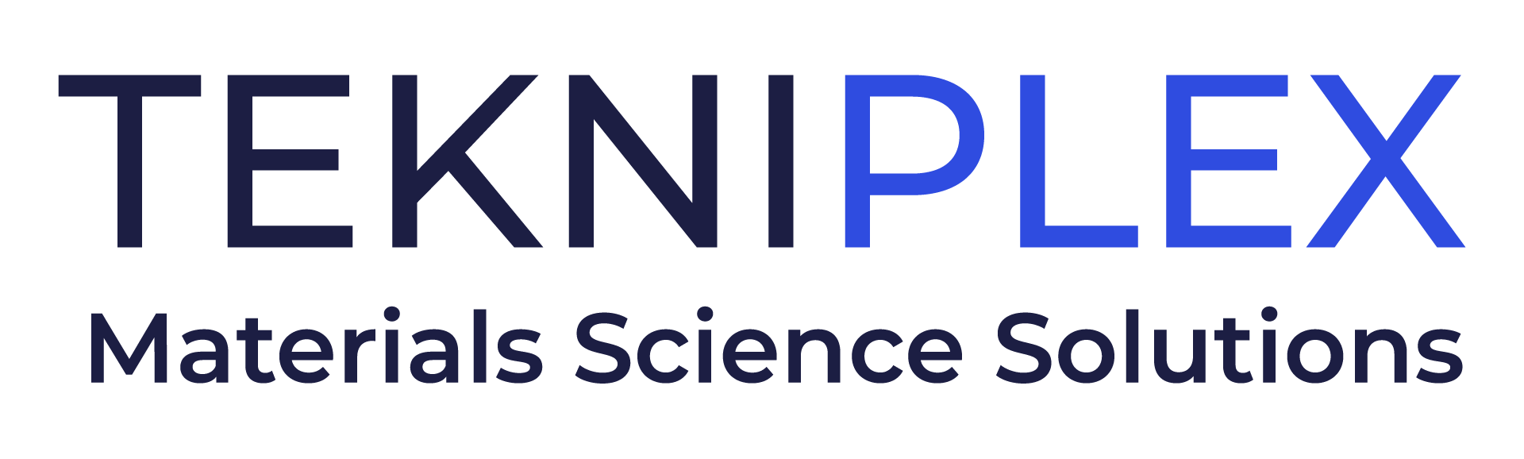
Press release

Media Contact: Peter Gavigan
TekniPlex
+1 (908) 720-5391
Peter.Gavigan@tekni-plex.com

Christopher Dale
Turchette Agency
+1 (973) 227-8080 ext. 116
cdale@turchette.com

At Connect in Pharma, TekniPlex Healthcare to Present
Forward-looking Approaches to Latest Sustainability
& Recyclability Packaging Regulations

Company also will showcase a range of healthcare packaging solutions, including new Recyclable Blister system, coated structures like Flexapharm® SBC,
and its Pentafill® vial filling & sealing machines, among others.

Wayne, PA – TekniPlex Healthcare, which utilizes advanced materials science expertise to help deliver better patient outcomes, will provide an in-depth look at the pharma packaging landscape amid the latest proposed sustainability and recyclability guidelines – including potential restrictions surrounding poly-fluoroalkyl substances (PFAS) – set to take effect across Europe at Connect in Pharma, June 14-15 in Geneva, Switzerland. On June 14 at 10:30am, Wouter Geurts, Business Development Manager for TekniPlex Healthcare, will present PPWR and REACH: Where are We Now, and Where are We Going?, exploring the pharma sector’s unique challenges involving these two distinct regulations intended to promote recyclability, reduce packaging waste, support a more circular economy, as well as reduce PFAS emissions into the environment and make products and processes safer.

Late last year, the European Commission presented the proposal to amend the Packaging and Packaging Waste Directive into a regulation, setting elevated sustainability standards for packaging materials. In February of this year, the European Chemicals Agency followed with proposed bans on both the use and production of PFAS. While the pharmaceuticals sector may be delayed in meeting the guidelines of both proposals in the short-term, the new mandates will require near-term innovation to meet longer-term compliance. For example, many drugs require high-barrier packaging solutions that face sizable hurdles to lofty EU goals for recyclability, post-consumer recycled content, single-use packaging limitations and other sustainability benchmarks. In his presentation, Mr. Geurts will stress the need for transparency, collaboration and innovation among materials science companies, drug manufacturers and supply chain organizations to achieve tangible, holistic progress toward compliance with both regulations.

In addition, at Connect in Pharma Stand C26, TekniPlex Healthcare will showcase a broad array of packaging and coating solutions. Among these is the world’s first fully transparent recyclable mid-barrier blister package. Recyclable in geographies where the #5 (polypropylene) recycling stream is available, the mid-barrier blisters feature a polyolefin blister film paired with a barrier PP lidding film. This marks the first time a formed blister + lidding combination is certified as recyclable– a significant milestone in the evolving push to make healthcare packaging more sustainable. TekniPlex Healthcare also will exhibit a fully recyclable polyester mono-material blister + lidding combination, suitable for products that do not require barrier protection.

Other solutions on display include Flexapharm® SBC, TekniPlex Healthcare’s series of PVC super barrier polyvinylidene chloride (PVDC) coated structures – which offer exemplary barrier against oxygen and moisture – as well as an array of Aclar® laminates designed to preserve the efficacy and shelf life of drugs with demanding environmental protection requirements. The company also will be available to discuss its series of Pentafill® vial filling and sealing machines, designed specifically to fill its single- and multi-dose packaging containers.

# # #

About TekniPlex Healthcare
TekniPlex Healthcare utilizes advanced materials science expertise and technologies to develop and deliver critical solutions for medical and diagnostic devices, drug delivery systems and healthcare packaging applications. With a global reach, the division’s deep understanding of the greater pharmaceuticals and medical landscape helps it produce exemplary barrier properties for drugs and precision medical devices for interventional and therapeutic procedures. TekniPlex Healthcare’s ever-evolving portfolio helps meet demands for high-leverage medicines and mission-critical healthcare products that benefit care providers and patients. For more information visit www.tekni-plex.com/healthcare.

