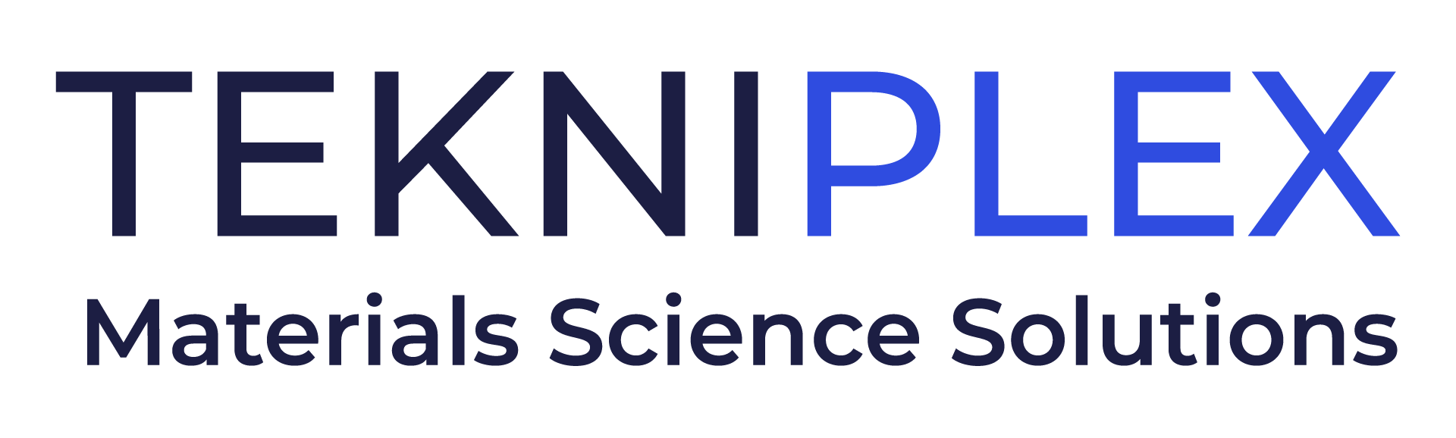
Press release

Media Contact: Peter Gavigan
TekniPlex
+1 (908) 720-5391
Peter.Gavigan@tekni-plex.com

Christopher Dale
Turchette Agency
+1 (973) 227-8080 ext. 116
cdale@turchette.com

At AMI Medical Tubing & Catheters Event, TekniPlex Healthcare to Give Presentation on Technology Advancements in Critical Fluids Transfer Applications

Pair of materials science technical experts to present ‘New Tubing Advancements Drive Dramatic Improvements for Critical Fluid Transfer Applications.’

Wayne, PA – TekniPlex Healthcare, which utilizes advanced materials science expertise to help deliver better patient outcomes, will give a presentation exploring materials science progress that significantly aids the administration of critical liquids and other medical fluids at AMI’s Medical Tubing & Catheters Conference, November 1-2 in Tampa, FL. On November 1 at 9:50am, two TekniPlex Healthcare experts – Alex Kakad, Global Product Manager, and Gary Mizenko, Global Head of Technical Operations – will present New Tubing Advancements Drive Dramatic Improvements for Critical Fluid Transfer Applications.

Among other points of interest, those attending the lecture will learn about unique tubing solutions for peristaltic pump applications that offer multiple, marked improvements over their conventional, silicone-based counterparts. Kakad and Mizenko will explore the causes of several common failures, and discuss recent design improvements for multilayer tubing used, for example, with infusion systems. The duo will provide real-world examples of problem solving across several tubing scenarios, and also cover validation techniques to best ensure consistent dimensional and peel strength tolerancing for fluid management solutions.

TekniPlex Healthcare is a longstanding leader in medical tubing applications, including paratubing solutions produced in up to eight custom-colored, textured or striped tube formations to distinguish between flow paths. The company’s validated manufacturing processes yield paratubes with uniform, repeatable and consistent bonding strength between 0.22 and 1.5 pounds, protecting dimensional stability and ensuring each individual tubing line’s integrity. Maintaining consistent bonding strength prevents individual tubes from separating prematurely and being rejected by healthcare providers, and also eliminates the need for excessive force to peel the tubes apart, which can damage or distort them to the detriment of patients.

TekniPlex Healthcare is also dedicated to developing custom solutions to unique problems in the medical and bioprocess fields. Recent examples include patented multilayer tubing configurations that offer extremely low absorption properties to help extend the usable life of insulin and other unstable drug products, such as chemotherapy drugs. Another patented configuration, designed for fluid transfer of DMSO and other solvent suspensions, allows for safe product delivery in dual hormone delivery systems and advanced cell & gene therapy processes.

# # #

About TekniPlex Healthcare
TekniPlex Healthcare utilizes advanced materials science expertise and technologies to develop and deliver critical solutions for medical and diagnostic devices, drug delivery systems and healthcare packaging applications. With a global reach, the division’s deep understanding of the greater pharmaceuticals and medical landscape helps it produce exemplary barrier properties for drugs and precision medical devices for interventional and therapeutic procedures. TekniPlex Healthcare’s ever-evolving portfolio helps meet demands for high-leverage medicines and mission-critical healthcare products that benefit care providers and patients. For more information visit www.tekni-plex.com/healthcare.

