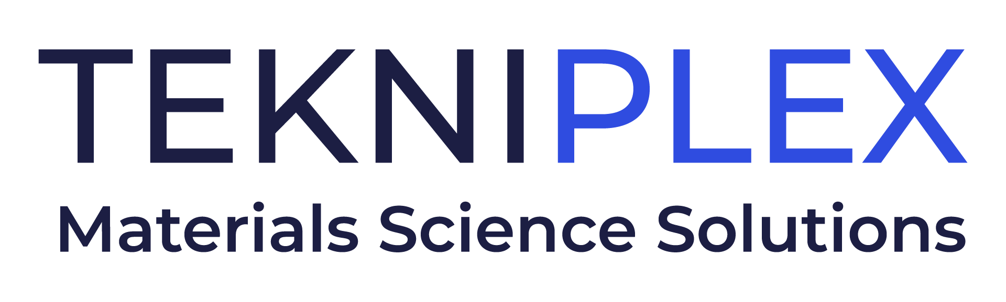
Press release

Media Contact: Peter Gavigan
TekniPlex
+1 (908) 720-5391
Peter.Gavigan@tekni-plex.com

Christopher Dale
Turchette Agency
+1 (973) 227-8080 ext. 116
cdale@turchette.com

TekniPlex Makes Enhancements
to Global Innovation Center in Ohio

Serving as hub for materials science research & development,
the facility features state-of-the-art labs, rapid prototyping capabilities, and ideation rooms.

Holland, OH – TekniPlex, a globally integrated provider of innovative solutions through materials science and manufacturing technologies, recently modernized its Global Innovation Center in Holland, Ohio. The improvements further enhance the center’s ability to serve as a hub for materials science research & development through sophisticated labs, rapid prototyping capabilities, and collaboration spaces.

TekniPlex’s Global Innovation Center focuses on the development of new materials science platforms for a variety of everyday items, including packaging solutions for healthcare, food & beverage, personal care, and household products. The facility also strives to be a center for learning; for example, TekniPlex recently hosted students from the Toledo Technology Academy of Engineering for an in-depth tour relevant to their coursework. Students met with experts from a variety of disciplines and enjoyed demonstrations of state-of-the-art manufacturing equipment – bringing abstract science into the real world of modern product packaging and protection.

“We’re committed to making this facility a world-class innovation center for our global materials science teams, customers, and surrounding community,” said Oscar Martin, Senior Vice President of Global Innovation for TekniPlex. “Continuing to invest in this hub for ideas and breakthroughs allows TekniPlex to remain at the forefront of materials science. This includes consumer products such as food & beverage and personal care products – where our solutions enhance customer experiences – as well as healthcare, where our overarching goal is always improving patient outcomes.”

# # #

About TekniPlex
TekniPlex is a globally integrated company that provides innovative solutions through materials science and manufacturing technologies. A global leader in the healthcare and consumer product markets, TekniPlex provides medical device components and a multitude of materials science solutions that lead to a healthier and more sustainable world. Its solutions are found in some of the most well-known names in the healthcare, pharmaceutical, personal care, household, and food & beverage markets.

Headquartered in Wayne, Pa., TekniPlex employs 7,000 team members throughout its operations in Belgium, Brazil, Canada, China, Colombia, Costa Rica, Germany, India, Italy, Mexico, Northern Ireland, and the United States. For more information visit www.tekni-plex.com.

