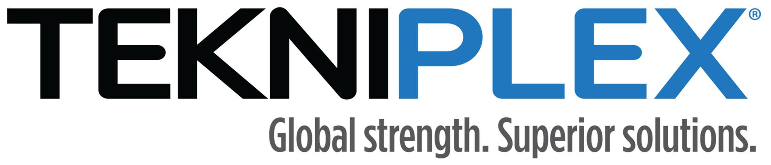
Press release

Media Contact: Peter Gavigan
Tekni-Plex
+1 (908) 720-5391
Peter.Gavigan@tekni-plex.com

Christopher Dale
Turchette Agency
+1 (212) 277-8080 ext. 116
cdale@turchette.com

TekniPlex Consumer Products to Host Virtual
Expo for Fresh Food Space on New Mytaverse Platform

August 31 from 1-5pm EST, TekniExpo will feature materials science presentations, breakout sessions and “virtual booths.”

Wayne, PA – TekniPlex Consumer Products, a globally integrated provider of innovative solutions through materials science and manufacturing technologies, is launching an immersive, next-level cyber experience to showcase its broad capabilities and product portfolios for the fresh food market.

To officially kick off its Mytaverse environment, the TekniPlex division will host an online event comprising a series of materials science presentations, “virtual booths,” and breakout sessions. Called TekniExpo, the event occurs August 31 from 1-5pm EST. Those wishing to attend can register here.

Far from mere spectators, those participating in the event will enjoy a truly interactive experience. Attendees will have their own avatars, and be free to discover the cyber-environment and interact with others throughout the virtual exhibit space. The result is a level of networking difficult to replicate in traditional online forums, as well as more impactful knowledge sharing opportunities.

The setup is ideal to explore the wide array of materials science capabilities TekniPlex Consumer Products brings to the food & beverage sector. The event also will feature two keynote speakers:

1:30–2:30pm: Suzanne Shelton, President & CEO of Shelton Group, a leading ESG marketing and communications agency, will present Sustainability Drivers in the Packaging Market.

2:30–3:30pm: Joel Morales, Executive Director, Polyolefins for IHS Index, presents Resin Trends in the Market.

Beginning at 3:30pm, TekniExpo will host breakout rooms featuring “virtual booths” staffed by TekniPlex experts on specific packaging solutions and substrates. These include dedicated cyber-spaces for:
- Processor Trays for Fresh Protein
- The Future of Foaming
- Fiber Substrates & Fresh Food
- Dairy & Ice Cream
- Shelf Stable Foods
- Coffee Pods
- Food Ware & Foodservice
- Sustainability’s 4Rs

“This event presents an exciting opportunity for us to connect with our audiences in a more meaningful way in these digital times to deepen our understanding of their packaging needs, so we can continue to create innovative, sustainable materials science solutions that help our customers meet their business goals,” said Carlos Tapias, Vice President & General Manager, Fresh Food North America.

# # #

About TekniPlex Consumer Products
TekniPlex Consumer Products specializes in advanced materials science solutions for companies in the food & beverage and CPG industries with a focus on protecting products, strengthening brands, and innovating sustainably. Trusted by companies around the world, TekniPlex Consumer Products serves sectors from beauty & personal care products, and household items to dairy, meat & poultry, eggs, produce, and beverages.

With an expanding selection of material-diverse solutions – bolstered in recent years, by a series of strategic acquisitions – TekniPlex Consumer Products is leading the way creating next-generation packaging designs that address real-world challenges in the markets it serves. Most notably, the company is focused on developing more sustainable solutions that continue to provide product safety and consumer satisfaction. For more information, visit www.tekni-plex.com/consumer

