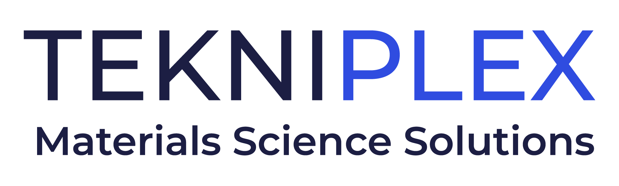
Press release

Media Contact: Peter Gavigan
TekniPlex
+1 (908) 720-5391
Peter.Gavigan@tekni-plex.com

Christopher Dale
Turchette Agency
+1 (973) 227-8080 ext. 116
cdale@turchette.com

TekniPlex Consumer Products Acquires Ematec, Expanding Portfolio of Sustainable Materials Science Solutions for Fresh Foods

Mexico-based manufacturer is the newest move from TekniPlex
to continue its expansion in molded fiber.

Wayne, PA – TekniPlex Consumer Products, a globally integrated provider of innovative solutions through materials science and manufacturing technologies, has acquired Empaques Moldeados de America Tecnologias S. de R.L. de C.V. (EMATEC), a Mexico-based manufacturer of molded fiber packaging solutions for eggs, produce, food service, and other fresh food items. Ematec’s portfolio of sustainable molded cellulose pulp packaging solutions further strengthens TekniPlex’s leading position as a materials-diverse solutions provider in the fresh foods industry.

Molded fiber is a renewable bio-based material derived from 100% natural, typically-recycled paper and cardboard fibers, making it highly attractive to brands seeking to expand their bio-based packaging offerings. Ematec also offers a line of post-consumer recycled PET plastic containers such as egg cartons, clamshells, and others.

Following the acquisitions of Keyes and Fibro, acquiring Ematec adds to TekniPlex’s substantial fiber-based solutions portfolio, and leverages its materials science insights and customer relationships. Overall, TekniPlex Consumer Products is becoming increasingly materials diverse, providing fresh foods companies with a broad range of packing and packaging solutions to help stand out in the perimeter of supermarkets.

“Ematec bolsters our commitment to leadership in the fresh foods and foodservice categories, reinforcing our strategy to focus on helping our customers win in the perimeter of the store,” said Eldon Schaffer, CEO of TekniPlex Consumer Products. “Ematec has a solid reputation for developing and commercializing packaging solutions for the segments it serves, and we’re proud to create a powerful fiber solution leveraging the combined strengths of Keyes, Fibro, Ematec, and TekniPlex.”

Ematec’s six facilities and 530 employees in Mexico strengthen TekniPlex’s footprint in the Americas, adding to its existing locations in Mexico, North America, and Colombia, and providing additional manufacturing capacity and diversification capabilities to better serve its customer’s needs.

The acquisition is the latest in a series of strategic moves by TekniPlex in the consumer goods space, especially in fresh food and foodservice solutions. It aims to boost the company’s growth based on its “Sustainability And” approach, combining sustainability-minded materials science solutions with its customers’ business needs such as product performance, supply assurance, competitiveness, and more. Ematec has been in business for over half a century, and has deep roots in the Americas.

# # #

About TekniPlex Consumer Products
TekniPlex Consumer Products specializes in advanced materials science solutions for companies in the food & beverage and CPG industries with a focus on protecting products, strengthening brands, and innovating sustainably. TekniPlex Consumer Products serves companies around the world in sectors including beauty and personal care, household items, and food and beverage.

With an expanding selection of material-diverse solutions – bolstered in recent years, by a series of strategic acquisitions – TekniPlex Consumer Products is leading the way creating next-generation packaging designs that address real-world challenges in the markets it serves. Most notably, the company is focused on developing more sustainable solutions that continue to provide product safety and consumer satisfaction. For more information, visit www.tekni-plex.com/consumer

