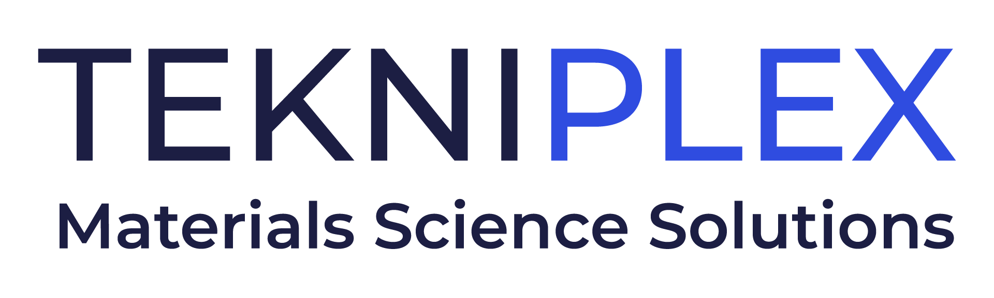
Press release

Media Contact: Peter Gavigan
TekniPlex
+1 (908) 720-5391
Peter.Gavigan@tekni-plex.com

Christopher Dale
Turchette Agency
+1 (973) 227-8080 ext. 116
cdale@turchette.com

At Pharmapack Paris, TekniPlex Healthcare to Debut World’s First Pharma-grade PET Blister Film with Recycled Content

Developed in collaboration with Alpek Polyester, the film is suitable for a wide array of primary packaging applications, with 30% of its PET polymerized from PCR-origin through chemical recycling.

Wayne, PA – TekniPlex Healthcare, which utilizes advanced materials science expertise to help deliver better patient outcomes, has partnered with petrochemical leader Alpek Polyester to introduce the world’s first pharmaceutical-grade polyethylene terephthalate (PET) blister film containing significant recycled content. Suitable for a wide array of primary packaging applications, 30% of the PET blister film is manufactured using post-consumer recycled (PCR) monomers. When combined with TekniPlex’s polyester lidding, Teknilid® Push, the film plus lidding blister system is also fully recyclable in the polyester recycling stream where recycling infrastructure exists. TekniPlex Healthcare will debut the promising new solution at Pharmapack Paris, Stands C48 & C49, January 24-25.

To create the next-generation film, post-consumer plastic waste undergoes a depolymerization process via chemical recycling, which reduces it back to monomers. After repolymerization to PET, the result is a recycled resin that is essentially virgin material. Notably, such monomer-level deconstruction and repolymerization is impossible to achieve via traditional mechanical recycling methods. The end product from Alpek’s polymer reactor is a sheet in master reel made according to the melt-to-sheet process.

The benchmark-setting new blister film meets all pharmaceutical requirements for PET as outlined in the European Pharmacopoeia Section 3.1.15, and United States Pharmacopoeia Section 661.1. The achievement was the latest in a longstanding relationship between TekniPlex Healthcare and Alpek Polyester, who frequently collaborate on projects involving the production and slitting of PET film for pharmaceutical and medical applications.

Among other benefits, adopting the new PET blister film with PCR content allows pharma companies to stay ahead of pending sustainability legislation poised to affect packaging in all industries. Perhaps most notably, the EU’s forthcoming Packaging & Packaging Waste Regulation likely will impose recyclability deadlines on all industries and PCR content baselines for various sectors. Similar movements are progressing elsewhere, leading to demand for more sustainable pharmaceutical packaging solutions that do not compromise on material quality, product protection or patient health.

“This is the first time pharmaceutical companies have the option to incorporate a blister pack that is fully recyclable and, at the same time, contains a significant portion of recycled material – all while still meeting stringent pharmaceutical quality standards for product protection and consumer safety,” said Melissa Green, Head of Global Marketing for TekniPlex Healthcare. “We anticipate high demand for this new, more sustainable film, as it meets ever-growing calls for elevated eco-friendliness in packaging across all sectors, including pharma.”

Also at Pharmapack, TekniPlex Healthcare will showcase its recently incorporated next-generation filling and sealing machine for plastic containers. The Pentafill® A25 Filling & Sealing Machine offers several improvements over previous models, including improved sterility and a smaller footprint. Capable of producing up to 25 five-vial strips (125 vials total) per minute, the PentafIll® A25 filling and sealing machine is suitable for filling a wide range of viscosities for applications serving the pharmaceutical, diagnostics, nutraceuticals and animal health markets.

Finally, TekniPlex Healthcare will exhibit examples of its pharma rubber compounding and manufacturing solutions for healthcare applications, including gaskets and closures. Manufactured to precise dimensional tolerances to ensure proper fit and function within packaging or medical devices, the company’s pharma-grade rubber substantially minimizes the risk of migration-associated impurities like extractables and leachables. In addition, TekniPlex’s modern laboratories enable development and testing of unique rubber solutions for customer-specific applications.
# # #

About TekniPlex Healthcare
TekniPlex Healthcare utilizes advanced materials science expertise and technologies to develop and deliver critical solutions for medical and diagnostic devices, drug delivery systems and healthcare packaging applications. With a global reach, the division’s deep understanding of the greater pharmaceuticals and medical landscape helps it produce exemplary barrier properties for drugs and precision medical devices for interventional and therapeutic procedures.

TekniPlex Healthcare’s ever-evolving portfolio includes CDMO capabilities, allowing the division to service every stage of the medical device product life cycle, from design and development through component manufacturing and final assembly. Its broad offering helps meet demands for high-leverage medicines and mission-critical healthcare products that benefit care providers and patients. For more information visit www.tekni-plex.com/healthcare.

About Alpek
Alpek is a leading petrochemical company operating two business segments: “Polyester” (PTA, PET, rPET, and polyester fibers), and “Plastics & Chemicals” (polypropylene, expandable styrenics, and other specialty & industrial chemicals). Alpek is a leading producer of PTA, PET resin and PET sheet worldwide, one of the largest rPET producers in the Americas, the third largest expandable polystyrene manufacturer worldwide, and the only producer of polypropylene in Mexico. In 2022, Alpek reported revenues of U.S. $10.6 billion and Comparable EBITDA of U.S. $1.4 billion. The Company operates 35 plants across the United States, Mexico, Canada, Brazil, Argentina, Chile, Oman, Saudi Arabia, and the United Kingdom, and employs over 7,000 people. Alpek is a publicly traded company listed on the Mexican Stock Exchange.

