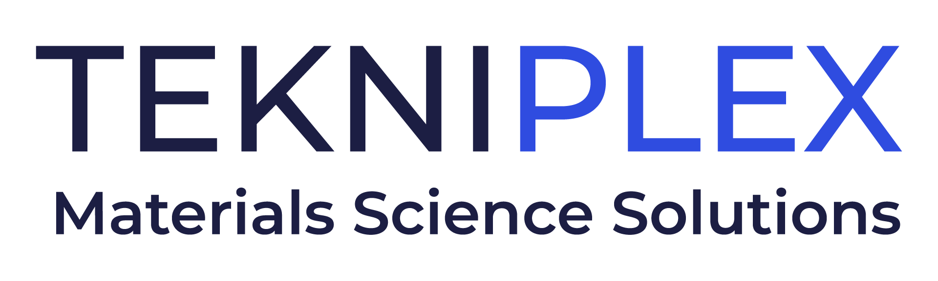
Press release

Media Contact: Tatiana Peisach
TekniPlex
tatiana.peisach@tekni-plex.com

Christopher Dale
Turchette Agency
+1 (973) 227-8080 ext. 116
cdale@turchette.com

At IPPE, TekniPlex Consumer Products to Highlight
New US Facility for Specialty Molded Fiber,
and Its Range of Sustainability-minded Processor Trays

Company’s 200,000-square-foot Ohio plant complements new high-performance molded fiber production lines in Mexico facility, while its broad range of sustainable processor trays are designed to be an alternative to traditional foam polystyrene, with options ranging from recyclable to biodegradable.

Wayne, PA – TekniPlex Consumer Products, a globally integrated provider of innovative solutions through materials science and manufacturing technologies, heads into IPPE 2025 on the heels of launching a 200,000-square-foot facility in Van Wert, Ohio, dedicated to the molded fiber solutions sector. At its Booth B34033, the company will emphasize its substantially expanded capacity and capabilities in this rapidly emerging, eco-conscious packaging segment. whose applications include the high-performance egg cartons for which TekniPlex Consumer Products has become known.

Among the novel technologies featured at the plant will be a proprietary fiber production process allowing for stronger, better-quality final products with enhanced protective properties – a differentiator particularly in the egg carton space, but also for several other food categories. Notably, the spacious, multilane Ohio plant parallels new high-performance molded fiber production lines at TekniPlex’s facility in Apodaca, Mexico.

From a meat and poultry solutions perspective, at IPPE TekniPlex Consumer Products will showcase its range of materials-diverse innovations, including those designed to address recent government initiatives to phase out conventional polystyrene trays. A prime example is the company’s foam polypropylene (PP) trays, which are being launched through a recent partnership with a nationwide fresh sausage company. Durable, lightweight and heat-resistant, the trays are a drop-in replacement for common foam polystyrene trays, and are compatible with existing overwrap equipment commonly found within case ready packing environments.

TekniPlex Consumer Products’ 100% PET Processor Trays are another attractive option for overwrap applications. The transparent trays offer premium product display and are recyclable in geographies where the PET recycling stream is available. Containing up to 50% PCR content, they are available in two unique, proprietary rim options to accommodate various film overwrapping materials and processes.

Also at IPPE, TekniPlex Consumer Products will showcase its collaboration with a fresh beef processor to launch its new lightweight modified atmosphere packaging (MAP) portfolio of trays. Designed to enhance food preservation and quality, the trays are made from recyclable PP and offer exceptional durability, flexibility, and temperature resistance, making them ideal for both microwave and freezer use.

“Our new Ohio plant, increased capacity in Mexico and expanded portfolio of eco-conscious protein trays showcase our continued progress not only in specialty molded fiber, but also other sustainability-minded materials,” said Eldon Schaffer, CEO of Consumer Products. “IPPE is an ideal setting to highlight the benchmark-setting packaging and processing solutions we bring to the fresh foods segment – ones that simultaneously advance sustainability, functionality and end user experiences.”

# # #

About TekniPlex Consumer Products
TekniPlex Consumer Products specializes in advanced materials science solutions for companies in the food & beverage and CPG industries with a focus on protecting products, strengthening brands, and innovating sustainably. TekniPlex Consumer Products serves companies around the world in sectors including beauty and personal care, household items, and food & beverage.

With an expanding selection of material-diverse solutions – bolstered in recent years, by a series of strategic acquisitions – TekniPlex Consumer Products is leading the way creating next-generation packaging designs that address real-world challenges in the markets it serves. Most notably, the company is focused on developing more sustainable solutions that continue to provide product safety and consumer satisfaction. For more information, visit www.tekni-plex.com/consumer.

