September 2022

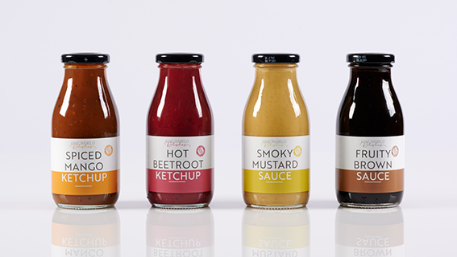

NEW SEMI-SOLID WHITE FILM FOR PRESSURE SENSITIVE LABELS

The innovative semi-solid film has an enhanced yield and opacity compared with solid white films.

Innovia Films has developed a high yield, semi-solid, glossy white BOPP film, Rayoface™ JB. This 47 micron film, designed for pressure sensitive labelling (PSL) applications, combines some of the advantages of cavitated and solid films into a semi-solid film. JB47 has a coating receptive surface to allow customers to add their own printable topcoat and has EU and FDA food compliance.

Rayoface™ JB is particularly suitable for use within a wide range of market segments such as Household and Personal Care, Food and Beverage, and other consumer packaged goods sectors.

Produced at Innovia Films Poland, on their advanced technology 5-layer BOPP line, JB is a superior performance product. Compared to a solid white film it has much better opacity and higher yield. The glossy film surface has excellent

compatibility to top-coatings and PSL adhesives and importantly also has EU and FDA food contact compliance.

Stephen Weber, Key Account Director, explains “The semi-solid nature of JB47 means it has some of the advantages of a cavitated film whilst still behaving closer to a solid film. It has the glossy white, high opacity appearance of a cavitated film and a higher yield than a solid white film. Combined these features make JB47 an aesthetically and economically attractive film.”

Rayoface™ JB is available now, so to find out more, contact your local Innovia Films Sales Manager or email labels@innoviafilms.com

Ends (Words: 241)

PICTURE CAPTION:
Rayoface™ JB high yield, semi-solid glossy white film for PSL label applications.

For further information contact:

Patricia Potts, Global Communications Manager / Charlotte Robinson, Assistant Communications Manager
Innovia Films Ltd, Lowther R&D Centre, Wigton, Cumbria, CA7 9XX, UK
Tel: +44 (0) 16973 42281 Fax: +44 (0) 16973 41452
Email: patricia.potts@innoviafilms.com
www.linkedin.com/company/innovia-films
Follow us on Twitter: www.twitter.com/InnoviaFilms
Watch our Videos on You Tube: www.youtube.com/innoviafilms
www.innoviafilms.com

Innovia Films is a major producer of highly differentiated specialty Biaxially Oriented Polypropylene (BOPP) films using proprietary ‘Bubble’, Stenter Technology and Cast manufacturing processes.

The company holds a leading global position in the markets for high performance coated films, tobacco overwrap, labels and security films. Innovia employs >1400 people worldwide and has production sites in Australia, Belgium, Germany, Mexico, Poland and the UK. The company is focused on high-quality value-added products, strong customer relationship, R&D and excellent service.

