PRESS RELEASE

13.03.2023

Interpack 2023
Lantech ensures efficient processes

Malden/NL. Clear the stage! At Interpack (Düsseldorf, 4-10 May 2023, Hall 13/D47), Lantech will be showing state-of-the-art automatic stretch wrappers and carton packaging systems. The machines make packaging processes more efficient and prevent transport damage. Visitors can also look forward to some new developments.

The highlight at the stand is the new RL Automatic ring stretch wrapper. The high-speed machine wraps up to 180 loads per hour with outstanding packaging quality and largely without operator intervention. The Metered Film Delivery feature offers increased wrapping force for maximum stability without squeezing and twisting the load or tearing the film. The Load Seeking Clamp feature protects against film tears by welding the film end to the load. With Wrap Cycle Control, the film stretch can be adjusted during operation via the control panel. The optional extra Automatic Roll Change allows the film rolls to be changed automatically. The RL Automatic stretch wrapper is suitable for load dimensions of up to 1200 mm x 1200 mm x 2700 mm.

A stretch wrapper as a time saver
The QL-400XT semi-automatic stretch wrapper saves two minutes of time on each wrapping cycle with the patented XT Cut & Clamp feature. The film is gripped and cut at the end of the wrapping cycle. The operation is completely mechanical and does not require a separate compressed air supply or power supply. The intelligent Load Guardian control system creates special profiles with the appropriate retention force for frequently occurring loading applications. Users process up to 35 loads per hour with the QL-400XT stretch wrapper, where the film can have a maximum pre-stretch of 300 per cent. Diagonal load sizes up to 1829 1830 mm and wrapping heights up to 2032 2030 mm are wrapped.

Cartons with square angles
The CI-1000 automatic inline carton erector processes up to 25 cases per minute, which are always square and therefore have maximum stability and are optimally suited for the logistics chain. Furthermore, the machine impresses with great flexibility, as it processes many types of cartons and closures. The dimensions of the cartons can range from 200 mm x 150 mm x 150 mm to 500 mm x 325 mm x 520 mm. The carton blanks are completely controlled from the moment they are inserted into the magazine until they are output as a finished formed case with a sealed bottom.

When smaller quantities are required, the C-300 case erector is the right choice. It can produce up to 10 square cases per minute with dimensions of up to 500 mm x 350 mm x 600 mm per minute. Other features of the machine are the ergonomic loading and the extremely controlled processing of the blanks.

Monitoring software for stretch wrappers
Lantech now offers the LINC (Lantech Intelligent Network Connection) software solution that monitors the operation, productivity, quality and cost of L-Series automatic stretch wrappers. The new online tool analyses key performance indicators and draws attention to inactive machines as well as incorrect winding profile settings. Employees can view the data in real time via the internet. The bottom line is higher availability, less film consumption and improved load quality.

About Lantech:
The packaging machine manufacturer Lantech is the world leader in stretch wrappers as well as robust and efficient case and tray handling machines. Founded in 1972, the US family-owned company developed the world's first rotating stretch wrapper and has continuously improved this technology ever since. Today, Lantech employs around 750 people. The European headquarters are located in Malden, the Netherlands. (www.lantech.com)

Image material:

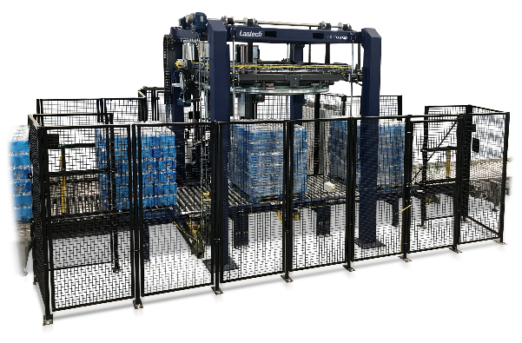
The fully automatic RL Automatic ring stretch wrapper wraps up to 180 loads per hour. (© Lantech)

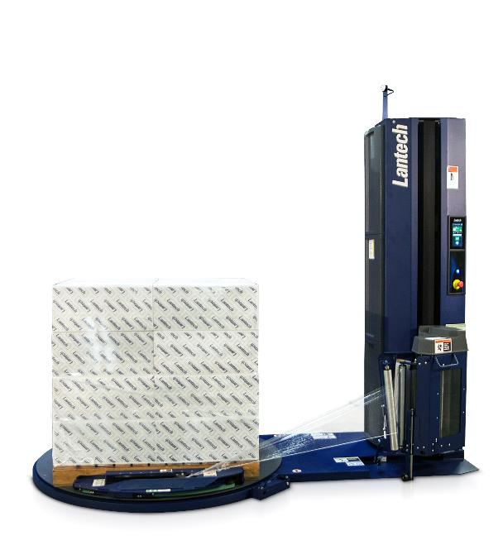
The QL-400 semi-automatic stretch wrapper has time-saving features. (© Lantech)

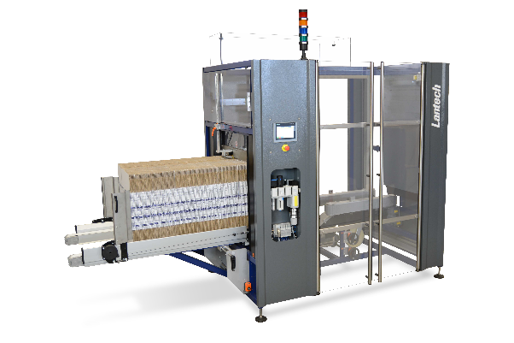
The CI-1000 inline case erector delivers up to 25 absolutely square cases per minute. (© Lantech)

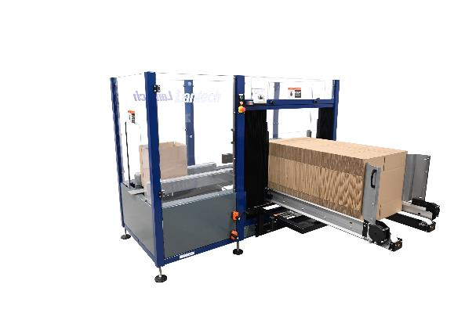
The C-300 case erector achieves an output of up to 10 cases per minute. (© Lantech)

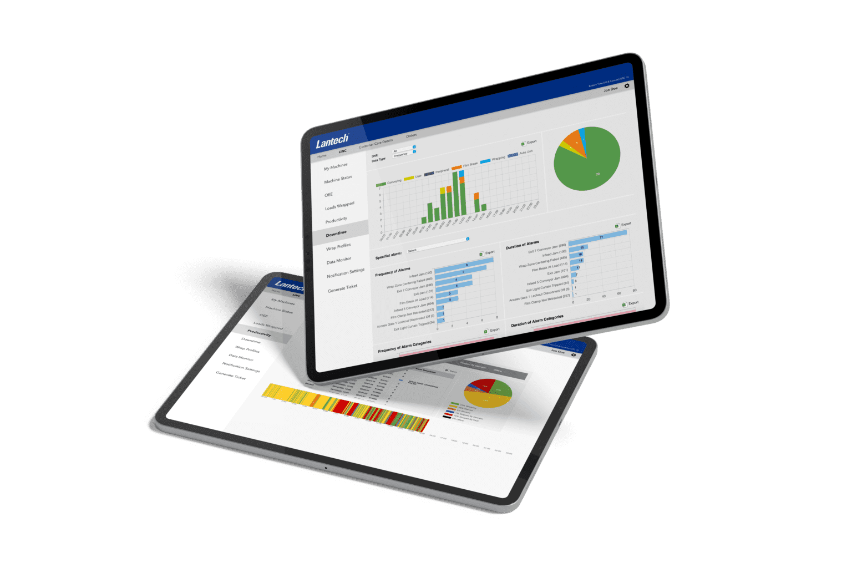
The web-based software LINC monitors the performance data of stretch wrappers. (© Lantech)

