April-June 2022 Quarter Sees UFlex Powering Product Innovations with Focus on Brand Positioning, Sustainability & Value Addition

10th August, 2022, Noida: Maintaining its position as an industry leader while advancing its technology to constantly innovate and introduce new ingenious products & solutions, UFlex has announced an array of exciting launches along with impressive financial results in April-June 2022 quarter. The flexible packaging giant has always had a multi-pronged goal of providing top notch end-to-end value added packaging solutions while also setting high standards for sustainability in the industry and making the product grab attention.

Take a look below at the latest pack of innovations that UFlex has to offer to its customers,

By Flexible Packaging business

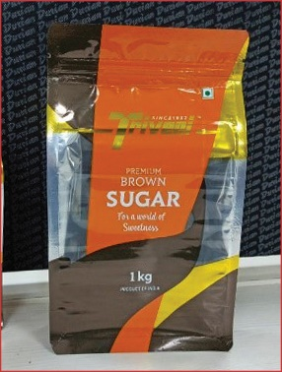
- 3D Pouch with Registered Window Metallization for Premium Brown Sugar by Triveni Engineering: After its recent success with Triveni Engineering for the packing of its premium crystal sugar, UFlex has come up with a three-layered 3D pouch with registered metallization for their premium brown sugar. The pack’s structure is made of PET / Window MET PET and NAT PE. Its structure provides a metallic sheen look to the pack while allowing consumers to see the packed content that helps them make an instant buying decision. Owing to its 3D structure, the brand leverages on pack’s standability at the base, and a side gusset that positions its premium brown sugar packs uniquely on the retail shelves.

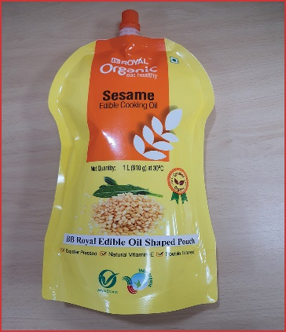
- Profile Spout Pouch with Re-closable Option & Easy Pour Experience for BB Royal Cold-press Cooking Oil: Conventionally, edible oil has been packed in either a regular pouch or a rigid bottle. Such packaging formats often offer limited differentiation on the shelves for buy as well as its use that sometimes could be quite cumbersome with oil spilling while pouring it. This development made by UFlex for BB Royal Organic Edible Oil is a unique offering for edible oil packaging applications in which the structure is made of PET / BON / PE with a spout for easy pour experience. This structure has emerged as a viable solution for packaging edible oil, and successfully replaces the need for rigid containers. Beyond convenience and striking aesthetics, its 3-ply packaging structure offers good standability that creates a unique shelf appeal on the retail shelves. The elegant look of the pack is achieved through a profiled format.

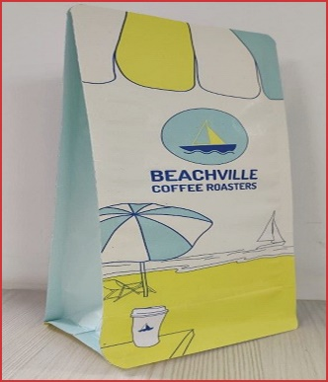
- 3D Pouch with Paper-based Barrier Laminate for Beachville Coffee Roaster: Around the world, coffee lovers have known to form an initial connect with their favourite coffee by its aroma. With the growing need for sustainability across the segments, coffee brands are turning towards more eco-friendly packaging formats like paper-based ones with attractive designs that make them stand out on the retail shelves. On these lines, UFlex has developed a unique pack for Beachville Coffee Roaster with a standable pack structure that offers good barrier properties to keep the packed coffee in the desired state. Its one side valve helps retain freshness of the coffee and prevents extraneous factors like moisture, air and more from affecting the quality of the packed content.

By Chemicals Business

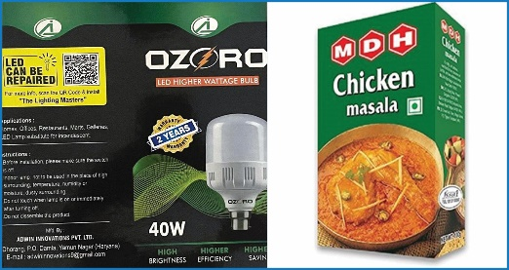
- FLEXBOND SF WET LM 35 Water-based Adhesive for Wet Lamination Application: UFlex has developed FLEXBOND SF WET LM 35, a water-based synthetic adhesive designed mainly for wet lamination of clear BOPP & PVC films to paper or duplex board applications with manual or semi-automatic machines. This adhesive when used on paper or duplex board offers excellent gloss and bond strength and can be applied via a smooth roller-coater. Being water-based, this product helps brand enhance their green footprint.

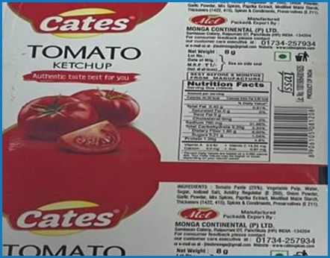
- Retort grade 2K PU Adhesive FLEXCOTE HP 875/ FLEXCOTE HP 75: With growing demand for ready-to-eat food, the need for retort packaging formats is witnessing a sharp surge. Retort packaging formats allow packed foods to be warmed within the pack to be made ready for consumption. However, to strengthen the structure, adhesives play a major role in keeping retort properties intact, even when it comes in contact with boiling water. Understanding the requirements of retort pouching, the company has developed a 2-pack solvent-based PU adhesive specially designed for high-end retort pouch applications. Due to its super strong adhesion, the pack can resist a boiling temperature of 131ºC for 30 minutes with upto 2 kilograms of packed pressure. This development is most suitable for food and pharma packaging applications.

By Packaging Films Business

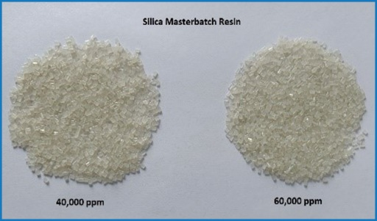
- PET-based Silica Master-batch Solution for BOPET film: The packaging films business has enhanced the handling methodology of BOPET films with the development of a new PET Silica master-batch solution that controls anti-blocking properties in BOPET film development. So far, the flexible packaging business had been using 6,000 ppm to 10,000 ppm of Silica chips that comprises of 7.5% to 12.5% dosing used of silica chips for film production that facilitates easy roll handling and prevents the film from blocking hazards like rippling, wrinkles and other. With the development of this value enriched Silica Masterbatch solution with upto 40,000 and 60,000 ppm, the packaging films business has not only achieved higher anti-blocking properties but has also been successful to make a significant reduction in production cost. Additionally with this development, the packaging films business has been able to lower down the dosage level to 1-2% for film manufacturers.

By Engineering Business

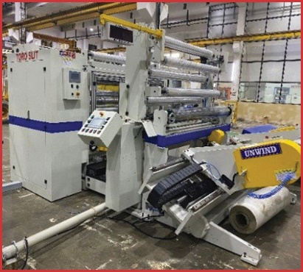
TOROSLIT-1650, a High-speed Turret Slitter for Wide Web Widths: With demand for packaging film on the rise, the need for a high-speed and high-performance slitter that overcomes the limitations of conventional slitters has been gaining importance. To meet the demand for high-quality slitters, UFlex has developed a high-speed turret slitter with a web width of 1650mm. TOROSLIT-1650 overcomes the shortcomings of conventional slitters that were observed during pancake applications. It is a floor lifting, self-shaft chucking, tool-less unwinder that ensures perfect tension control and winding even while handling low gauge films ranging from 8 microns onwards. The fast and continuous change over from rotary cutter to razor cutter, further adds to the operators comfort while using the machine. This slitter comes with a turret type auto splicing re-winder with a quick and automated roll removal system. Its compact design is a big advantage that keeps from the need of large spaces for installation. Furthermore, adding to the accuracy and productivity are its automated blades placed at the core position that elevates overall slitting experience. Owing to its advantages, TOROSLIT-1650 is fast emerging as the preferred slitter for the packaging film manufacturers worldwide.

By Holography business

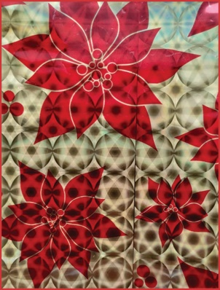
- Multi-coloured Holographic Textile Foil with New Pattern for Enhanced Aesthetics: The post COVID period has witnessed the emergence of a significant trend in the holographic material application field. Fashion brands are on a constant lookout for recognition by the use of new, attractive bright and shiny reflective materials that scream for attention and signify nothing less than a celebration. Radiating an extremely futuristic vibe, the foil-effect fabric has taken the fashion industry by storm. With this trend, fashion gets enhanced into a joyous atmosphere of reflection and radiance, making it more eye-catchy and vibrant. Catering to the demand for aesthetic rich development in the textile space, the company has developed an array of appealing textile foil options that can stunningly make brands stand out. This development has gained acceptance of many textile brands.

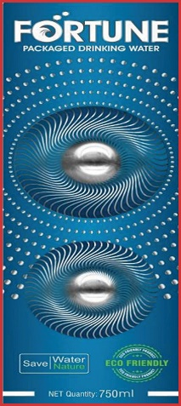
- Fresnel Lens Self-Adhesive Holographic Labelling Solution to Prevent Counterfeiting & Enhance Aesthetics: Taking note of the pain area of brands on rising counterfeiting cases that jeopardise business interest coupled with the need for premium product positioning, UFlex has integrated Registered Fresnel Lens Technology in labelling solution to give a premium look by placing two lenses at the middle and bottom of the label. The Fresnel lens used on the printed area reflects light at multiple angles providing 3-dimensional depth and look to the product. The combination of a Fresnel lens that is reflective from various angles along with vibrant printing produces an effect that is both aesthetically striking and instantly recognizable for scrutiny.
The printing technology combines two major features; the first is the registered holographic substrate while the second involves doing a precise re-registration printing on the same substrate, making it next to impossible to replicate using a compromised set-up. This application is used across several industry verticals such as FMCG, Automobile, Lubricants, Apparel, Liquor, Agro Chemicals, Personal Care and Electronics.

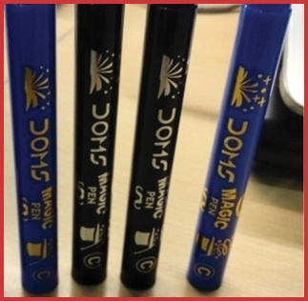
Plastic-grade Hot Stamping Foil for Premium Aesthetics on Stationary Products: In the competitive business landscape, Plastic Grade Hot Stamping foil is gaining widespread prominence as it adds a glow to products’ appearance to make it stand out on the retail shelves. To help brands elevate their products’ look and make it grab attention, UFlex has developed Plastic-grade Hot Stamping Foil solution that is used for a very wide range of applications. This special plastic grade foil is suitable for plastic surfaces such as PVC and PP. It is widely used for writing instruments, picture frames, wall clocks, etc. This development is witnessing big orders especially from the stationery segment.

For media queries, contact:
Saloni Singh| Madison PR| E: saloni.singh@madisonpr.in | M: +91 7486895267
Shweta Singh | Madison PR | E: shweta.singh@madisonpr.in | M: +91 91674 85016

About UFlex:
UFlex is India’s largest multinational flexible packaging materials & solutions company and a global player in polymer sciences. Since its inception in 1985, UFlex has grown from strength-to-strength and has created a presence across all verticals of the packaging value chain – Flexible Packaging, Packaging Films, Aseptic Liquid Packaging, Holography, Printing Cylinders, Engineering and Chemicals.

With a 10,000+ strong multi-cultural workforce that works to develop innovative, value-added and sustainable packaging solutions, the company has earned an irreproachable reputation defining the contours of the ‘Packaging Industry’ in India and overseas, by providing end-to-end solutions to numerous Fortune 500 clients across various sectors such as FMCG, Consumer Product Goods, Pharmaceuticals, Building Materials, Automobile and more, in over 150 countries. Headquartered in Noida, UFlex enjoys a global reach with sophisticated manufacturing facilities in India, UAE, Mexico, Egypt, USA, Poland, Russia, Nigeria and Hungary.

A winner of various marquee global awards for its products’ excellence, innovation and sustainability, UFlex became the ‘first company in the world to recycle mix plastic waste’ earning it recognition at Davos Recycle Forum in 1995. For more details, click on: www.uflexltd.com

