Blocking period until April 16, 2023

Press release

The beginning of a new era
Leibinger to introduce new Coding & Marking System at the interpack fair

Tuttlingen (Germany), 9 March 2023 – Leibinger, the global innovation leader in Coding & Marking Systems, will be presenting an all-new Coding & Marking System at the interpack in Düsseldorf from 4-10 May 2023. With the ground-breaking innovation, the company is raising the benchmark and promising a new era in the marking of, for example, best-before dates and other codes on a wide range of materials.

“Especially in the case of cost-sensitive applications, such as in the F&B sector or in the Fast Moving Consumer Goods (FMCG) segment, it is decisive that the marking runs smoothly and without any interruptions. We have developed an entirely new Coding & Marking System that delivers exactly what it promises: absolutely worry-free printing. We will be bringing our innovation to life at our interpack trade fair stand,” reveals Christina Leibinger, CEO of Paul Leibinger GmbH & Co. KG and explains: “Also worthy of mention is the fact that the new system boasts the lowest operating costs in the industry. Just one of the reasons we are talking about a new era.”

Leibinger can be found at the interpack fair in Hall 8B, Stand D26.

For more information, visit www.leibinger-group.com.

Captions:

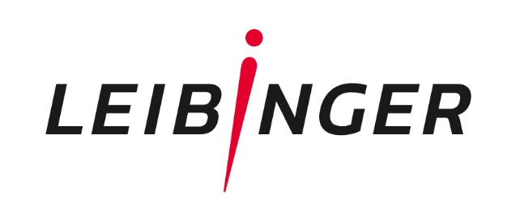 | Leibinger Logo
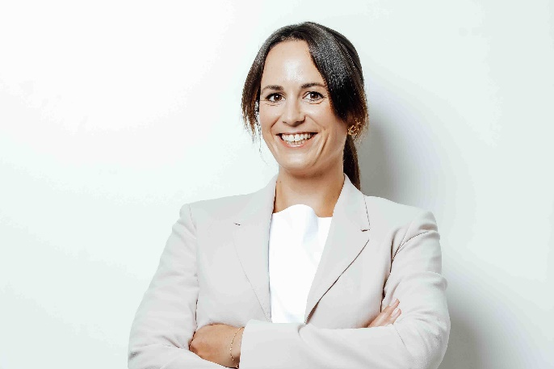  LB_Portrait_Christina Leibinger_Hintergrund weiß.jpg | CEO Christina Leibinger promises: “Leibinger is ushering in a new era in product coding and marking at the interpack.”  Source: Paul Leibinger GmbH & Co. KG

Contact
Paul Leibinger GmbH & Co. KG
Maren Klose (Marketing & Communication)
Daimlerstraße 14
78532 Tuttlingen
Germany
Tel.: +49(0)7461 / 9286-224
Fax: +49(0) 7461 / 9286-199
E-Mail: mklose@leibinger-group.com
Website: www.leibinger-group.com

In the event of publication, please send a specimen copy to the Marketing Department.

About Paul Leibinger GmbH & Co. KG
Leibinger is a globally positioned specialist in Coding & Marking Systems with headquarters in Germany. The third-generation family-run company, founded in 1948, develops and produces industrial inkjet printers at its site in Tuttlingen, Baden-Württemberg, with a workforce of some 300 employees. The CIJ systems stand out due to their high quality standard and a patented fully automatic nozzle sealing technology, which minimizes time-consuming printer cleaning. The company’s global network with over 150 service partners and subsidiaries in the USA and China ensures that Leibinger can maintain close relationships with its customers anywhere around the world.

