Press release

Consistent, holistic, future-oriented – “sustainability” as the operative word
From processes, products, and technologies to the circular economy – SÜDPACK continues to set new standards with sustainable film and packaging concepts as well as responsible practices. Only recently, the company group joined the SBT initiative – and was also ranked 36th among the most sustainable medium-sized enterprises by WirtschaftsWoche. The film manufacturer’s forthcoming appearance at this year’s FachPack trade show is therefore all about sustainability. Chief among the eye-catching highlights at Stand 224 in Hall 7 will be a large “theme island” illustrating the Group’s sustainability roadmap. Key focus areas: recyclable packaging concepts for a wide range of industries, solutions for the circular economy, downgauging and material reduction, and high-performance films made from renewable resources.
A trade show appearance with the wow-factor: In Nuremberg, SÜDPACK will demonstrate that sustainability – when planned holistically and implemented honestly – delivers immense benefits for people, the environment, and also the economy. In addition to optimizing its own carbon footprint in line with the goal of NET ZERO, a major focus of the film manufacturer’s sustainability strategy is the development of high-performance structures that optimally meet current requirements in terms of recyclability and material efficiency. The best example of this is SÜDPACK’s innovative Pure-Line product family, which in addition to recyclable mono-materials based on PP, now also includes solutions made of PE for diverse packaging concepts.
Sustainable high-performance films for a wide range of applications
SÜDPACK expects its practical tubular bags to provide a powerful draw for the trade fair’s visitors. “We aligned our product range to meet the changing requirements in the market at an early stage. As a result, we can now offer an attractive selection of highly efficient and recyclable solutions for a wide variety of food products. Currently, start-ups in the “new food” segment are especially interested in our flow packs. And for meat products like minced meat or alternative sources of protein, this concept is nothing short of a packaging revolution,” confirms Valeska Haux, Vice President Strategic Marketing at SÜDPACK. Despite their low material thickness, these structured materials based on Pure-Line films, which can be efficiently processed on horizontal and vertical flow pack lines, offer a degree of stability and product protection that is comparable to conventional packaging systems. Unlike tray packaging, material savings of up to 60 percent are possible, which also has a positive impact on CO₂ emissions along the entire logistics chain.
In addition, SÜDPACK will put the spotlight on the new Doypacks in its Pure-Line range. Like the flow packs, these products can be equipped with barriers and functional properties to meet the respective requirements. As a stand-out feature, the barrier composite material, which was previously based on aluminium, has been replaced by a recyclable mono-plastic solution made of polypropylene. This means that customers in this segment can now also benefit from an appealing and above all sustainable packaging concept – for example, for cured sausages and similar products – which meets the legislative requirements for recyclable packaging.
Turning to the production of sustainable thermoformed packaging, SÜDPACK will present two compelling film concepts in Nuremberg: Multifol PurePP and Multipeel PurePP, both of which are also characterized by a highly efficient use of materials as well as certified recyclability. For example, the packaging weight of a flexible packaging concept consisting of a Multifol PurePP flexible film as the bottom web and a peelable PP-based top web is only about 55 percent compared to conventional tray packaging.
If, on the other hand, the fair’s trade visitors are interested in film solutions made from renewable resources, they need venture no further than Hall 7, where SÜDPACK will present two attractive solutions at its stand – Ecocraft Skin and Ecocraft Shape.
“We are closing loops”
SÜDPACK closed its internal material loops years ago thanks to in-house compounding and regranulation processes. Plastic waste from film production is thus collected, sorted, and processed into high-quality compounds in modern plants for subsequent use in the manufacture of new products.
A variety of products consisting of 30 percent recycled content (based on mechanical recycling) are already available to customers. These solutions can be equipped with either a high or medium barrier as required – and are available as both conventional and recyclable solutions.
At the same time, the Group is strongly committed to the further development and implementation of chemical recycling as an alternative, complementary recycling process in the market. SÜDPACK’s extensive investment in the promising CARBOLIQ process is aimed at creating a closed-loop, high-performance, industry-standard system for flexible and previously non-recyclable products. Besides the diverse range of input materials, CARBOLIQ offers competitive advantages in terms of energy efficiency and low emissions. The recovered oil is virgin-grade quality and can be used by the plastics industry in the same way as fossil fuels to produce a wide spectrum of plastic granulates. These granulates can in turn be processed to produce high-performance films for sophisticated packaging applications which are required above all in the food industry.
An important building block in this context is the ISCC PLUS certification (International Sustainability and Carbon Certification). SÜDPACK was one of the first film manufacturers to successfully achieve this for all its German sites as early as the end of 2021. Among other things, the company uses this certification to demonstrate the use of recycled materials – and has thus laid an important foundation for the ongoing development of processes and products that will continue to drive the transformation from a linear to a circular economy.
SPQ also reduces the carbon footprint during package printing
In addition, SÜDPACK will provide full details of its innovative and pioneering SPQ printing technology. Already honoured with the German Packaging Award in gold, this printing process reduces the use of ink and solvents to a minimum and sets new standards in flexo printing due to its small carbon footprint. At the SÜDPACK stand, visiting professionals will be able to verify the advantages of this novel technology, including its brilliant print quality, using a CO₂ calculator and a sample book.
Life cycle assessment – a new service from SÜDPACK
To give its customers extra peace of mind when choosing sustainable packaging, the film manufacturer now also offers a life cycle assessment for suitable packaging concepts, if required. “Despite the fact that only one to three percent of harmful greenhouse gas emissions in Germany are linked to food packaging – every gram of packaging material that can be saved from the outset reduces the environmental impact of the packaging,” Says Valeska Haux.
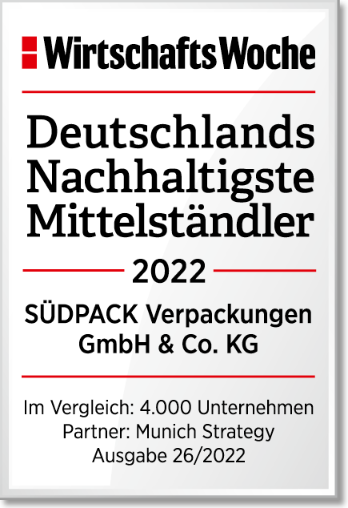

About SÜDPACK
SÜDPACK is a leading manufacturer of high-tech films and packaging materials for the food, non-food, and medical product industries. The solutions ensure maximum product protection as well as additional pioneering features with minimum material input.
The family business, which was founded by Alfred Remmele in 1964, is headquartered in Ochsenhausen. The production sites in Germany, France, Poland, Switzerland, the Netherlands and the USA are equipped with the latest plant technology and manufacture to the highest standards, including the capacity to operate under clean room conditions. The global sales and service network ensures a high degree of proximity to the customer and comprehensive application technology support in more than 70 countries.
With its state-of-the-art Development and Application Centre at its headquarters in Ochsenhausen, the innovation-oriented company offers its customers an optimal platform for carrying out application tests and for developing individual and tailor-made solutions.
SÜDPACK is committed to sustainable development and fulfils its responsibility as an employer and towards society, the environment, and its customers by developing packaging solutions that are unparalleled in their efficiency and sustainability.
In June 2022, SÜDPACK was named one of the most sustainable medium-sized companies by the German magazine WirtschaftsWoche.
www.suedpack.com

Company contact

SÜDPACK VERPACKUNGEN GmbH & Co. KG
Isabell Buchschuster / Product Marketing
Jägerstrasse 23
D-88416 Ochsenhausen, Germany
Phone: +49 (0) 7352 925 – 1534
E-mail: isabell.buchschuster@suedpack.com
www.suedpack.com

Press contact
REDAKON
Vera Sebastian
Seestrasse 18
D-80802 Munich, Germany
Phone: +49 (0) 89 – 31 20 338-21
E-mail: vera.sebastian@redakon.com
www.redakon.com

