Editorial Contact:  Cortec® Advertising Agency | Ana Juraga  (651) 429-1100 Ext. 1114 | ana.juraga@ecocortec.hr
Company Contact: Cortec® Corporation | Julie Holmquist  (651) 429-1100 Ext. 1194 | jholmquist@cortecvci.com
Technical Contact: Cortec® Corporation | Rick Shannon  (651) 429-1100 Ext. 1146 | rshannon@cortecvci.com

Attention: Editor
November 13, 2023
PRESS RELEASE

Corrosion Protection + Heat Sealable Paper = New Custom Packaging Solution!

Cortec® has released new metals packaging solution with an eye to sustainability and convenience! CorShield® VpCI®-146 Heat Sealable Paper combines the heat sealable properties of EcoShield® Heat Sealable Paper with the corrosion inhibiting properties of CorShield® VpCI®-146 Paper for a dual corrosion inhibiting heat sealable paper that opens the door to a wide variety of recyclable custom packaging solutions for metal parts.

VCI/VpCI® Paper Mechanics
CorShield® VpCI®-146 Paper is coated with Vapor phase Corrosion Inhibitors that vaporize and diffuse off the paper over time. When VCI/VpCI® paper is wrapped around metal parts, folded, and taped shut, the corrosion inhibiting vapors are trapped inside the package. These corrosion inhibitors are attracted to metal surfaces, where they adsorb as a molecular protective layer against corrosion. Common uses for VCI/VpCI® paper include packaging of bearings, brakes, and automotive aftermarket parts. Because the protective molecular layer simply floats away after the component is taken out of the package, there is no need for special cleaning or degreasing as is often the case when using traditional greasy and oily rust preventatives. This creates a huge advantage for end users who can immediately use or install the part.

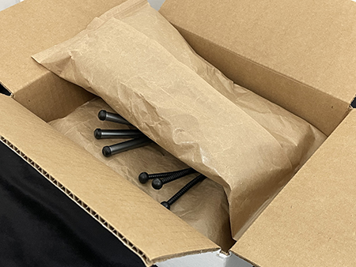
Heat Sealable Paper Mechanics
On the other side of the equation, EcoShield® Heat Sealable Paper offers an innovative recyclable packaging solution that is highly customizable. A water-based heat sealable adhesive coating creates a strong bond when the paper is heated with coated sides together, allowing it to be made into custom envelopes and bags. In testimony to the flexibility and sustainability of this material, one creative application that made industry news in 2023 was the use of EcoShield® Heat Sealable Paper to make dunnage bags. A tool distribution center made the bags with EcoShield® Heat Sealable Paper on an AVM vertical form, fill, and seal machine, automatically filling them with chopped cardboard boxes from their recycling waste to make cushioning material for outgoing packages.

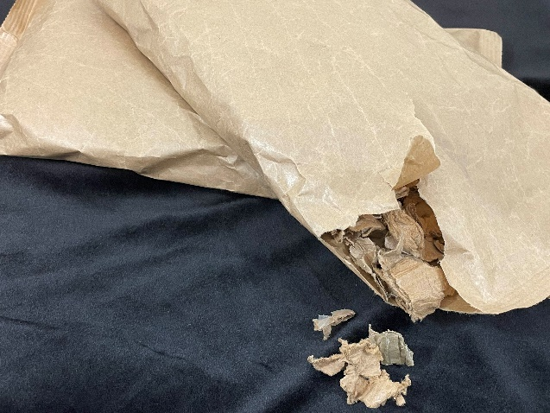
Two-in-One Packaging Paper
Now, with the merging of these two papers, CorShield® VpCI®-146 Heat Sealable Paper expands the potential applications for each paper. Manufacturers and distributors like the company that made dunnage bags with regular EcoShield® Heat Sealable Paper can expand to packaging and protecting metal parts with a VpCI®-enhanced version. Automakers and auto parts manufacturers who could only wrap or interleave parts with VCI/VpCI® paper can now make custom bags out of CorShield® VpCI®-146 Heat Sealable Paper, automatically fill them with metal parts, and seal them shut for delivery to the customer.

Do a Heat Sealable VCI Bag Assessment
Cortec® is eager to find creative solutions to corrosion that help the end user do their job better while also being mindful of the environment and offering alternatives to plastic. CorShield® VpCI®-146 Heat Sealable Paper does so in a special way, opening up new doors to metals packaging opportunities that were previously unavailable with regular VCI/VpCI® paper. Contact Cortec® to discuss your metals packaging application and how CorShield® VpCI®-146 Heat Sealable Paper might fit in today!

Keywords: heat sealable paper, recyclable packaging solutions, VCI paper, corrosion inhibitor, rust preventative packaging, packaging solutions for metal, Cortec, VpCI, form fill seal bags, corrosion solutions

Need a High-Resolution Photo? Visit: www.cortecadvertising.com
Cortec® Corporation is the global leader in innovative, environmentally responsible VpCI® and MCI® corrosion control technologies for Packaging, Metalworking, Construction, Electronics, Water Treatment, Oil & Gas, and other industries. Our relentless dedication to sustainability, quality, service, and support is unmatched in the industry. Headquartered in St. Paul, Minnesota, Cortec® manufactures over 400 products distributed worldwide. ISO 9001:2015, ISO 14001:2015, & ISO/IEC 17025:2017 certified. Cortec® Website: http://www.cortecvci.com Phone: 1-800-426-7832 FAX: (651) 429-1122

