e
Editorial Contact: Ana Juraga ana.juraga@ecocortec.hr
Cortec® Europe Advertising Agency +385 (0) 1 48 54 486

Company Contact: Ivana Radic Borsic iborsic@cortecvci.com
Cortec® Corporation: +385 98 267 572

Attention: Editor
March 21, 2024
PRESS RELEASE
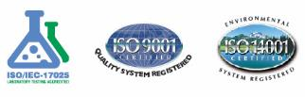

Great Honor for CEO of Cortec® Corporation:
Boris Miksic Receives Special Recognition for 50 Years
of Dedicated Work at NACE-International!
Boris Miksic, a Croatian-American entrepreneur and owner of Cortec® Corporation, has received special recognition for 50 years of dedicated work at NACE-International, the largest global organization focusing on developing standards for corrosion prevention. Cortec® is a global corrosion inhibitor manufacturer and a leader in green corrosion protection technologies. This valuable recognition confirms Mr. Miksic as one of the leading global experts in the field of VCI/VpCI corrosion inhibitors. Patented Vapor phase Corrosion Inhibitors are revolutionary technology that simplifies corrosion protection and is ideal for keeping enclosed void spaces such as packages, equipment internals, or structural metal cavities, corrosion-free. This technology is designed to save time, money and offer more thorough, reliable, and easier-to-use protection than a variety of other metals preservation strategies.
Boris Miksic receiving special recognition at the grand ceremony event organized by NACE/AMPP.
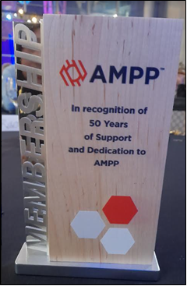
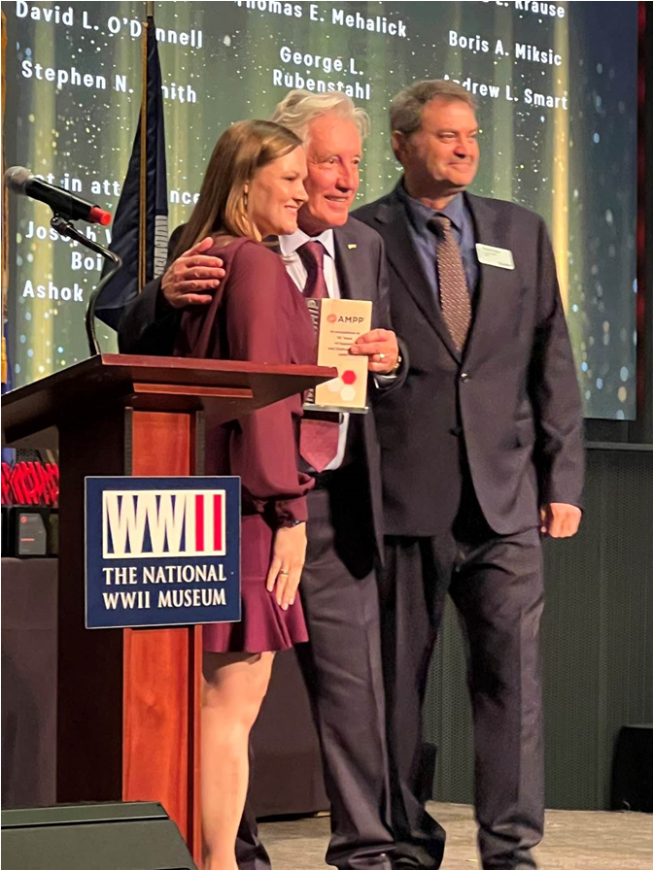
Boris Mikšić is a Croatian-American who immigrated to the USA in the 1970s, where he founded Cortec® in his garage. From modest beginnings in Hugo, Minnesota, Cortec® grew into the world's leader in VpCI®/MCI® corrosion protection technology. With its 9 plants, warehouses, and laboratories, Cortec is the world's largest producer of VCI, VpCI®, and MCI® products and services. It operates in over 100 countries and is the world's largest privately held company involved in corrosion and environmental protection. "I have dedicated my life to developing new green technologies in the corrosion industry, and this award is a great honor. All my investments have a sustainability focus, and my vision from the beginning was to develop environmentally safe solutions. Our plants operate on the circular economy principle, and we recently started utilizing our energy resources by installing solar power plants,” says Miksic. “Most of our products are bio-based and recyclable. We reprocess them in-house, significantly reducing the amount of waste for disposal. This is how we demonstrate not only responsibility towards our customers but also toward our communities. For me, this is equally important. Cortec®, is an example of a modern company that is based on sustainability principles,” he adds. In his rich 50-year career, he received 66 patents and played an important role in the National Association of Corrosion Engineers (NACE, now AMPP). He has won numerous awards, chaired NACE symposiums and working groups, helping to develop numerous industrial testing standards. His discoveries on vapor-phase corrosion inhibitor technology have been published in various scientific journals.
Green Production Complex in Croatia
In the early 2000s, Mikšić launched production in his home country Croatia, which experienced significant expansion. Today, Croatian plants supply not only Europe but also a large part of Asia. Boris Miksic is very pleased with how business is developing in Europe: “EcoCortec®- our sustainable, solar-powered production complex, located in the green fields of the Baranja region, made Croatia one of the central points in Europe for manufacturing and exporting green corrosion inhibitors worldwide" he states.

50 years in NACE-International
The event entitled CORROSION 2024—Conference and Exposition was organized earlier this month by NACE International. During the event, NACE’s recognition for long-standing work and achievements in the field of corrosion protection was awarded to Boris Miksic. He received this honorable recognition at a grand ceremony held at the World War II Museum in New Orleans. Over the past 50 years, Boris Miksic issued 66 patents and played a significant role in the National Association of Corrosion Engineers (NACE, now AMPP). He has won numerous awards, chaired NACE symposiums and working groups, and helped develop numerous industrial testing standards. His discoveries on vapor-phase corrosion inhibitor technology have been published in various scientific journals. Miksic’s vision of pushing boundaries towards sustainability in the industry is prevalent today. More and more companies are following Cortec’s example and turning towards environmentally responsible technologies. "My mission was, and still is, to always be one step ahead. I promoted the importance of green anticorrosion solutions when it was still something that very few were considering. Today, it has become the gold standard in our industry. After many years of hard work advocating for sustainability, I am pleased to see great progress," concludes Miksic.
Boris Miksic attended the grand ceremony event with his wife Ines and the rest of Cortec's team.

Keywords: Cortec Corporation NACE, AMPP, EcoCortec, sustainability, green inhibitors, corrosion protection, , VCI, VpCI, corrosion inhibitors, rust prevention

Photo? Visit: www.cortecadvertising.comCortec® Corporation is the global leader in innovative, environmentally responsible VpCI® and MCI® corrosion control technologies for Packaging,Metalworking, Construction, Electronics, Water Treatment, Oil & Gas, and other industries. Our relentless dedication to sustainability, quality, service, and support is unmatched in the industry. Headquartered in St. Paul, Minnesota, Cortec® manufactures over 400 products distributed worldwide. ISO 9001, ISO m14001:2004, & ISO 17025 Certified. Cortec Website: http://www.cortecvci.com

