PRESS RELEASE

**Mondi’s Containerboard portfolio ready to meet the rising demand for sustainable, high-performance packaging**

* *Mondi's comprehensive containerboard portfolio offers a wide range of paper grades, from fully recycled to 100% virgin fibre, providing sustainable, high-performance packaging solutions for various applications.*
* *Current investments, including a paper machine at Duino in Italy, help to meet growing customer demands with reliable, forward-thinking packaging solutions.*

**24 April 2025** – Mondi's ProVantage containerboard paper grades range, available in both brown and white, ensures that businesses can meet the growing demand for sustainable packaging without compromising on performance. From fully recycled to 100% fresh fibre, the containerboard papers provide a strong foundation for corrugated packaging and are also well-suited for applications like honeycomb structures and fibre drums.

**Fit-for-purpose solutions for every packaging need**

Mondi's ProVantage paper range meets the packaging needs of applications in eCommerce, fresh fruit & vegetable and heavy-duty applications, offering a variety of paper grades that balance strength, sustainability, and printability. The portfolio includes:

* Appearance grades for premium printability and standout branding
* Kraft grades for superior strength and protection
* Recycled grades that deliver a sustainable edge
* Semi-Chem grades for moisture resistance and durability, ideal for long-distance transportation

"As sustainability expectations rise, businesses need packaging that protects their products while reducing environmental impact," says Remy Eecke, Senior Value Chain and Sustainability Manager at Mondi Containerboard. "Our containerboard papers are 100% recyclable and made from 100% sustainably sourced raw materials, giving brands the edge they need in a competitive, eco-conscious marketplace."

**Investing in innovation for the future**

Mondi has been at the forefront of papermaking innovation for over 100 years, continually investing in technology to provide reliable solutions. Recent advancements include the paper machine at the Ružomberok mill in Slovakia, which launched the ProVantage SmartKraft White paper grade in 2021. This Kraft Top White grade combines fresh and recycled fibres, offering both strength and printability for brands looking to make an impact.

Once fully ramped up, the machine at Mondi Duino will produce 420,000 tonnes of high-quality recycled containerboard annually, increasing Mondi's integration and enhancing security of supply for customers.

**Enhancing efficiency with expert support and digital solutions**

Reliable supply and consistent quality keep operations running smoothly, but expert support can elevate efficiency even further. Mondi provides customers with expert support and digital tools designed to optimise production efficiency and reduce waste. The Orange Board technical sales service helps customers maximise board performance, troubleshoot production challenges, and enhance output, all while minimising waste.

Efficiency doesn't stop at materials - it extends to how you manage your supply chain. The myMondi platform supports businesses by simplifying procurement, tracking deliveries, and providing valuable insights into material selection, helping companies make data-driven decisions to improve their supply chain management.

**A long-term partner for success in a changing market environment**

With a diverse portfolio, a secure supply chain, and over a century of expertise, Mondi Containerboard is the trusted partner businesses need to navigate evolving market demands. By combining sustainability, innovation, and expert support, Mondi is helping companies across various industries-such as eCommerce, fresh produce, and heavy-duty applications-optimise production, reduce environmental impact, and meet the growing demand for sustainable packaging solutions.

/ends

**About Mondi**

Mondi is a global leader in packaging and paper, contributing to a better world by producing products that are sustainable by design. We employ 24,000 people in more than 30 countries and operate an integrated business with expertise spanning the entire value chain, enabling us to offer our customers a broad range of innovative solutions for consumer and industrial end-use applications. Sustainability is at the centre of our strategy, with our ambitious commitments to 2030 focused on circular driven solutions, created by empowered people, taking action on climate.

In 2024, Mondi had revenues of €7.4 billion and underlying EBITDA of €1.0 billion. Mondi is listed on the London Stock Exchange in the ESCC category (MNDI), where the Group is a FTSE100 constituent. It also has a secondary listing on the JSE Limited (MNP).

[www.mondigroup.com](http://www.mondigroup.com)

**Contact:**

Michael Schwarz

Marketing Manager, Mondi Corrugated Packaging

Tel: +43 1 79013 4518

Email: [michael.schwarz@mondigroup.com](mailto:michael.schwarz@mondigroup.com)

Kim Lommaert

EMG

Tel: +31 164 317 021

Email: [klommaert@emg-marcom.com](mailto:klommaert@emg-marcom.com)

**Photos:**

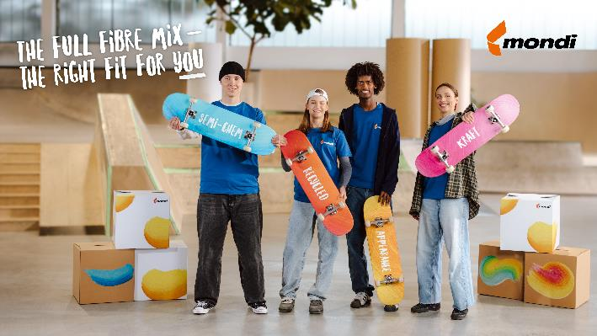

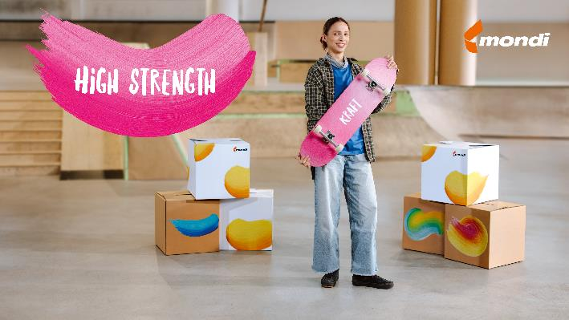

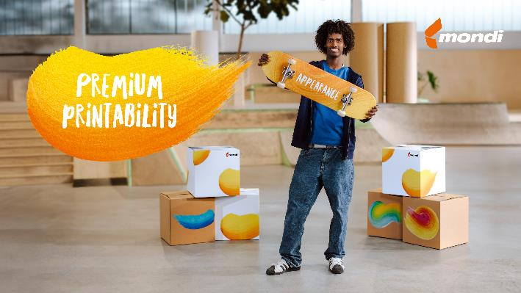

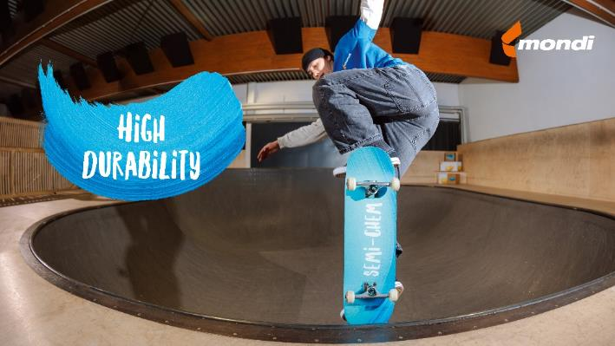

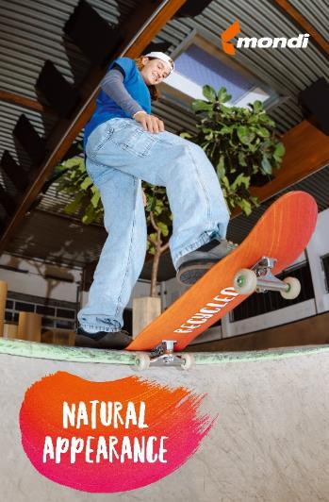

Mondi’s Containerboard portfolio ready to meet the rising demand for sustainable, high-performance packaging. (Photos: Mondi, PR321)

This press release and relevant photography can be downloaded from

[www.PressReleaseFinder.com](http://www.PressReleaseFinder.com).

Alternatively for very high resolution pictures please contact Kim Lommaert ([klommaert@emg-marcom.com](mailto:klommaert@emg-marcom.com), +31 164 317 021).