PRESS RELEASE

First-ever skateboard half pipe successfully built from containerboard to highlight material values

13 February 2024 – Mondi, a global leader in sustainable packaging and paper, proudly unveils a fresh initiative to highlight the values of its containerboard materials that we use in our everyday lives. In partnership with Olympian skateboarder Julia Brückler, Mondi challenges myths around making paper through a fusion of innovation, sustainability and athleticism.

The challenge was to build the first-ever skateboard half pipe from containerboard, the paper used in corrugated packaging. Why? Because it’s a fresh, analogous way of showing how containerboard is an ideal material that we rely on every day, and we are constantly on the lookout for the next generation of people who are passionate about paper.

Unique collaboration: Olympian Julia Brückler takes the first ride
Julia's passion for skateboarding aligns with Mondi's commitment to excellence and, like the sport's resilience, this project mirrors the meticulous processes of perfecting paper grades.

Professional skateboarder Julia Brückler, who debuted at the 2020 Tokyo Olympics, shares her excitement: "This was such a unique experience! It made me realise that we often take paper items used in our day-to-day lives for granted, not thinking about where they're coming from or how they're made. Discovering the details of paper packaging and how durable and strong the material can be during this project was eye-opening!"

Attracting the next generation of talent by explaining the values of paper packaging
At Mondi, our focus is on circular-driven solutions created by empowered people who are taking action on climate. We offer an environment where creativity and purpose converge – a workplace that continually pushes the boundaries of what's possible.

We have several world-leading containerboard paper mills with expert teams who make our containerboard product range. This containerboard paper is used to create corrugated solutions with nature-like strength and resilience.

Markus Gärtner, CEO Corrugated Packaging at Mondi, comments, "This initiative is about inspiring people to see the value of our containerboard paper grades through a fresh perspective. Partnering with Olympian Julia Brückler was a great experience and it embodies our commitment to innovation, excellence and enjoying new challenges! Get in touch with us if you are looking for sustainable packaging solutions or a career full of potential.”

Watch Julia's full ride on Mondi's containerboard skate ramp here.
High-res images can be downloaded here.

/ends

About Mondi
Mondi is a global leader in packaging and paper, contributing to a better world by making innovative solutions that are sustainable by design. Our business is integrated across the value chain – from managing forests and producing pulp, paper and films, to developing and manufacturing sustainable consumer and industrial packaging solutions using paper where possible, plastic when useful. Sustainability is at the centre of our strategy, with our ambitious commitments to 2030 focused on circular driven solutions, created by empowered people, taking action on climate.

In 2022, Mondi had revenues of €8.9 billion and underlying EBITDA of €1.8 billion from continuing operations, and employed 22,000 people worldwide. Mondi has a premium listing on the London Stock Exchange (MNDI), where the Group is a FTSE100 constituent, and also has a secondary listing on the JSE Limited (MNP).

www.mondigroup.com

Contact:
Bettina Pokorny
Communication Manager, Mondi Corrugated Packaging
Tel: +43 1 79013 4347
Email: Bettina.Pokorny@mondigroup.com

Kim Lommaert
EMG
Tel: +31 164 317 021
Email: klommaert@emg-marcom.com

Photos:
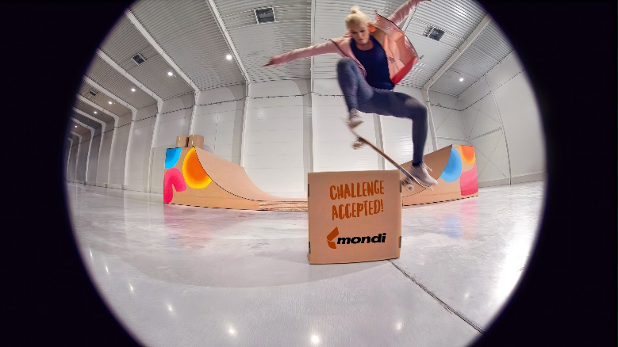

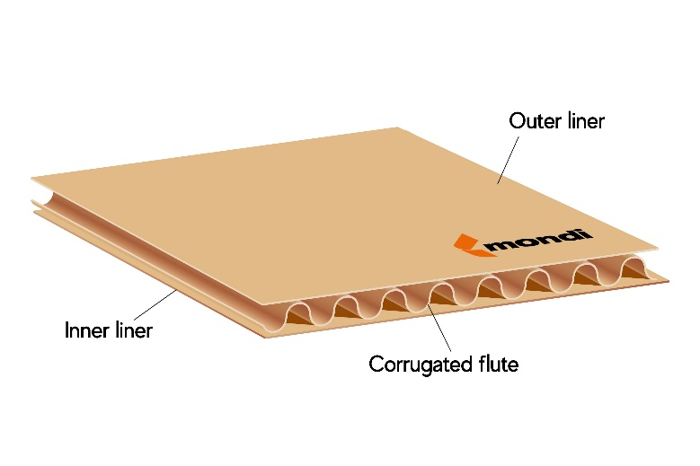

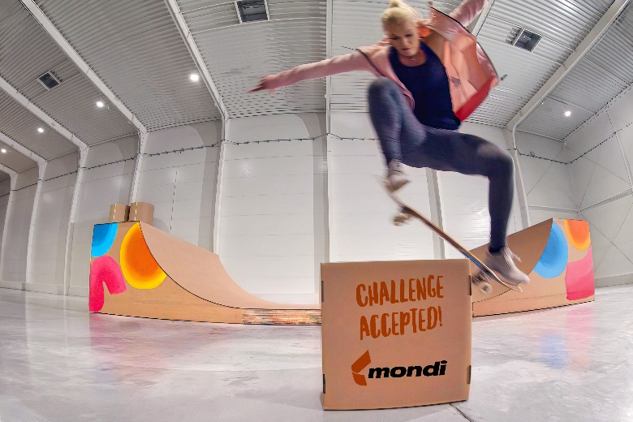

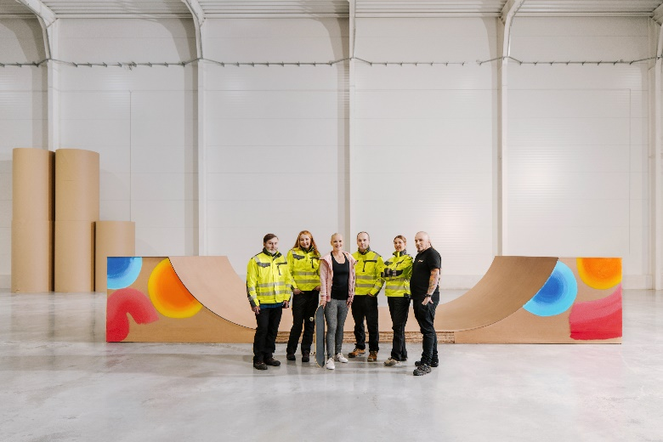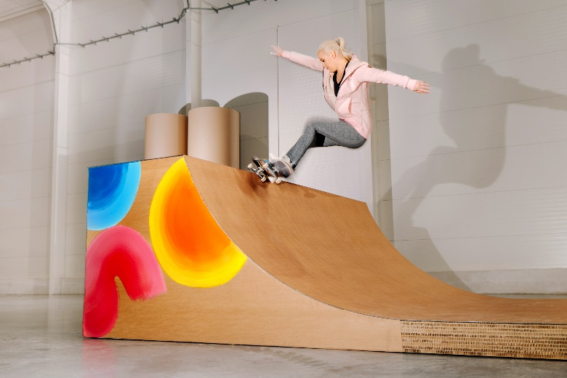

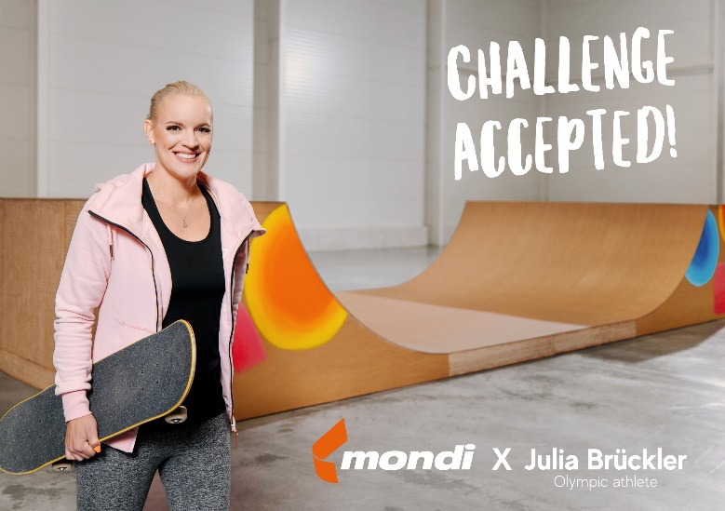

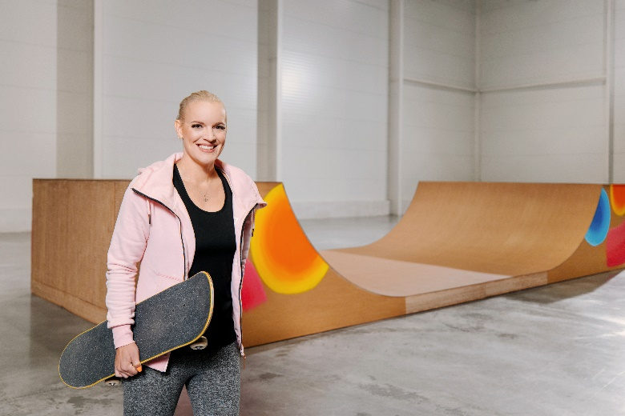
First-ever skateboard half pipe successfully built from containerboard to highlight material values. (Photos: Mondi, PR275)

This press release and relevant photography can be downloaded from
www.PressReleaseFinder.com.
Alternatively for very high resolution pictures please contact Kim Lommaert (klommaert@emg-marcom.com, +31 164 317 021).

