PRESS RELEASE

Mondi’s commitment to boost saturating kraft paper gives customers the advantage

- Efficiency and production process improvements increase output of Advantage MF Boost.
- Previously announced investment in new paper machine at Štĕtí mill frees up capacity at Mondi Dynäs, Sweden and Mondi Frantschach, Austria to produce saturating kraft paper.
- R&D initiatives expand portfolio including range of paper basis weights.

5 December 2023 – Mondi, a global leader in sustainable packaging and paper, has expanded its range of saturating kraft paper and increased capacity, in order to improve and enhance its service to manufacturers of internal and external building panels, worktops, furniture and technical films.

With the previously announced investment in a new paper machine at its Štĕtí plant in the Czech Republic and further increases in production efficiency, Mondi will optimise capacity across its mill network, providing increased production of its saturating kraft, Advantage MF Boost, at Mondi Frantschach in Austria and Mondi Dynäs in Sweden. Both Frantschach and Dynäs mills are ideally placed to deliver short lead times across Europe and provide customers with reassurance of good service and production back-up. These changes signal Mondi's commitment to increase the availability of Advantage MF Boost – the kraft paper that is used in laminated applications.

Mondi has further made improvements in the efficiency of its paper machines running the saturating kraft paper, meaning enhanced formation, better drying properties and faster production. Ongoing R&D has also meant this quality paper is available in a larger product range, with lower and higher grammages to suit each individual customer need.

Mondi’s Advantage MF Boost is ideally suited for laminates due to its porous properties: the unbleached and natural brown kraft paper is created with responsibly sourced fresh fibres in Sweden and Austria and is available FSC or PEFC certified. Its long fibre pulp makes it highly absorbent, ideal for taking in and acting as a carrier for resin used to adhere the layers, essential to the final laminate.

Roman Senecky, COO Kraft Paper, Mondi says: “We are very committed to boosting production of our Advantage MF Boost in order to serve the markets for decorative and compact laminates as well as industrial and technical films for plywood. Our existing infrastructure means we can produce and deliver this essential porous kraft paper globally, in suitable quantities, providing a reliable supply to all our existing and new customers.”

/ends

About Mondi
Mondi is a global leader in packaging and paper, contributing to a better world by making innovative solutions that are sustainable by design. Our business is integrated across the value chain – from managing forests and producing pulp, paper and films, to developing and manufacturing sustainable consumer and industrial packaging solutions using paper where possible, plastic when useful. Sustainability is at the centre of our strategy, with our ambitious commitments to 2030 focused on circular driven solutions, created by empowered people, taking action on climate.

In 2022, Mondi had revenues of €8.9 billion and underlying EBITDA of €1.8 billion from continuing operations, and employed 22,000 people worldwide. Mondi has a premium listing on the London Stock Exchange (MNDI), where the Group is a FTSE100 constituent, and also has a secondary listing on the JSE Limited (MNP).

www.mondigroup.com

Contact:
Judith Wronn
Head of Communication, Mondi Flexible Packaging
Tel: +49 151 1771 4692
Email: Judith.Wronn@mondigroup.com

Kim Lommaert
EMG
Tel: +31 164 317 021
Email: klommaert@emg-marcom.com

Photos:

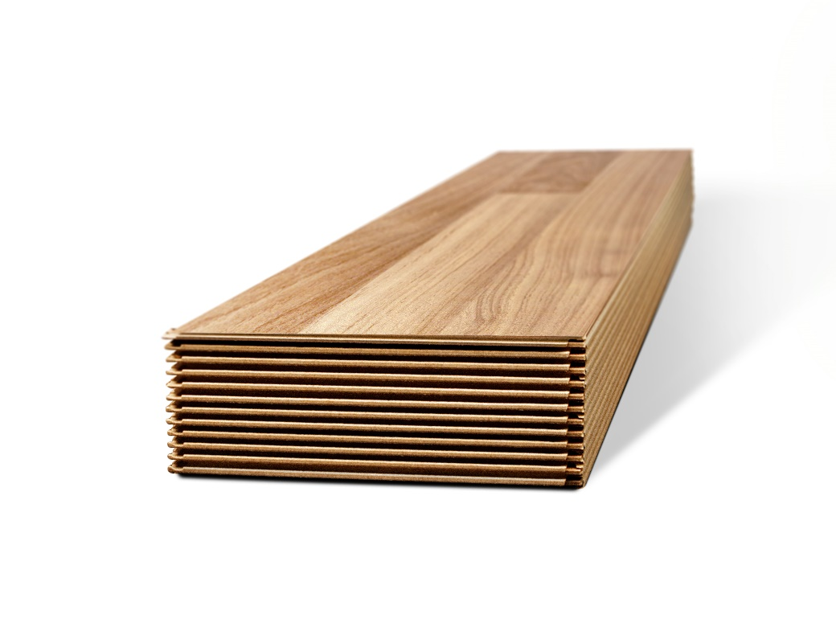
Mondi’s commitment to boost saturating kraft paper gives customers the advantage.
(Photos: Mondi, PR271)

This press release and relevant photography can be downloaded from
www.PressReleaseFinder.com.
Alternatively for very high resolution pictures please contact Kim Lommaert (klommaert@emg-marcom.com, +31 164 317 021).

Licencenumber FSC-C012179

