PRESS RELEASE

Mondi collaborates with partners to replace PolyStyrene (EPS) and lead the change on white goods packaging

22 November 2023 – Expanded PolyStyrene (EPS) microplastics are widely recognised as a significant contributor to marine plastic pollution, making up over 40% of plastic debris on Asian beaches.¹ Bans on EPS packaging have gained tremendous momentum recently, particularly in the European Union and the wider Caribbean region.^{2,3} Legislation banning the use of EPS packaging has also been introduced in Fiji, the Philippines, and regions in the United States, just to name a few.^{4,5,6}

With the ongoing development of the United Nations Treaty on Plastic Pollution, governments from over 170 nations are working toward policy measures to combat the negative environmental impacts of hard-to-recycle plastics. The introduction of bans, levies, and increased disposal fees for EPS packaging materials will continue to be on trend for the foreseeable future, especially in regions lacking recycling infrastructure.

Corrugated Packaging: A sustainable alternative
Corrugated packaging solutions are 100% recyclable and 100% compostable, making them the ideal packaging material. What’s more, Mondi’s corrugated packaging solutions includes a wide portfolio of corrugated boxes made of recycled fibres. Paper-based packaging boasts an impressive 82.5% recycling rate in Europe, outperforming the combined recycling rates of all other packaging materials.⁷ The recycling value of corrugated packaging has enormous potential worldwide. Paper fibre can be recycled with good quality many times, keeping fibres in circulation.^{8,9}

As a partner for sustainable growth, Mondi material and design experts are developing high-performance, corrugated solutions to enable a shift toward circular packaging for white goods and electronic equipment. Industries have long relied on crumble-prone EPS material to protect valuable goods. Until now, replacing EPS materials with paper-based solutions was prohibitive from a cost perspective, but extended producer responsibility mandates like those under the EU Packaging and Packaging Waste Directive (PPWD) have transformed economic factors.¹⁰

Snug & Strong: Recyclable, efficient, and sustainable
There is no silver bullet when it comes to white goods and electronic packaging – EPS can chip or break during transport, resulting in costly product damage and returns. When designing Snug&Strong corrugated solutions, Mondi gather an entire team of experts to collaborate with customers to understand their production line and packaging requirements. Whether developing a recyclable, multi-material packaging concept or creating a plan to gradually replace EPS components over an extended period – through collaboration it is possible to find sustainable and viable solutions.

By setting out to replace EPS materials in packaging, manufacturers have a unique opportunity when partnering with Mondi to create fully recyclable packaging solutions while also optimising and automating their packaging processes. Fit-for-purpose recyclable packaging satisfies consumer demands for sustainability, and fulfils upcoming legislative requirements.

Balancing protection, cost, and sustainability
Mondi’s Snug&Strong corrugated solution can do more: it can ease supply chain complexity, improve packaging processes, and help brands be more environmentally friendly. The custom-fit, 100% paper-based industrial packaging offers excellent protection for white goods and electronic equipment. Additionally, Snug&Strong is delivered flat and requires less space than traditional EPS packaging, making the component solution easier to handle and less expensive to store and transport.

It is not always easy to strike a good balance between protection, cost, and sustainability when it comes to packaging. Mondi’s Snug&Strong corrugated solution, however, is a cost-efficient and viable alternative to EPS when considering the total cost of ownership.

Join the Movement
Together, let’s lead the change with corrugated solutions to replace expanded polystyrene in packaging. To learn more, visit www.mondigroup.com/products-and-solutions/replacing-expanded-polystyrene-in-white-goods-packaging/.

/ends

References
¹ Hamsun H.S. Chan, Christelle Not. (2023) Variations in the spatial distribution of expanded polystyrene marine debris: Are Asian coastlines more affected? Retrieved from: www.sciencedirect.com/science/article/pii/S2666765723000029.
² Directive (EU) 2019/904. The reduction of the impact of certain plastic products on the environment. European Parliament, Council of the European Union. Retrieved from: www.eur-lex.europa.eu/eli/dir/2019/904/oj.
³ UNEP. Report on the Status of Styrofoam and Plastic Bag Bans in the Wider Caribbean. Retrieved from: www.unep.org/cep/resources/report/report-status-styrofoam-and-plastic-bag-bans-wider-caribbean.
⁴ Chaudhary, Felix. (2021) Ban on polystyrene to start next month. Retrieved from: www.fijitimes.com/ban-on-polystyrene-to-start-next-month/.
⁵ Parkinson, Lindey. (2021) Philippines House passes Single-use Plastic Products Regulation Act. Retrieved from: www.foodpackagingforum.org/news/philippines-house-passes-single-use-plastic-products-regulation-act.
⁶ McCarthy, Joe. (2017) States declare war on Styrofoam. Retrieved from: www.cbsnews.com/news/styrofoam-ban-states-declare-war-people-think-it-breaks-down/.
⁷ Eurostat 2023. Retrieved from: www.ec.europa.eu/eurostat/databrowser/view/cei_wm020/default/table?lang=en.
⁸ CEPI (2022) Cepi position paper on the revision of the Packaging and
Packaging Waste Directive. Retrieved from: www.cepi.org/wp-content/uploads/2022/10/PPCG-MG-22-030_Cepi-position-paper.pdf.
⁹ European Paper Recycling Council. Monitoring Report 2022. Retrieved from: www.cepi.org/wp-content/uploads/2023/09/EPRC-Monitoring-Report-2022_Final.pdf.
¹⁰ Directive 94/62/EC. Packaging and packaging waste. European Parliament, Council of the European Union. Retrieved from: www.eur-lex.europa.eu/legal-content/EN/TXT/?uri=CELEX:01994L0062-20150526.

About Mondi
Mondi is a global leader in packaging and paper, contributing to a better world by making innovative solutions that are sustainable by design. Our business is integrated across the value chain – from managing forests and producing pulp, paper and films, to developing and manufacturing sustainable consumer and industrial packaging solutions using paper where possible, plastic when useful. Sustainability is at the centre of our strategy, with our ambitious commitments to 2030 focused on circular driven solutions, created by empowered people, taking action on climate.

In 2022, Mondi had revenues of €8.9 billion and underlying EBITDA of €1.8 billion from continuing operations, and employed 22,000 people worldwide. Mondi has a premium listing on the London Stock Exchange (MNDI), where the Group is a FTSE100 constituent, and also has a secondary listing on the JSE Limited (MNP).

www.mondigroup.com

Contact:
Bettina Pokorny
Communication Manager, Mondi Corrugated Packaging
Tel: +43 1 79013 4347
Email: bettina.pokorny@mondigroup.com

Kim Lommaert
EMG
Tel: +31 164 317 021
Email: klommaert@emg-marcom.com

Photos:
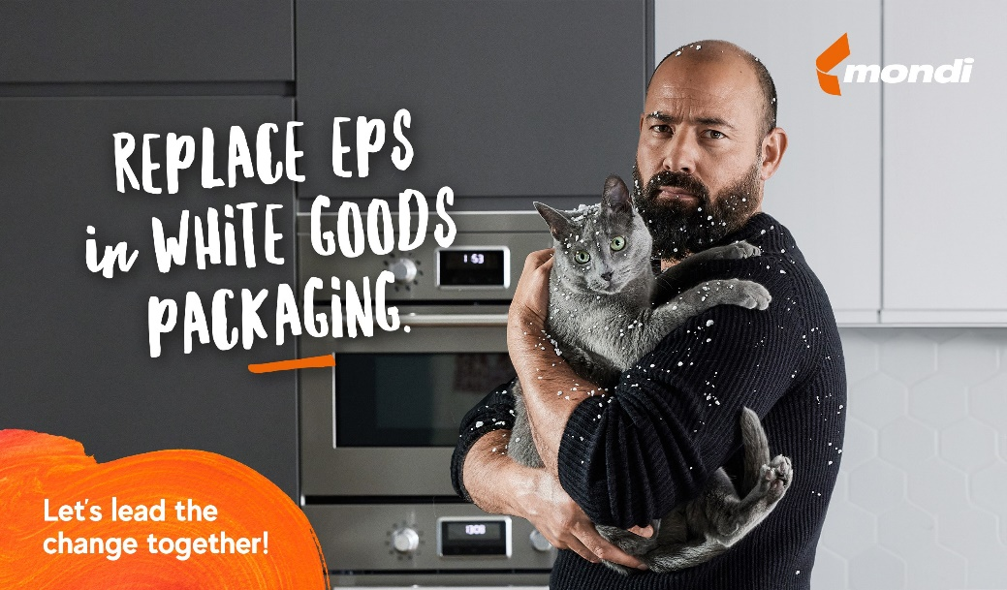

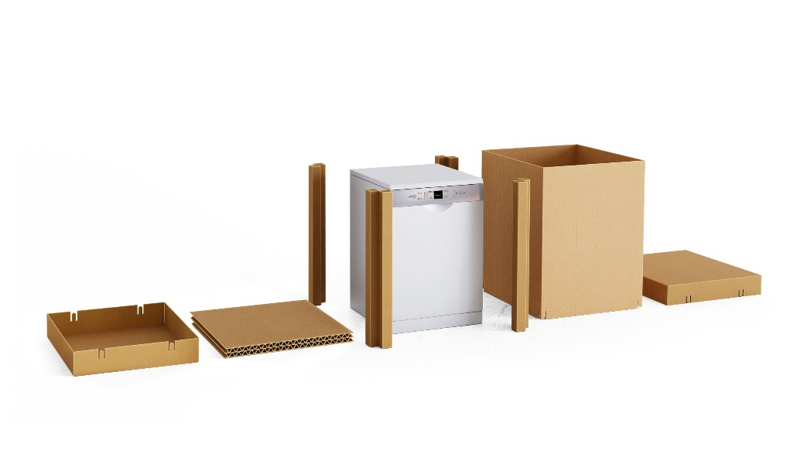

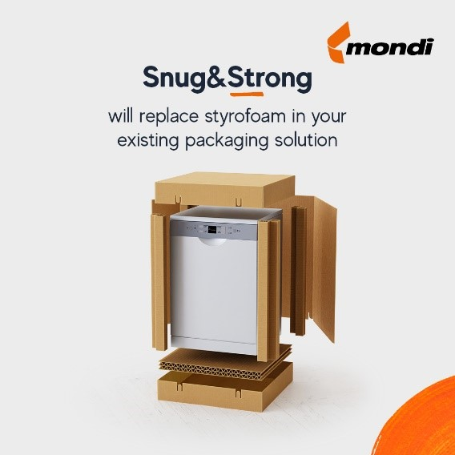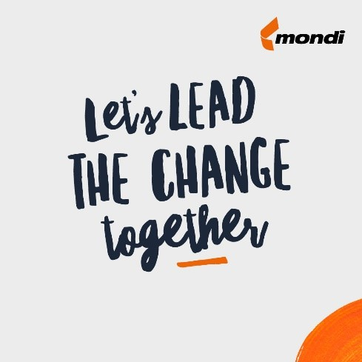
Mondi collaborates with partners to replace PolyStyrene (EPS) and lead the change on white goods packaging. (Photos: Mondi, PR270)

This press release and relevant photography can be downloaded from
www.PressReleaseFinder.com.
Alternatively for very high resolution pictures please contact Kim Lommaert (klommaert@emg-marcom.com, +31 164 317 021).

