PRESS RELEASE

Say cheese! Mondi and Skånemejerier partner to introduce mono-material plastic packaging

- Mondi and Skånemejerier collaborate to create new mono-material packaging for cheese.
- The new packaging is designed for recycling and replaces the previous solution not designed for recycling.
- Packs protect the food while keeping materials in circulation.

9 November 2023 – Mondi, a global leader in packaging and paper, has collaborated with Skånemejerier to create a mono-material, polypropylene (PP) based packaging for, among others, ICA’s Hushållsost cheese.

The new packaging comprises a mono-material base web and lidding film, all of which is produced and printed by Mondi before being converted for 1kg and 2kg blocks of cheese by Skånemejerier. It will be sold in leading Swedish supermarket ICA and now comes in packaging that is designed for recycling.

Mondi’s mono-material solution provides high barriers against oxygen and water vapours, keeping the product fresh on the supermarket shelf. It offers high puncture resistance protecting the cheese, and great printability so that the brand and recycling messages can be communicated well on-pack.

This innovative packaging is being launched in the same time period as Site Zero, the world's largest sorting facility for used plastic packaging, will open its doors in Sweden. This state-the-of-art facility, slated to go live in November 2023, will process used plastic waste from both Sweden and Finland. Thanks to the packaging’s mono-material design, the facility will be able to effectively sort this solution for recycling, contributing to a circular economy.

Helene Brynell, Regional Sales Nordic Consumer Flexibles at Mondi says: “30% of the world’s food is lost or wasted - that equates to 1.3 billion tonnes – so fit-for-purpose packaging design has a crucial role to play. Fresh products like cheese need to be packaged properly – and protection must go hand in hand with sustainable packaging. Our new mono-material solution is fulfilling exactly that: it keeps the cheese fresh while also keeping the packaging materials in circulation through design for recycling.”

Ingemar Jönsson, Packaging Manager, Skånemejerier, adds: “Our collaboration with Mondi has been a thorough process: we started our first test and trials in 2019 and are delighted to be bringing this fully recyclable packaging to market before the end of 2023. The great working relationship we had, meant that we were able to adapt materials and machinery efficiently, resulting in a successful, fit for purpose solution. We have strong, effective and good-looking packaging that keeps materials in the loop and responds to consumer demands for more sustainable solutions.”

Rickard Jansson, Development Engineer at Swedish Plastic Recycling states; “We are very positive about the new packaging that Mondi has developed together with Skånemejerier for ICA. By using mono-material film instead of laminate consisting of different types of plastic, we can sort out and recycle the packaging that is left in the system, thus avoiding incineration. With Site Zero's new technology, this PP film-based packaging will be able to become new products, which has not been possible in any facility in Sweden before. It provides circular plastic flows that reduce the need for fossil raw materials and combustion”.

The mono-material cheese packaging on ICA’s shelves won this year’s PackNorth Award in the ‘Food’ category and was also recognised at the Empack fair in October in Stockholm, Sweden.

/ends

About Mondi
Mondi is a global leader in packaging and paper, contributing to a better world by making innovative solutions that are sustainable by design. Our business is integrated across the value chain – from managing forests and producing pulp, paper and films, to developing and manufacturing sustainable consumer and industrial packaging solutions using paper where possible, plastic when useful. Sustainability is at the centre of our strategy, with our ambitious commitments to 2030 focused on circular driven solutions, created by empowered people, taking action on climate.

In 2022, Mondi had revenues of €8.9 billion and underlying EBITDA of €1.8 billion from continuing operations, and employed 22,000 people worldwide. Mondi has a premium listing on the London Stock Exchange (MNDI), where the Group is a FTSE100 constituent, and also has a secondary listing on the JSE Limited (MNP).

www.mondigroup.com

Contact:
Judith Wronn
Head of Communication, Mondi Flexible Packaging
Tel: +49 151 1771 4692
Email: Judith.Wronn@mondigroup.com

Kim Lommaert
EMG
Tel: +31 164 317 021
Email: klommaert@emg-marcom.com

Photos:
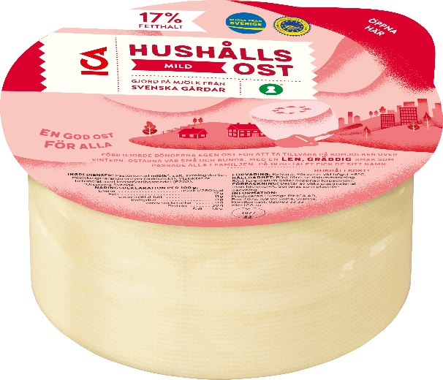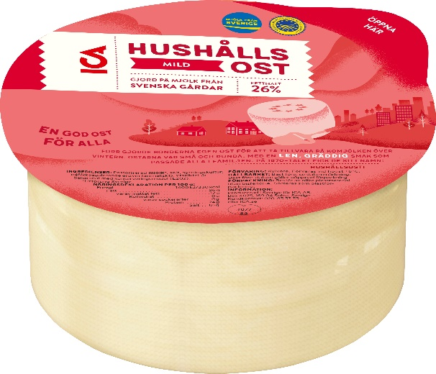

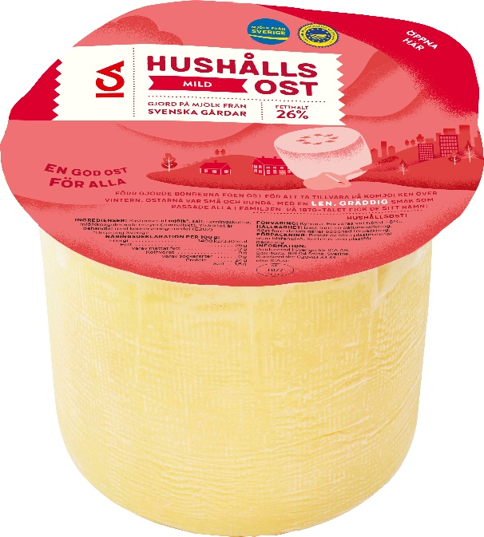
Say cheese! Mondi and Skånemejerier partner to introduce mono-material plastic packaging. (Photos: ICA Group, PR269)

This press release and relevant photography can be downloaded from
www.PressReleaseFinder.com.
Alternatively for very high resolution pictures please contact Kim Lommaert (klommaert@emg-marcom.com, +31 164 317 021).

