PRESS RELEASE

**Mondi’s entire portfolio of kraft papers for packaging certified compostable**

* *Mondi announces compostability certification for its full portfolio of kraft papers for packaging.*
* *Certification reaffirms the Group's MAP2030 commitment to make all its packaging and paper products recyclable, reusable or compostable by 2025.*

**31 October 2023** – Mondi, a global leader in packaging and paper, has announced that its entire portfolio of kraft papers for packaging has been certified as home or industrially compostable[1].

The certification underpins Mondi’s MAP2030 (Mondi Action Plan 2030) sustainability commitment to make 100% of its packaging and paper products reusable, recyclable, or compostable by 2025, ensuring a sustainable end-of-life for all paper and packaging products. While recyclability remains Mondi’s focus to keep fibres in circulation, composting can be a viable end-of-life option for certain applications, such as those disposed in the biowaste stream.

Mondi’s kraft papers are made from renewable and certified sources, which can support customers to achieve their own sustainability targets. Customers can benefit from a comprehensive product range to meet requirements for industrial packaging, shopping bags for retailers and attractive food packaging for supermarket shelves.

An example of Mondi’s compostable kraft papers is Advantage MF EcoComp, which is specifically designed for household and agricultural use and is used for paper bags for wet organic household waste. Another example is Mondi’s EcoVantage kraft paper, which combines fresh and recycled fibres for sustainable and food compliant shopping packaging.

Silvia Hanzelova, Sales Director Specialty Kraft Paper, Mondi says: “Certifications like these illustrate our ongoing commitment to provide our customers with the most suitable and sustainable packaging materials and solutions. They give all our industrial, commercial and manufacturing customers the confidence that our papers are compostable and reassure them that, with us, they are working towards a more sustainable future. A future that continues to provide strong, effective packaging tailored to their individual needs.”

/ends

**About Mondi**

Mondi is a global leader in packaging and paper, contributing to a better world by making innovative solutions that are sustainable by design. Our business is integrated across the value chain – from managing forests and producing pulp, paper and films, to developing and manufacturing sustainable consumer and industrial packaging solutions using paper where possible, plastic when useful. Sustainability is at the centre of our strategy, with our ambitious commitments to 2030 focused on circular driven solutions, created by empowered people, taking action on climate.

In 2022, Mondi had revenues of €8.9 billion and underlying EBITDA of €1.8 billion from continuing operations, and employed 22,000 people worldwide. Mondi has a premium listing on the London Stock Exchange (MNDI), where the Group is a FTSE100 constituent, and also has a secondary listing on the JSE Limited (MNP).

[www.mondigroup.com](http://www.mondigroup.com)

**Contact:**

Judith Wronn

Head of Communication, Mondi Flexible Packaging

Tel: +49 151 1771 4692

Email: [Judith.Wronn@mondigroup.com](mailto:Judith.Wronn@mondigroup.com)

Kim Lommaert

EMG

Tel: +31 164 317 021

Email: [klommaert@emg-marcom.com](mailto:klommaert@emg-marcom.com)

**Photos:**

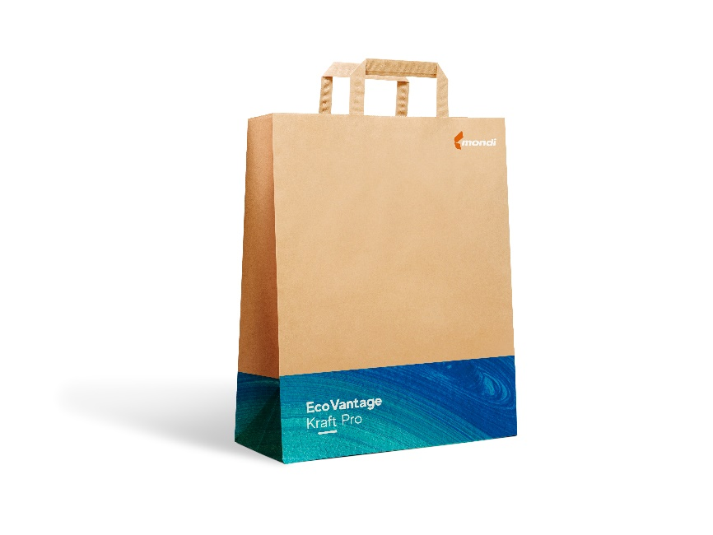

Mondi’s EcoVantage contains fresh and recycled fibres for sustainable and food compliant shopping packaging converted into shopping bags. (Photo: Mondi, PR268)



Mondi’s compostable Advantage MF EcoComp is used for paper bags for wet organic household waste. (Photo: Mondi, PR268)

This press release and relevant photography can be downloaded from

[www.PressReleaseFinder.com](http://www.PressReleaseFinder.com).

Alternatively for very high resolution pictures please contact Kim Lommaert ([klommaert@emg-marcom.com](mailto:klommaert@emg-marcom.com), +31 164 317 021).

1. Home compostable: NF T51-800:2015; Industrial compostable: EN 13432.