PRESS RELEASE

Mondi puts the fizz into Coca-Cola HBC Austria’s functional packaging solution

- Coca-Cola HBC Austria and Mondi partnered to create an innovative paper sleeve that tightly wraps and secures bottle bundles during transit.
- The new Hug-IT sleeve will secure 1.5-liter PET multi-packs of the Coca-Cola, Fanta, Sprite and Mezzo Mix brands.
- Hug-IT replaces existing plastic shrink wrap, using paper as a more sustainable solution made from responsibly sourced fibres.

18 September 2023 – Mondi, a global leader in packaging and paper, is delighted to launch a new more sustainable sleeve packaging, created to replace conventional plastic shrink wrap around 1.5 litre sparkling soft drink multipacks produced by Coca-Cola HBC in Austria and keep them secure. Mondi’s Hug-IT, which keeps six bottles together during transportation, is made of Mondi’s Advantage SpringPack Plus, crowned by Guinness World Records as the strongest paper in the world.

The Hug-IT sleeve has high tensile strength and incomparable stretchability, so it can be trusted to wrap around the six bottles tightly, keeping them upright and held together during transit – from factory site, to retailer, to the consumer’s home. It will secure 1.5-liter PET multi-packs of the Coca-Cola, Fanta, Sprite and Mezzo Mix brands and will be sold in retail outlets throughout Austria. Hug-IT is an innovative solution, and Advantage SpringPack Plus is currently the only paper on the market offering such unique capabilities, being strong enough holding the bottle bundles together as final Hug-IT solution.

Advantage SpringPack Plus is 100 % kraft paper made from wood that is FSC® Certified (with the licence code C012179) as being made with responsibly sourced fibres, and recyclable in existing paper recycling streams: paper has one of the highest recycling rates among packaging materials in Europe (82% within the EU) and is convenient to dispose of for consumers.

The Hug-IT solution has taken three years to complete, from conception through to planning, trialling, and getting the product onto shelf. Its development involved a number of Mondi’s divisions and cross-segment collaboration, making the most of the company’s expertise in paper packing and converting and creating more sustainable, technically advanced solutions. The sleeves are engineered on automated machinery provided by Krones, a technology group and service provider for the beverage & liquid food industry, whose swift installation and close collaboration with Mondi made the process smooth and efficient. Expert teams from Mondi, Coca-Cola HBC and Krones worked closely together to meet the challenges related to required strength and stretchability of the paper.

Felix Sprenger, Supply Chain Director at Coca-Cola HBC Austria, says: “The careful use of resources and recyclable materials is one of the most important pillars in our sustainability strategy and plays a central role in the design of the sustainable packaging mix for the Austrian market. With the introduction of our new solution, which is unique in the world to date, we will be able to reduce material use by a further 200 tons of plastic per year in the future. It was a pleasure to work with Mondi and our other partners to jointly walk the talk contributing to a circular economy."

Silvia Hanzelova, Sales Director Speciality Kraft Paper at Mondi, adds: “Our approach is paper where possible, plastic when useful - and the shrink wrap solution that is used for bundling bottles across continents and industries provides the ideal opportunity to put that into practice. By producing a paper as strong as this, we are able to replicate what the plastic shrink wrap does, delivering secure and safe transportation of multipacks with our Hug-IT paper sleeves that reduce plastic use.”

/ends

About Mondi
Mondi is a global leader in packaging and paper, contributing to a better world by making innovative solutions that are sustainable by design. Our business is integrated across the value chain – from managing forests and producing pulp, paper and films, to developing and manufacturing sustainable consumer and industrial packaging solutions using paper where possible, plastic when useful. Sustainability is at the centre of our strategy, with our ambitious commitments to 2030 focused on circular driven solutions, created by empowered people, taking action on climate.

In 2022, Mondi had revenues of €8.9 billion and underlying EBITDA of €1.8 billion from continuing operations, and employed 22,000 people worldwide. Mondi has a premium listing on the London Stock Exchange (MNDI), where the Group is a FTSE100 constituent, and also has a secondary listing on the JSE Limited (MNP).

www.mondigroup.com

About Coca-Cola HBC Austria
Coca-Cola HBC Austria supplies the entire Austrian market with Coca-Cola products. The company employs around 800 people in Austria - at its state-of-the-art production and logistics center in Edelstal, Burgenland, and at regional sales centers and distribution warehouses. Coca-Cola HBC Austria offers an innovative product range tailored to the needs of consumers - 24 hours a day, seven days a week. Responsible action within the local environment and the sustainable use of resources are firmly anchored in the corporate strategy. Within this framework, Coca-Cola HBC Austria promotes innovative packaging solutions as well as strong partnerships to increase collection rates.

Coca-Cola HBC Austria is a subsidiary of the Coca-Cola HBC Group, a growth-oriented consumer goods and strategic bottling partner of The Coca-Cola Company with a sales volume of 2.7 billion unit cases.

Contact:
Judith Wronn
Head of Communication, Mondi Flexible Packaging
Tel: +49 151 1771 4692
Email: Judith.Wronn@mondigroup.com

Kim Lommaert
EMG
Tel: +31 164 317 021
Email: klommaert@emg-marcom.com

Photos:
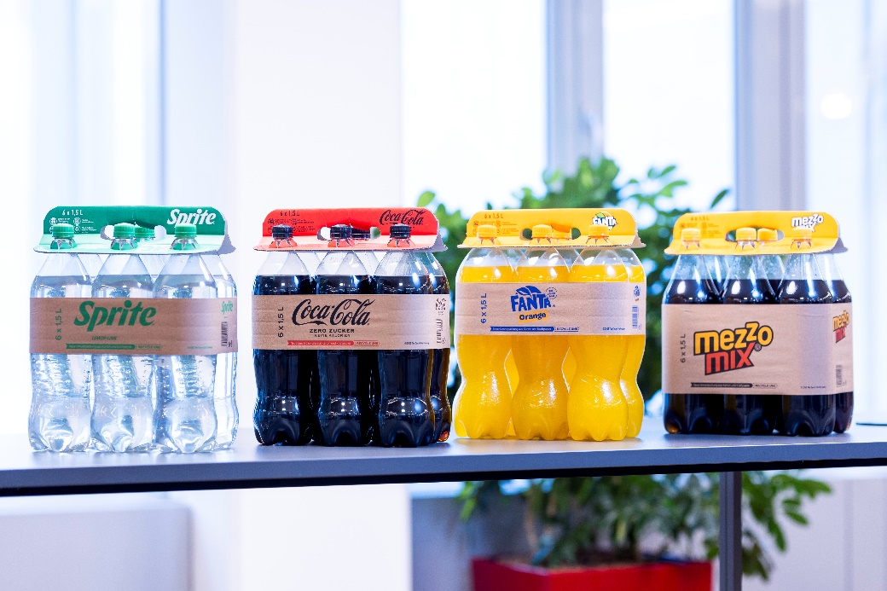

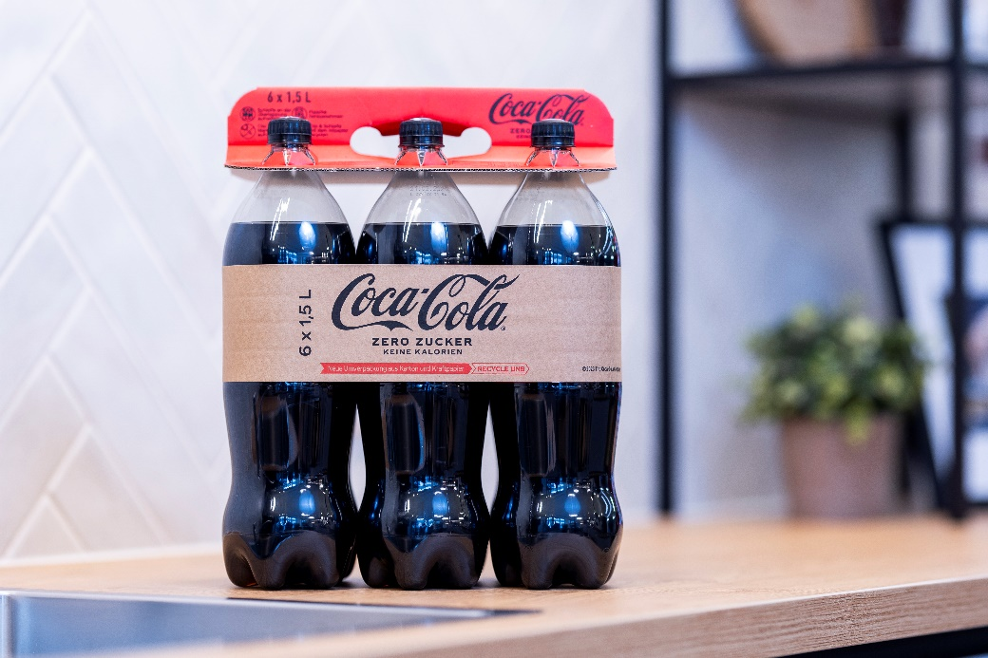
Mondi puts the fizz into Coca-Cola HBC Austria’s functional packaging solution.
(Photos: Martin Steiger, PR263)
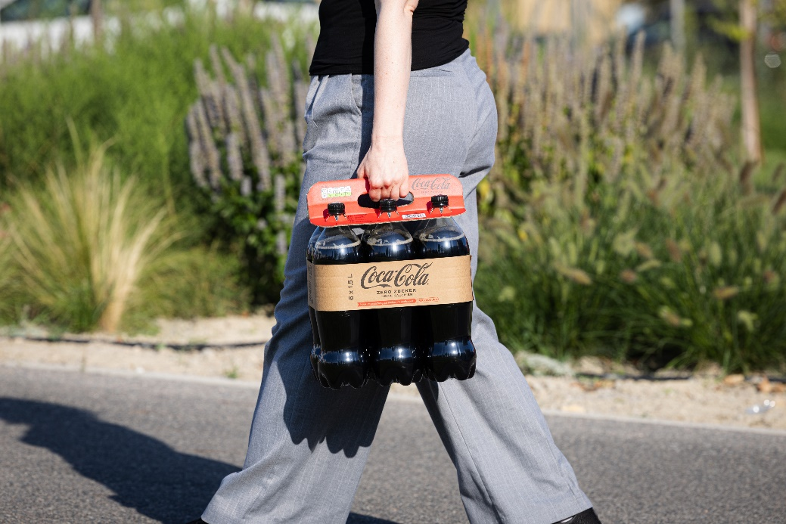
Mondi puts the fizz into Coca-Cola HBC Austria’s functional packaging solution.
(Photo: Christian Lendl, PR263)

This press release and relevant photography can be downloaded from
www.PressReleaseFinder.com.
Alternatively for very high resolution pictures please contact Kim Lommaert (klommaert@emg-marcom.com, +31 164 317 021).

Advantage MF SpringPack Plus holds the record for being the strongest paper in the world, according to Guinness World Record (2001, Swedish Edition). The strength of this brown MF grade was demonstrated by lifting a 4.2-tonne container on a single sheet. In 2003 Mondi unofficially broke its own record by parking and lifting a 9.8-tonne locomotive on a single sheet.
Source: Eurostat, 2019, https://ec.europa.eu/eurostat/databrowser/view/ten00063/default/table?lang=en

