PRESS RELEASE

Mondi’s TankerBox revolutionises sustainable shipping for Aromsa's flavourful products

- Turkish flavour company Aromsa partners with Mondi to achieve sustainability goals by replacing stainless-steel containers.
- The strong and lightweight alternative TankerBox, made from renewable resources, simplifies transportation, boosts shipping capacity, and eliminates container maintenance.

6 July 2023 – Industry-leading Turkish flavour company Aromsa, whose products include sauces, toppings, extracts and seasonings, was faced with a challenge. The company was fully committed to its sustainability strategy, but it had also started to work with a new customer who wanted to use stainless-steel containers for shipping. This would require an investment into approximately 250 stainless-steel containers, which is a costly packaging solution. In addition to high price, there are also the logistical costs of storage and maintenance, washing and sterilising the containers.

Mondi was invited to develop an alternative solution and proposed the TankerBox which Aromsa trialled on their production line. After a few months of close collaboration and innovation at the Aromsa facilities, the TankerBox was ready for Aromsa’s commercial use.

Produced from corrugated cardboard and developed as a substitute for the traditional Intermediate Bulk Container (IBC) and metal barrel, the TankerBox is an innovative product and a more sustainable solution. Its patented design consists of 5 parts: an outer box, inner octabin, angle frame, bottom star and top cover pieces. It offers an intelligent discharge system with two alternative design options for discharging either from the top or bottom and is structured to minimise residual contents in the product.

Nil Okyar, Production Manager at Aromsa, says, “We can do all the operations we did with the stainless-steel container with the TankerBox much more comfortably. We have been able to simplify transportation because we now avoid the return event associated with metal containers. We can also stock and ship the TankerBox on top of each other, gaining storage space and doubling the shipping capacity. These benefits were only possible because of the excellent collaboration with Mondi.”

In comparison to its metal drum or IBC equivalents, the TankerBox’s optimised design creates cost advantages from efficiencies in storage and logistics, as it does not need to be chemically cleaned or returned as empty cargo. Additional benefits include easy handling and integration into filling lines as well as printability for brand enhancement.

“We pride ourselves on working with our customers to fulfil their requirements,” said Gozdecan Demir, Heavy Duty Sales and Business Development Manager for Mondi. “We designed this solution for Aromsa and it worked perfectly because it was based on their needs. It is this level of collaboration which leads to excellence and success.”

Tankerbox can be safely used in various industries, including chemistry, paint, pharmaceuticals, and oil, as well as in the food industry for concentrated beverages, industrial liquid food and additives, alcoholic drinks, milk, and dairy products. Mondi supplies the TankerBox and its fittings, while our product development service offers comprehensive support throughout the entire sales process. This includes sourcing aseptic liners tailored to customer requirements, which is yet another demonstration of Mondi’s commitment to its customers.

Aromsa's commitment to sustainability, coupled with Mondi's dedication to customer-centric solutions, exemplifies the power of partnership in driving positive change. Together, they are shaping a more sustainable future for the industry, one flavour-packed shipment at a time.

/ends

About Mondi
Mondi is a global leader in packaging and paper, contributing to a better world by making innovative solutions that are sustainable by design. Our business is integrated across the value chain – from managing forests and producing pulp, paper and films, to developing and manufacturing sustainable consumer and industrial packaging solutions using paper where possible, plastic when useful. Sustainability is at the centre of our strategy, with our ambitious commitments to 2030 focused on circular driven solutions, created by empowered people, taking action on climate.

In 2022, Mondi had revenues of €8.9 billion and underlying EBITDA of €1.8 billion from continuing operations, and employed 22,000 people worldwide. Mondi has a premium listing on the London Stock Exchange (MNDI), where the Group is a FTSE100 constituent, and also has a secondary listing on the JSE Limited (MNP).

www.mondigroup.com

About Aromsa
Aromsa has been the leading flavour company in the food and beverage industry for 41 years. As your creative flavour partner, we are currently exporting to more than 70 countries with seven factories and R&D Center in Turkey and two factories in Germany. Investing approximately 6% of our yearly turnover in R&D, we offer tailor-made solutions on a global scale. We offer unique and creative flavours, extracts, sauces, fruit preparations, toppings, caramelised sugar and caramel colourants, fruit powders, enzyme-modified dairy ingredients, seasoning and spice mixes. We provide an innovative and sustainable business model from creating recipes to product design, from test production to sensory analysis, combining our passion with science and advanced technology. The brand-new flavours that we design and produce for the world’s most liked brands reach millions of consumers. Aromsa is always your creative flavour partner.

Contact:
Bettina Pokorny
Communication Manager, Mondi Corrugated Packaging
Tel: +43 1 79013 4347
Email: bettina.pokorny@mondigroup.com

Kim Lommaert
EMG
Tel: +31 164 317 021
Email: klommaert@emg-marcom.com

Photos:
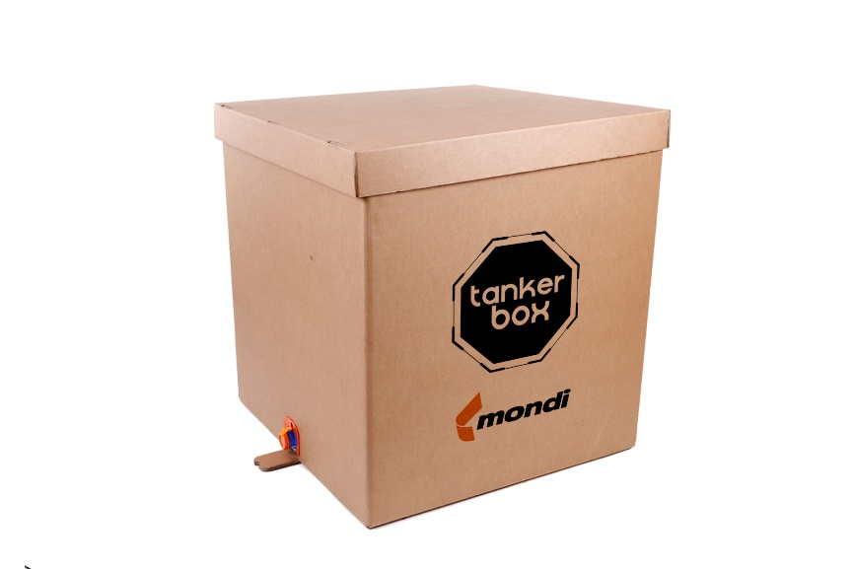
Mondi’s TankerBox revolutionises sustainable shipping for Aromsa's flavourful products. (Photo: Mondi, PR256)

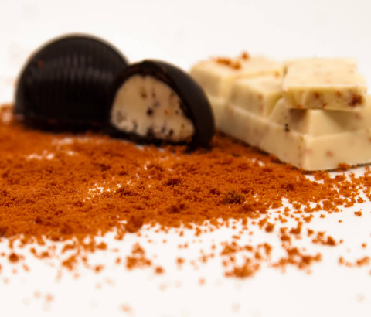

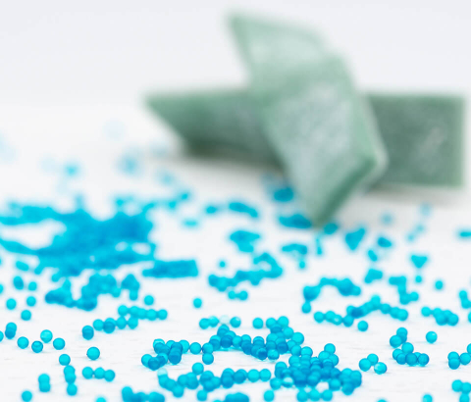

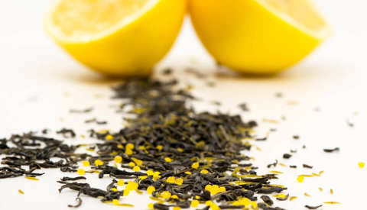
Mondi’s TankerBox revolutionises sustainable shipping for Aromsa's flavourful products. (Photos: Aromsa, PR256)

This press release and relevant photography can be downloaded from
www.PressReleaseFinder.com.
Alternatively for very high resolution pictures please contact Kim Lommaert (klommaert@emg-marcom.com, +31 164 317 021).

