PRESS RELEASE

Mondi scoops RISI PPI Product Innovation Award with paper-based Hug&Hold solution

- The RISI PPI Awards honours paper and pulp businesses that develop groundbreaking, commercially viable products
- Mondi's Hug&Hold beverage packaging recognised as a stand-out product that replaces plastic shrink wrap, while saving costs and driving efficiencies

13 March 2023 – Mondi, a global leader in sustainable packaging and paper, has won the coveted PPI Award in the Product Innovation category for its Hug&Hold packaging solution. The Fastmarkets Forest Products PPI Awards are the only global awards dedicated to recognising the achievements of companies, mills and individuals in the pulp and paper sector.

Hug&Hold is a paper packaging solution designed and developed to wrap and transport PET beverage bottles, replacing plastic shrink wrap. It is a recyclable 100% paper-based solution, comprising a kraft paper sleeve and a corrugated clip to secure the bottles and offer a comfortable handle for transportation.

The Product Innovation Award is presented to companies that demonstrate how a newly developed product solves an existing need or problem. Hug&Hold is perfect for FMCG brands and beverage producers, who want more sustainable packaging solutions that appeal to consumers and meet their product protection needs.

A sustainable, functional and fully automated alternative to plastic shrink wrap means that brand owners can safely switch to the recyclable paper-based packaging solution, without any risk to their product or logistics. With Hug&Hold, Mondi is the first to manufacture and market a complete concept, providing a strong and stable solution that is made from renewable and fully recyclable materials, suitable for existing paper waste streams throughout Europe.

Tarik Aniba, Sales & Marketing Director Corrugated Solutions at Mondi, says: “We are committed to making the most sustainable packaging solutions for our customers and we are very proud to see our innovations being recognised by our peers.”

Silvia Hanzelova, Sales Director Specialty Kraft Paper at Mondi, says: “Leveraging Mondi's team of kraft paper and corrugated specialists, we were able to develop a fully paper-based solution with minimal material usage. Following thorough testing, Hug&Hold has been confirmed in terms of runnability and viability.”

The award ceremony took place in the city of Prague, Czechia, on 8 March 2023. Find out more about Hug&Hold, the responsible way to deliver your beverages.

/ends

About Mondi
Mondi is a global leader in packaging and paper, contributing to a better world by making innovative solutions that are sustainable by design. Our business is integrated across the value chain – from managing forests and producing pulp, paper and films, to developing and manufacturing sustainable consumer and industrial packaging solutions using paper where possible, plastic when useful. Sustainability is at the centre of our strategy, with our ambitious commitments to 2030 focused on circular driven solutions, created by empowered people, taking action on climate.

In 2021, Mondi had revenues of €7.0 billion and underlying EBITDA of €1.2 billion from continuing operations, and employed 21,000 people worldwide. Mondi has a premium listing on the London Stock Exchange (MNDI), where the Group is a FTSE100 constituent, and also has a secondary listing on the JSE Limited (MNP).

www.mondigroup.com

Contact:
Bettina Pokorny
Communication Manager, Mondi Corrugated Packaging
Tel: +43 1 79013 4347
Email: bettina.pokorny@mondigroup.com

Kim Lommaert
EMG
Tel: +31 164 317 021
Email: klommaert@emg-marcom.com

Photos:
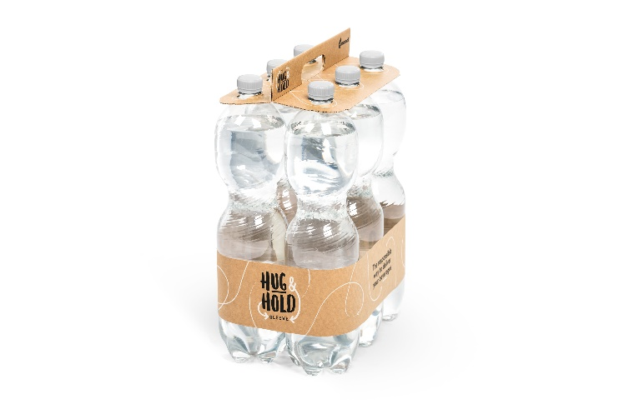
Mondi scoops RISI PPI Product Innovation Award with paper-based Hug&Hold solution. (Photo: Mondi, PR244)

This press release and relevant photography can be downloaded from
www.PressReleaseFinder.com.
Alternatively for very high resolution pictures please contact Kim Lommaert (klommaert@emg-marcom.com, +31 164 317 021).

