PRESS RELEASE

Mondi and FRESH!PACKING reinvent the cooler bag with recyclable kraft paper alternative

- FRESH!PACKING and Mondi have collaborated to create a new recyclable consumer cooler bag.
- Fresh!Bag is made entirely from renewable materials, providing excellent protective cooling properties, offering consumers a durable cooler bag to carry chilled or frozen food home.
- Certified as fully recyclable in existing European paper waste streams, the Fresh!Bag has already scooped the "functionality & convenience" category at the German Packaging Award.

15 December 2022 – Mondi, a global leader in sustainable packaging and paper, has worked with FRESH!PACKING, to design an innovative cooler bag, to protect and transport chilled or frozen goods home by consumers.

The Fresh!Bag outer layer is entirely made from Mondi’s durable kraft paper replacing the traditionally used unrecyclable, multi-material packaging while improving cooling protection by up to 2.5 times.

Certified as fully recyclable in Europe’s existing paper waste streams, the bag’s cooling element is created using pulp, which is encased in Mondi’s kraft paper. The paper has a high stretchability, allowing easy sewing of the different plies to create a strong bag structure. The bag has a high resistance to tear and can carry large weights and sizes. Extra security and convenience for the consumer is provided by the handle on the Fresh!Bag, which loops within itself easily, forming an open seal.

The bags are durable and can be re-used multiple times by the consumer. Mondi’s kraft paper also provides retailers with good printability for branding and messaging. Fresh!Bag recently won the German packaging award 2022 in the “Functionality & Convenience” category. FRESH!PACKING now aims to launch the bag across Europe.

Alexander Baars, International Sales Manager Speciality Kraft Paper, Mondi: “Fresh!Bag provides a genuinely exciting opportunity for retailers; it responds to the consumer demand for more sustainable packaging, while delivering convenience and durability for frozen and chilled goods. Sometimes we need to ask different questions to come up with new solutions – and by working closely with FRESH!PACKING we were able to create this innovative addition for the retail industry.”

Kevin Hendzlik, General Manager & Fresh!Bag Product Manager, FRESH!PACKING adds: “Mondi trusted in our idea and brought a wealth of additional expertise to the table. While developing Fresh!Bag, the team was able to easily identify the right opportunities and advise us throughout the process, helping us to achieve our sustainability goals of avoiding plastic waste and using material that contributes to a circular economy.”

/ends
About Mondi
Mondi is a global leader in packaging and paper, contributing to a better world by making innovative solutions that are sustainable by design. Our business is integrated across the value chain – from managing forests and producing pulp, paper and films, to developing and manufacturing sustainable consumer and industrial packaging solutions using paper where possible, plastic when useful. Sustainability is at the centre of our strategy, with our ambitious commitments to 2030 focused on circular driven solutions, created by empowered people, taking action on climate.

In 2021, Mondi had revenues of €7.0 billion and underlying EBITDA of €1.2 billion from continuing operations, and employed 21,000 people worldwide. Mondi has a premium listing on the London Stock Exchange (MNDI), where the Group is a FTSE100 constituent, and also has a secondary listing on the JSE Limited (MNP).

www.mondigroup.com

Contact:
Judith Wronn
Head of Communication, Mondi Flexible Packaging
Tel: +49 151 1771 4692
Email: Judith.Wronn@mondigroup.com

Kim Lommaert
EMG
Tel: +31 164 317 021
Email: klommaert@emg-marcom.com

Photos:
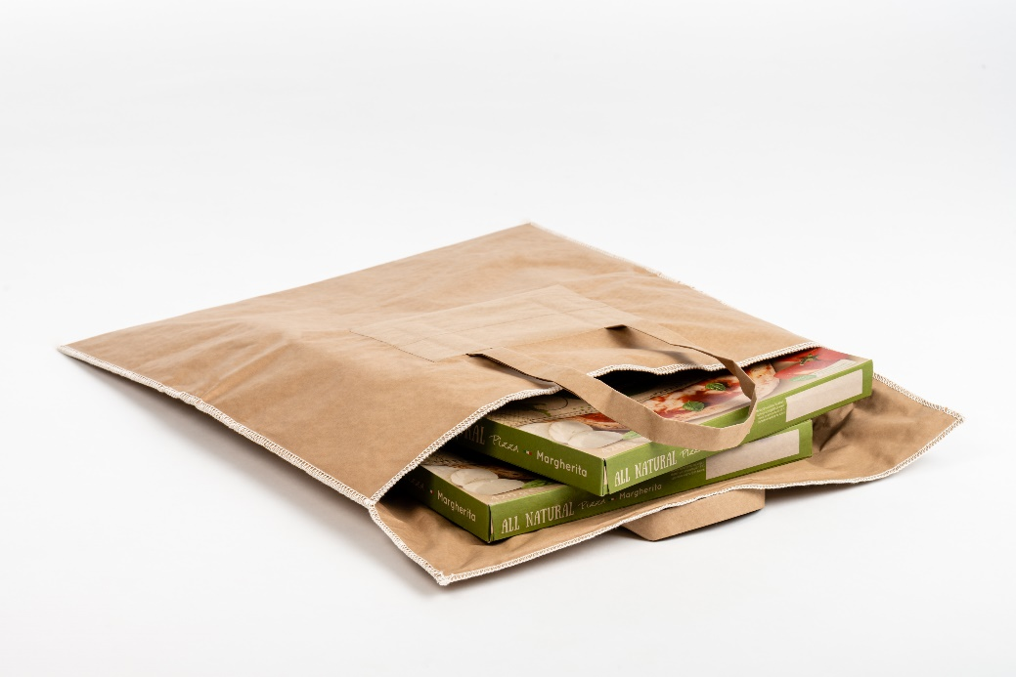

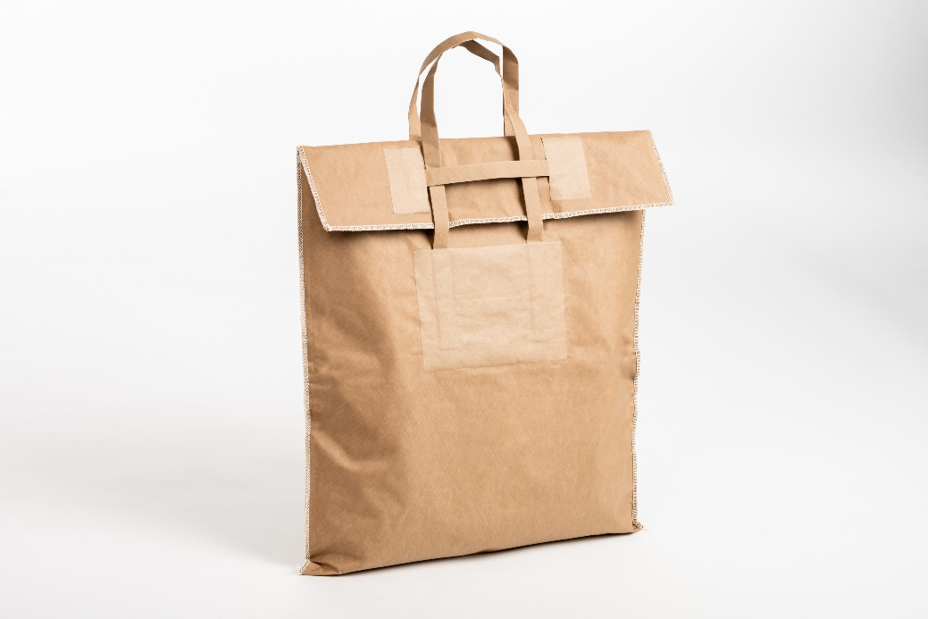
Mondi and FRESH!PACKING reinvent the cooler bag with recyclable kraft paper alternative. (Photos: Mondi, PR237)

This press release and relevant photography can be downloaded from
www.PressReleaseFinder.com.
Alternatively for very high resolution pictures please contact Kim Lommaert (klommaert@emg-marcom.com, +31 164 317 021).

