PRESS RELEASE

Mondi has expanded its paper bag footprint in Morocco

- Mondi has started production at its €16 million plant in Tangier (Morocco), increasing production capacity in West Africa to over 500 million bags each year.
- Investment builds on Mondi's existing expertise to meet growing demand for paper bags in the area.
- Mondi uses sack kraft paper made at its own mills, helping to ensure security of supply of packaging materials.

14 December 2022 – Mondi, a global leader in sustainable packaging and paper, has started production at its €16 million greenfield plant in Morocco, which can produce 100 million paper bags each year.

This brings Mondi’s total capacity in West Africa to over 500 million bags annually, helping to meet the growing customer demand for paper bags in the region. This plant is Mondi’s fourth site in West Africa (in addition to two plants in Morocco and one in Ivory Coast).

The sack kraft paper used by these locations is produced by Mondi, helping to ensure security of supply of packaging materials to the region’s building industry. In addition, Tangier is ideally located within a free economic trade zone making it well positioned to supply to neighbouring countries.

Hicham Jalal, Mondi’s Regional Manager West Africa Paper Bags, comments: “It is really exciting to see the growth in the West African building industry. Mondi is uniquely positioned to deliver paper-based packaging materials directly to customers in the region, who benefit from a reliable supply of high-quality paper bags and local services.”

Claudio Fedalto, COO Paper Bags, Mondi, adds; “This investment illustrates our commitment to growing our offering of sustainable packaging through our integrated value chain. Thanks to the excellent work and spirit of the local team, we secured, progressed and turned this project around incredibly quickly. Work on the ground started in January 2022, and we have already started production at our new plant. This excellent achievement was only possible thanks to the highly motivated local team.”

/ends

About Mondi
Mondi is a global leader in packaging and paper, contributing to a better world by making innovative solutions that are sustainable by design. Our business is integrated across the value chain – from managing forests and producing pulp, paper and films, to developing and manufacturing sustainable consumer and industrial packaging solutions using paper where possible, plastic when useful. Sustainability is at the centre of our strategy, with our ambitious commitments to 2030 focused on circular driven solutions, created by empowered people, taking action on climate.

In 2021, Mondi had revenues of €7.0 billion and underlying EBITDA of €1.2 billion from continuing operations, and employed 21,000 people worldwide. Mondi has a premium listing on the London Stock Exchange (MNDI), where the Group is a FTSE100 constituent, and also has a secondary listing on the JSE Limited (MNP).

www.mondigroup.com

Contact:
Judith Wronn
Head of Communication, Mondi Flexible Packaging
Tel: +49 151 1771 4692
Email: Judith.Wronn@mondigroup.com

Kim Lommaert
EMG
Tel: +31 164 317 021
Email: klommaert@emg-marcom.com

Photos:
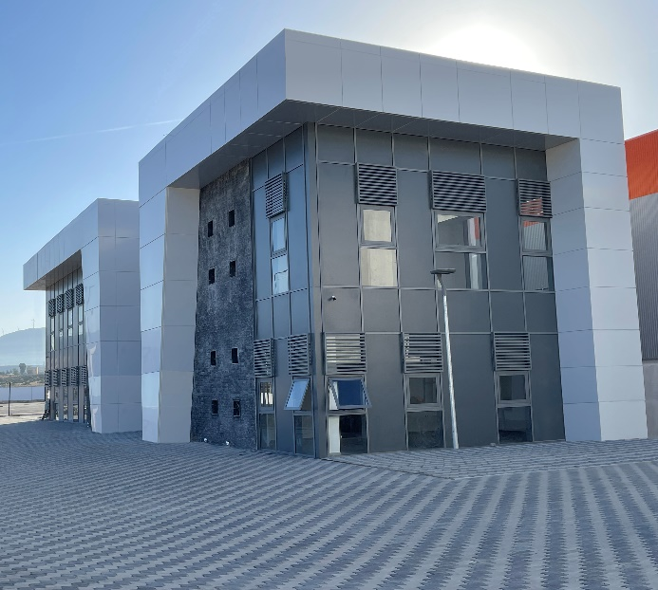

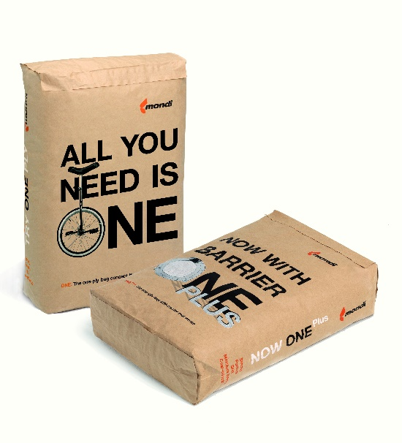
Mondi has expanded its paper bag footprint in Morocco. (Photos: Mondi, PR236)

This press release and relevant photography can be downloaded from
www.PressReleaseFinder.com.
Alternatively for very high resolution pictures please contact Kim Lommaert (klommaert@emg-marcom.com, +31 164 317 021).

