PRESS RELEASE

Mondi lands a catch with Krissia® surimi sticks and its switch to recyclable, paper-based packaging

- Mondi designs new paper-based secondary packaging for Krissia® chilled surimi sticks.
- Packaging uses Mondi's FunctionalBarrier Paper 95/5 and saves 20 tonnes of plastic each year.
- Solution provides product protection while ensuring recyclability of the paper packaging.

7 December 2022 – Mondi, a global leader in sustainable packaging and paper, has supported Angulas Aguinaga® on its journey to switch to a recyclable paper-based packaging for its Krissia® brand chilled surimi sticks, greatly reducing the amount of plastic being used.

The surimi sticks were previously packed in a multi-material plastic solution. By collaborating closely with Mondi, Angulas Aguinaga® and its Krissia® brand is now transitioning to a secondary packaging using Mondi’s FunctionalBarrier Paper. Mondi’s wealth of expertise in paper packaging meant that it was able to create a solution that would be genuinely fit for purpose, protecting the chilled product while significantly reducing plastic – eliminating up to 20 tonnes of plastic every year.

Mondi’s FunctionalBarrier Paper is made from renewable and certified resources, responsibly sourced and delivers a range of benefits: the strong and tear-resistant kraft base paper is fully converted in-house by Mondi to ensure customised barrier protection of the food and sealability of the packaging. The final packaging is recyclable in Spain’s existing paper recycling streams.

Jordi Gorchs, Regional Manager France & Southern Europe, Consumer Flexibles, Mondi, says: “By working closely with the Krissia® team and looking into the entire journey of the product, we have been able to ensure the surimi sticks are packed in recyclable packaging that supports a circular economy, keeping valuable materials in the loop. We took the time to focus on the needs of the product first before optimising our FunctionalBarrier Paper to provide a responsible, recyclable replacement to the previous plastic alternative.”

Mikel Grande, Angulas Aguinaga® Marketing and Innovation Manager, says: “We are committed to creating innovative solutions in the food industry that solve real consumer needs. In this context, switching our product packaging to materials that come from renewable resources is a must: it is our responsibility to offer solutions to our consumers, whose preferences have shifted towards paper-based packaging. This new solution significantly replaces unnecessary plastic while assuring the quality of our Krissia® surimi sticks. We are very proud to be the first brand commercialising this type of paper-based packaging for chilled fish.”

/ends

About Mondi
Mondi is a global leader in packaging and paper, contributing to a better world by making innovative solutions that are sustainable by design. Our business is integrated across the value chain – from managing forests and producing pulp, paper and films, to developing and manufacturing sustainable consumer and industrial packaging solutions using paper where possible, plastic when useful. Sustainability is at the centre of our strategy, with our ambitious commitments to 2030 focused on circular driven solutions, created by empowered people, taking action on climate.

In 2021, Mondi had revenues of €7.0 billion and underlying EBITDA of €1.2 billion from continuing operations, and employed 21,000 people worldwide. Mondi has a premium listing on the London Stock Exchange (MNDI), where the Group is a FTSE100 constituent, and also has a secondary listing on the JSE Limited (MNP).

www.mondigroup.com

Contact:
Judith Wronn
Head of Communication, Mondi Flexible Packaging
Tel: +49 151 1771 4692
Email: Judith.Wronn@mondigroup.com

Kim Lommaert
EMG
Tel: +31 164 317 021
Email: klommaert@emg-marcom.com

Photos:
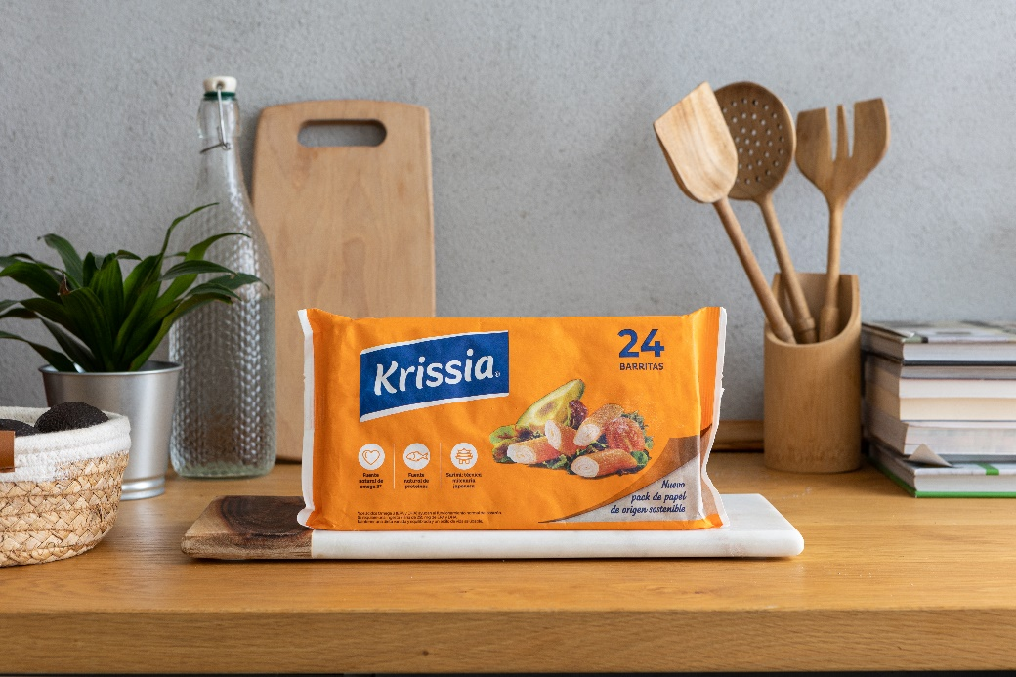

Mondi lands a catch with Krissia® surimi sticks and its switch to recyclable, paper-based packaging. (Photos: Mondi, PR235)

This press release and relevant photography can be downloaded from
www.PressReleaseFinder.com.
Alternatively for very high resolution pictures please contact Kim Lommaert (klommaert@emg-marcom.com, +31 164 317 021).

