PRESS RELEASE

Mondi and Essity launch packaging for feminine care range made from post-consumer recycled and biomass balanced materials

- Leading hygiene and health company Essity has collaborated with Mondi and Dow to improve the carbon footprint of its global feminine care packaging
- Mondi’s new mono-material for feminine care range is designed for recycling
- New packaging uses renewable material and a by-product from paper making as well as post-consumer recycled content supporting Essity’s sustainability targets.

9 August 2022 – Mondi, a global leader in packaging and paper, has collaborated with Essity and Dow to create new, recyclable secondary packaging for Essity’s feminine care products, using renewable materials and post-consumer recycled content that reduces use of fossil-based materials.

Essity’s feminine care towels were previously packed in bags that already used 50% renewable materials. Extensive research and testing by Mondi however, resulted in the recommendation of a new solution that aligns with Essity’s packaging goals: to work towards 100% recyclability and to use up to 85% biomass, renewable or recycled material in all bags where up to 25% are recycled plastics.

The new packaging contributes to these sustainability goals by using a renewable material and by-product from the paper making industry that is produced from circular feedstock based on the ISCC (International Sustainability & Carbon Certification) mass balance approach. The innovative packaging also contains mechanically recycled content from post-consumer material. Mondi worked with long-term supplier Dow and other companies along the value chain to find the most suitable resin formulation for this solution. The end result is an extruded film that is printed on and converted into a bag.

Providing the same high-level of protection as the previous alternative, the solution prevents moisture and light damaging the feminine care range, has strong sealing properties and delivers outstanding print quality to maintain on-shelf appeal for Essity’s European recognised brands, such as Bodyform, Libresse, Nana and Nuvenia.

Marjo Kuisma, Regional Sales Consumer Flexibles, Mondi, says: “The challenge was to find the best combination of renewable and recycled content that maintains product quality and the production efficiency already enjoyed by Essity. We tested several options until we found the most suitable solution. Working in collaboration with Essity and Dow validates our EcoSolutions approach; we go back to the start and ask the right questions to ensure we create the best possible solution for our customers.”

Guosheng Zhang, Global Technical Innovation Manager Feminine Care says: “We are excited to launch the new feminine care packaging that has a reduced carbon footprint and will contribute to our sustainable innovations. The solution demonstrates our and Mondi’s commitment to the Ellen MacArthur Foundation: to work towards full recyclability and to increase the use of recycled plastic in our packaging. The end result is eye-catching, well designed and makes a positive impact on the environment.”
Editor’s note:
Mondi is exhibiting at FachPack in Nuremberg, Germany from 27.09. - 29.09.2022 and will be presenting a variety of sustainable packaging solutions that are fit for purpose. You can visit Mondi in Hall 7-258, where different innovations and sustainable packaging options will be showcased. There is more than one path to sustainability and Mondi is determined to map the best one together with our customers. In line with the Mondi Action Plan 2030 (MAP2030) sustainability framework, Mondi is contributing towards a circular economy by using paper where possible and plastic when useful.

About Mondi
Mondi is a global leader in packaging and paper, contributing to a better world by making innovative packaging and paper solutions that are sustainable by design. Our business is integrated across the value chain – from managing forests and producing pulp, paper and plastic films, to developing and manufacturing effective industrial and consumer packaging solutions. Sustainability is at the centre of our strategy and intrinsic in the way we do business. We lead the industry with our customer-centric approach, EcoSolutions, where we ask the right questions to find the most sustainable solution. In 2021, Mondi had revenues of €7.7 billion and underlying EBITDA of €1.5 billion.

Mondi has a premium listing on the London Stock Exchange (MNDI), and a secondary listing on the JSE Limited (MNP). Mondi is a FTSE 100 constituent, and has been included in the FTSE4Good Index Series since 2008 and the FTSE/JSE Responsible Investment Index Series since 2007.

www.mondigroup.com

About Mondi Consumer Flexibles
Mondi Consumer Flexibles is part of Mondi’s Business Unit Flexible Packaging and a global manufacturer of tailor-made flexible plastic and hybrid packaging solutions that are sustainable by design. The product range includes pre-made bags, stand-up pouches and high-performance barrier materials with film- and paper-based solutions. Making it possible to provide paper where possible, and plastic when useful. We serve some of the world’s biggest brands and FMCG’s in categories such as fresh food, pet food, home, and personal care. Committed to quality, we provide customer-oriented packaging solutions and cutting-edge innovations developed by our state-of-the-art R&D centre in Gronau. Our network serves customers from 27 operations located in 12 countries.

Contact:
Judith Wronn
Head of Communication, Mondi Flexible Packaging
Tel: +49 151 1771 4692
Email: Judith.Wronn@mondigroup.com

Kim Lommaert
EMG
Tel: +31 164 317 021
Email: klommaert@emg-marcom.com

Photos:
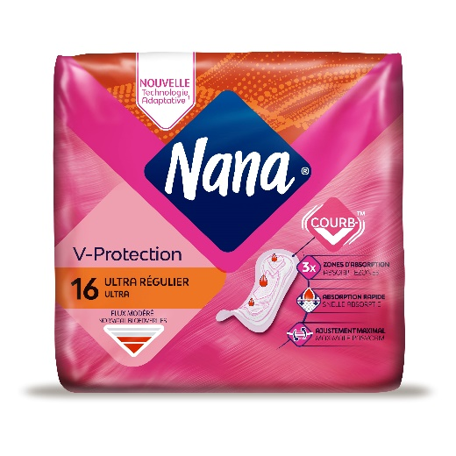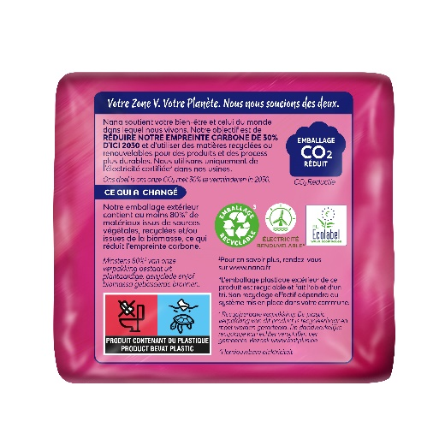
Mondi and Essity launch packaging for feminine care range made from post-consumer recycled and biomass balanced materials. (Photos: Mondi, PR222)

This press release and relevant photography can be downloaded from
www.PressReleaseFinder.com.
Alternatively for very high resolution pictures please contact Kim Lommaert (klommaert@emg-marcom.com, +31 164 317 021).

