Editorial Contact: Ana Juraga [ana.juraga@ecocortec.hr](mailto:ana.juraga@ecocortec.hr)

Cortec® Europe Advertising Agency +385 (0) 1 48 54 486

Company Contact: Ivana Radic Borsic iborsic@cortecvci.com

Cortec® Corporation: +385 98 267 572

**Attention: Editor**

**April 29, 2024**

**PRESS RELEASE**

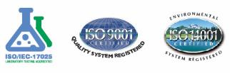

Cortec® Corporation Announces the Expansion of Cooperation in the Finnish Market with Mercamer into a Strategic Partnership

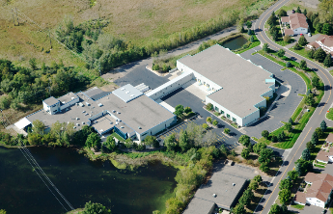We are thrilled to announce that Cortec® Corporation, a leading global manufacturer specializing in environmentally responsible VpCI®/VCI corrosion protection technologies, has welcomed a new authorized distribution partner in Finland for Cortec® chemical products. Cortec® Corporation has ended its long-term relationship with Teknoma Oy and is looking forward to a new phase of growth and collaboration with new partner. Mercamer, distributor of Cortec® flexible VpCI packaging, has been authorized to offer Cortec's innovative patented corrosion protection chemical products and solutions to the Finnish market. Mercamer is now the only authorized distributor for Cortec® Corporation’s products in Finland. The company is a packaging specialist with 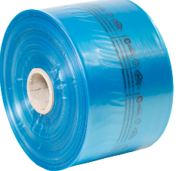a broad range of products and expertise. Mercamer has over 50 years of experience in the Finnish packaging market. As part of the OptiGroup, Mercamer is one of the leading brands in the packaging business and the market leader in Finland. Their success largely depends on their ability to fulfill customers' individual needs. The company has long-term customer and supplier relationships, as well as highly skilled and motivated personnel. They provide total packaging services all over Finland, with the headquarters in Vantaa and a regional office in Turku. Their portfolio covers services from designing, analyzing, to standardizations.

**Mercamer's team in Finland**

**Cortec's headquaters in St.Paul, MN**

**Partnering with the world-renowned VpCI®/VCI inhibitor manufacturer, Cortec® Corporation**

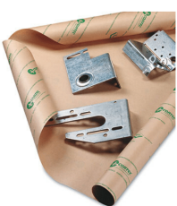

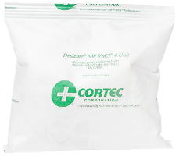As an organization that invests in quality, environmental safety, transparency and innovation, Mercamer has recognized Cortec® Corporation as a valuable partner in corrosion protection business. Cortec® has been a pioneer and industry leader in the corrosion prevention field for several decades, producing a wide range of multifunctional products that provide unparalleled benefits to customers. With over 400 products tailored for packaging, oil and gas, metalworking, construction, electronics, water treatment, and other industries, the company is focused on innovation, green technologies, and sustainable materials. Cortec® is not only a front-runner in the industry but has also set new levels of standards in the corrosion protection market. Cortec's VpCI®/VCI technology enables many advantages designed to save time, money, and provide more thorough, reliable, and easier-to-use protection compared to other metals preservation strategies. Cortec’s VCI’s are safe to handle and completely nitrite free.

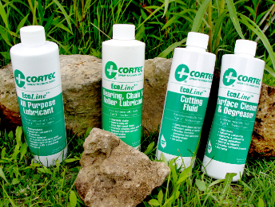Most of the products are recyclable or water-based, typically having a lower environmental impact than harsher chemicals. As an ISO 9001, ISO 14001, and ISO 17025 certified company, Cortec®'s biobased and water-based liquids replace polluting oil/solvent-based coatings. Cortec’s VP of Sales for Europe, Ivana Radic Borsic, looks forward to cooperation: “We are delighted that Mercamer’s team has recognized the quality of the Cortec® Corporation brand. We eagerly await future successful collaboration. Together, Cortec® and Mercamer will continue to offer the best support to our partners and clients in the Finnish market. We share the same values and are committed to providing world-class corrosion protection solutions of the highest standards, with sustainability in mind,” she concluded.

**Cortec® offers environmentally friendly methods of treatment with low toxicity and low polluting effects.**

* ***You can find out more about Mercamer Oy here:*** [***https://www.mercamer.fi/***](https://www.mercamer.fi/)

***Keywords: Cortec Corporation, Mercamer, sustainability, green inhibitors, corrosion protection, VCI, VpCI, corrosion inhibitors, rust prevention. multimetal protection, packaging industry, coatings industry***

Photo? Visit:[**www.cortecadvertising.com**](http://www.cortecadvertising.com)Cortec® Corporation is the global leader in innovative, environmentally responsible VpCI® and MCI® corrosion control technologies for Packaging,Metalworking, Construction, Electronics, Water Treatment, Oil & Gas, and other industries. Our relentless dedication to sustainability, quality, service, and support is unmatched in the industry. Headquartered in St. Paul, Minnesota, Cortec® manufactures over 400 products distributed worldwide. ISO 9001, ISO m14001:2004, & ISO 17025 Certified. Cortec Website: http://www.cortecvci.com