Aptar CSP Technologies and Porton Bring Activ-Blister™ Technology to Asia-Pacific Market

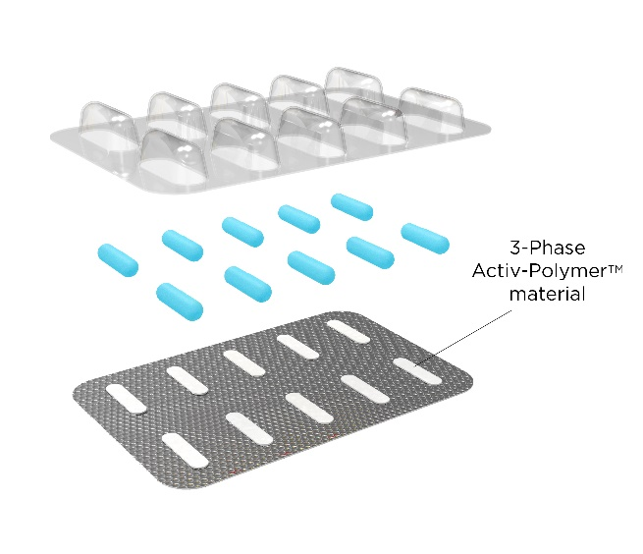
Auburn, AL, August 9, 2023 – Aptar CSP Technologies, part of AptarGroup, Inc. and a leader in active material science solutions announces a strategic collaboration with Porton Pharmatech Co., Ltd, a subsidiary of Porton Pharma Solutions Co., Ltd, a leading global end-to-end CDMO headquartered in China, to bring Activ-Blister™ Solutions to the Asia-Pacific (APAC) region. The move follows successful commercialization and approval of Activ-Blister™ technology with two HIV medications currently marketed in North America and the EMEA region.
Figure 1: Activ-Blister™ Technology
This collaboration with Porton provides pharma developers in the APAC region with access to a local development and manufacturing resource for leveraging Aptar CSP’s Activ-Blister™ solutions to protect their sensitive drugs. Bringing production of this technology closer to patients and consumers will help mitigate supply chain disruptions and expedite time to market.
“Expanding global manufacturing sites for Activ-Blister™ technology reflects our commitment to delivering global access to innovative active material science solutions for patients and consumers,” said Badre Hammond, VP Commercial Operations and GM APAC, Aptar CSP Technologies. “This collaboration with Porton enables us to better serve the regional market for both local production and export business.”
“Porton is proud to collaborate with Aptar CSP Technologies to bring the first application of Activ-Blister™ technology to the APAC market,” said Donna Deng, Director of Strategic Procurement at Porton Pharmatech. “This partnership highlights Porton’s global strategic vision and mission of bringing quality medicine to the public.”
Activ-Blister™ Solutions (Figure 1) integrates Aptar CSP’s proprietary 3-Phase Activ-Polymer™ platform technology into individual blister cavities or in a fishbone blister format to provide bespoke microclimate protection for sensitive drug products. This technology can be customized specifically for the drug developer’s formulation to provide a broad spectrum of specific drug protection including moisture adsorption, and oxygen and odor scavenging. The technology can also scavenge volatile organic compounds (VOCs) and emit aromas. Most recently, Aptar CSP leveraged the Activ-Blister™ platform to develop a solution to mitigate risk of mutagenic N-nitrosamine impurity formation and drug degradation.
In order to better serve the Asia Pacific market, Aptar CSP brought local production of Activ-Vial™ technology, the world choice for blood glucose test strip protection, to diabetes patients in the China region early this year. cGMP produced Activ-Vial™ products are now available on site in Guangzhou for commercial launch.
###
About Aptar CSP Technologies
Aptar CSP Technologies is part of AptarGroup, Inc., a global leader in drug and consumer product dosing, dispensing and protection technologies. Aptar CSP Technologies leverages its active material science expertise to transform ideas into market opportunities, accelerate and de-risks the product development process, and provide complete solutions that improve consumers’ and patients’ lives. The company offers a complete set of services from concept ideation, to design and engineering, to product development, global production, quality control, and regulatory support that results in expedited speed-to-market. For more information, please visit www.csptechnologies.com and www.aptar.com.
About Porton Pharma Solutions
With over 5,000 customer-centric employees, operations and commercial offices across the US, EU and China, Porton Pharma Solutions provides global pharmaceutical companies with innovative, reliable and end-to-end process R&D and manufacturing services across small molecule APIs, dosage forms and biologics. Porton is committed to be the most open, innovative and reliable pharmaceutical service platform in the world and enabling the public’s early access to good medicines.

