Editorial Contact:  Cortec® Advertising Agency | Jeni Duddeck  (651) 429-1100 Ext. 1114 | jduddeck@cortecvci.com
Company Contact: Cortec® Corporation | Julie Holmquist  (651) 429-1100 Ext. 1194 | jholmquist@cortecvci.com
Technical Contact: Cortec® Corporation | Rick Shannon  (651) 429-1100 Ext. 1146 | rshannon@cortecvci.com

Attention: Editor
December 14, 2023
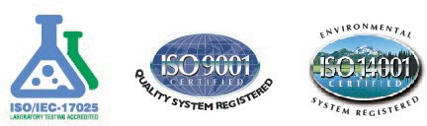
PRESS RELEASE

Cortec® Coated Products Wins
Wisconsin DNR Recycling Excellence Award

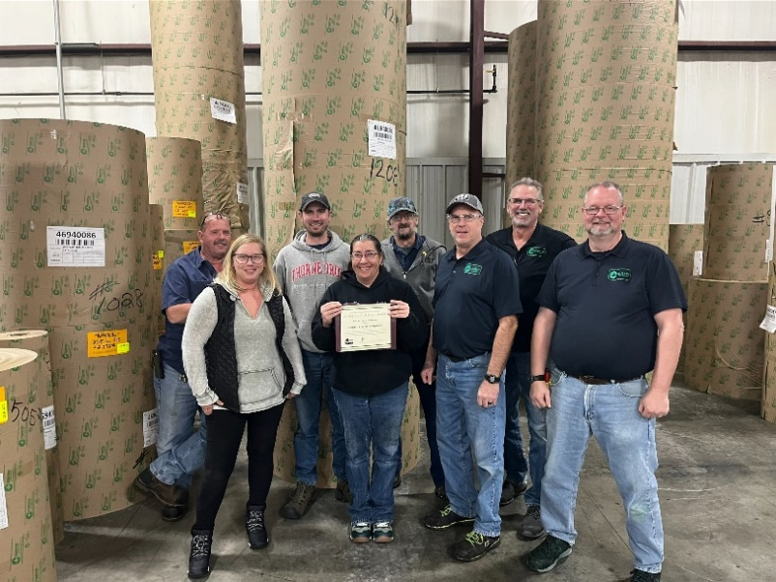
Cortec® is pleased to announce that its Cortec® Coated Products (CCP) division in Eau Claire, Wisconsin, has won the Wisconsin Recycling Excellence Award! CCP is one of 11 organizations that received the award this year from the Wisconsin DNR (Department of Natural Resources) in recognition of outstanding efforts to recycle and reduce waste. CCP’s award falls under the category of “Projects and Initiatives” that have led to the recycling of more material and/or better recycling cost-effectiveness.

In addition to sourcing most of its paper rolls from recycled content, CCP’s specialty is to apply a corrosion inhibiting coating that still allows the paper to be recycled after use. This is an important environmental benefit for manufacturers and distributors that use Cortec® VpCI® Paper to package and protect metal parts in a variety of industries. It is also an advantage for CCP’s waste handling processes. Converting its coated VpCI® Papers into marketable rolls and different sizes of sheeting inevitably leaves behind a large amount of paper scrap. CCP collects the scrap, compacts it into bales, and sends it to a recycling broker that sorts and resells the scrap to various paper/recycling plants. Cortec® Environmental Specialist, Derek Jensen, estimates that since 2017, CCP has recycled 616 tons of paper, equal to approximately 12,320 trees saved!

Cortec® is honored to receive this award, which underscores the company’s strong commitment to recycling, waste reduction, and sustainability in the quest for practical solutions to corrosion. Learn more about the award here!

Keywords: Cortec, Cortec Coated Products, Wisconsin recycling excellence award, recycled paper, what to do with paper scrap, Cortec environmental commitment, reduce waste, Wisconsin DNR, corrosion inhibiting paper, corrosion protection

Need a High-Resolution Photo? Visit: www.cortecadvertising.com
Cortec® Corporation is the global leader in innovative, environmentally responsible VpCI® and MCI® corrosion control technologies for Packaging, Metalworking, Construction, Electronics, Water Treatment, Oil & Gas, and other industries. Our relentless dedication to sustainability, quality, service, and support is unmatched in the industry. Headquartered in St. Paul, Minnesota, Cortec® manufactures over 400 products distributed worldwide. ISO 9001:2015, ISO 14001:2015, & ISO/IEC 17025:2017 certified. Cortec® Website: http://www.cortecvci.com Phone: 1-800-426-7832 FAX: (651) 429-1122

