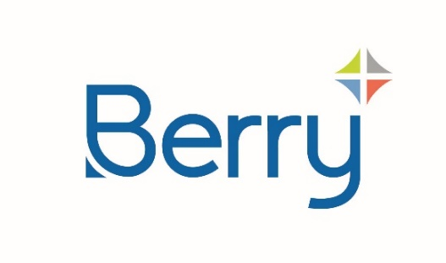
Media Alert

Issue Date: 7th February 2024
For Immediate Release

Berry Global and Glatfelter Announce Plans for Tax-Free Spin-Off and Merger of Berry’s Health, Hygiene and Specialties Global Nonwovens and Films Business with Glatfelter, Creating a Global Specialty Materials Leader

Berry Global Group, Inc. (NYSE:BERY) and Glatfelter Corporation (NYSE:GLT) announced today they have entered into definitive agreements for Berry to spin-off and merge the majority of its Health, Hygiene and Specialties segment to include its Global Nonwovens and Films business (“HHNF”) with Glatfelter, to create a leading, publicly-traded company in the specialty materials industry. The Boards of Directors of Berry and Glatfelter have unanimously approved the transaction.
The new combined company (“NewCo”) will become a global leader in the growing specialty materials industry, serving the world’s largest brand owners across global end markets with favorable long-term growth dynamics. HHNF brings an extensive portfolio of proprietary technologies, with a strong focus on healthcare, hygiene, and specialty end markets, while Glatfelter provides a broad range of innovation capabilities and sustainability solutions. Together, the combined company will offer a highly complementary product suite, including both polymer-based and fiber-based solutions, supported by strong innovation capabilities, with significant geographic diversification and a presence in all major markets.
“This announcement is the culmination of a comprehensive review of strategic alternatives to determine the value-maximizing path forward for Berry shareholders,” said Kevin Kwilinski , Berry’s Chief Executive Officer. “We believe these two businesses, in combination, can drive significant value for shareholders with complementary portfolios, positioning each for greater success. Following completion of the transaction, Berry will become a pure-play provider of innovative, sustainable global packaging solutions, which we believe will deliver even more predictable earnings growth for Berry shareholders. Additionally, we believe HHNF in combination with Glatfelter will thrive as an independent company that is positioned to drive long-term growth with its global brand-owner customers.”
"The uniting of our organizations creates a premier nonwovens supplier and a global leader in specialty materials, with the talent, technologies, scale, and footprint to deliver commercial and operational excellence, and a wide range of solutions for our customers. Our combined company is scaled to accelerate innovation and leverage our intellectual property over a large worldwide commercial platform and is well positioned to deliver substantial shareholder value," said Thomas Fahnemann , Glatfelter's President and Chief Executive Officer.
Read the full article here: https://www.berryglobal.com/en/news/articles/15106-berry-global-and-glatfelter-announce-plans-for-tax
Ends
About Berry
At Berry Global Group, Inc. (NYSE: BERY), we create innovative packaging solutions that we believe make life better for people and the planet. We do this every day by leveraging our unmatched global capabilities, sustainability leadership, and deep innovation expertise to serve customers of all sizes around the world. Harnessing the strength in our diversity and industry-leading talent of over 40,000 global employees across more than 250 locations, we partner with customers to develop, design, and manufacture innovative products with an eye toward the circular economy. The challenges we solve and the innovations we pioneer benefit our customers at every stage of their journey. For more information, visit our website, or connect with us on LinkedIn or X.

About Glatfelter
Glatfelter is a leading global supplier of engineered materials with a strong focus on innovation and sustainability. The Company’s high-quality, technology-driven, innovative, and customizable nonwovens solutions can be found in products that are Enhancing Everyday Life®. These include personal care and hygiene products, food and beverage filtration, critical cleaning products, medical and personal protection, packaging products, as well as home improvement and industrial applications. Headquartered in Charlotte, NC, the Company’s 2022 revenue was $1.5 billion with approximately 2,980 employees worldwide. Glatfelter’s operations utilize a variety of manufacturing technologies including airlaid, wetlaid and spunlace with fifteen manufacturing sites located in the United States, Canada, Germany, France, Spain, the United Kingdom, and the Philippines. The Company has sales offices in all major geographies serving customers under the Glatfelter and Sontara® brands. Additional information about the Company may be found on our website at www.glatfelter.com or connect with us on LinkedIn.

Berry Global, Inc.
Investor Contact
Dustin Stilwell
VP, Investor Relations
+1 812.306.2964
ir@berryglobal.com
Global Media Contact
Laci Scourfield
+1 812.250.3884
mediarelations@berryglobal.com

Glatfelter Corporation
Investor Contact
Ramesh Shettigar
+1 717.225.2746
Ramesh.Shettigar@glatfelter.com
Media Contact
Eileen L. Beck
+1 717.225.2793
Eileen.Beck@glatfelter.com

