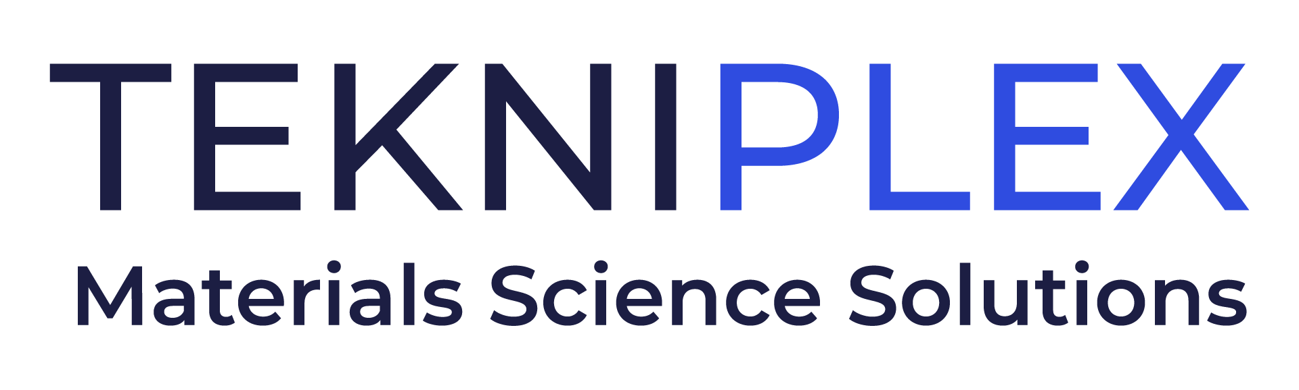
Press release

Media Contact: Peter Gavigan
TekniPlex
+1 (908) 720-5391
Peter.Gavigan@tekni-plex.com

Christopher Dale
Turchette Agency
+1 (973) 227-8080 ext. 116
cdale@turchette.com

At Pack Expo, TekniPlex Consumer Products to Give
Sustainability-focused Presentation on Innovation Stage

“Rethink Responsibly” highlights company’s
materials diversity-driven approach to optimizing sustainability.

Wayne, PA – TekniPlex Consumer Products, a globally integrated provider of innovative solutions through materials science and manufacturing technologies, will host a presentation highlighting its materials science-based approach to sustainability at Pack Expo in Chicago. On Sunday, October 23 at 3:00 p.m., on Innovation Stage 1 (Stand N4560), the company will present Rethink Responsibly, which discusses a variety of challenges surrounding one of packaging’s most complex, all-encompassing topics.
“Rethink Responsibly” has become a mindset for TekniPlex. The half-hour presentation will provide an overview of this concept, which commits to continually considering what it means to provide responsible solutions to customers, their consumers, and the planet. The approach reflects the company’s promise to perpetual progress across materials science design innovation, supply chain and operational efficiencies, materials reduction, closed loop manufacturing, and promotion of bio-based and post-consumer recycled (PCR) resins, among other areas relevant to sustainability.

The presentation will be delivered by a pair of executives well versed in the sustainability space. As TekniPlex’s Senior Vice President of Global Innovation, Oscar Martin works with cross-functional teams, executive leaders, and customers to drive innovation strategy and long-term growth. Martin’s co-presenter, Vice President of Sales Greg Ambrogi, steers efforts to create sustainable solutions that reduce environmental impact while maximizing manufacturability, performance, and end-user experiences.

The presentation also will introduce an expanded product line that TekniPlex Consumer Products is debuting at Pack Expo. The company’s GeoPack portfolio comprises a broad spectrum of product families meeting defined criteria for sustainability. These criteria comprise varying combinations of materials science sustainability’s “4 Rs” – reduce, recycle, reuse and renew – including biodegradable or compostable materials, post-consumer recycled content, recyclability, renewable substrates, and legislation compliance. The goal is to deliver solutions tailored toward customers’ sustainability metrics, including providing information on specific products’ environmental impact.

# # #

About TekniPlex Consumer Products
TekniPlex Consumer Products specializes in advanced materials science solutions for companies in the food & beverage and CPG industries with a focus on protecting products, strengthening brands, and innovating sustainably. TekniPlex Consumer Products serves companies around the world in sectors including beauty and personal care, household items, and food and beverage.
With an expanding selection of material-diverse solutions – bolstered in recent years, by a series of strategic acquisitions – TekniPlex Consumer Products is leading the way creating next-generation packaging designs that address real-world challenges in the markets it serves. Most notably, the company is focused on developing more sustainable solutions that continue to provide product safety and consumer satisfaction. For more information, visit www.tekni-plex.com/consumer

