Absolut Mosaik limited edition vodka bottle: a symbol of unity and diversity

Luxembourg (Mar 21, 2024) – Ardagh Glass Packaging-Europe (AGP-Europe), an operating business of Ardagh Group, works closely with The Absolut Group to create the limited edition Absolut vodka bottle each year. The latest design: Absolut Mosaik was created in a collaboration with British artist Olly Alexander: a singer, songwriter, actor and social activist.

The 70cl and 1 litre glass bottles feature a stunning ribbed design within the glass, with a concave label area containing a bold mosaic design and Absolut branding.

AGP–Europe created a series of ribs and fins around the surface of the glass using 3D software and used sculptured embossing to soften the design across the bottle’s part line.

Katharina Chemnitz, AGP–Europe Product Designer, explains one of the challenges of developing the design into the finished glass bottle:
“The front label, which is the main print area for the mosaic design, originally stood out from the bottle, making it a potential contact point on the production line. To accommodate this challenge, the label area was carefully engineered within a concave, curved surface, framed perfectly by the surrounding rib design.”

Deb Dasgupta, Global Vice President Marketing, Absolut Vodka, comments:

“Absolut Mosaik, as part of the Born to Mix brand values, is our latest launch that represents Absolut’s ongoing commitment to celebrating the power of diversity. Deeply embedded in Absolut’s DNA, it’s our invitation for everyone to make positive change by creating connections beyond differences. The vibrant, colourful bottle designed by the formidable Olly Alexander is the perfect embodiment of this, and how we’re all part of a greater whole in society.”
For more information about Ardagh Glass Packaging, click here.

Further information
Sharon Todd, Head of Marketing, Ardagh Glass Packaging - Europe sharon.todd@ardaghgroup.com +44 7768 718941

Download image
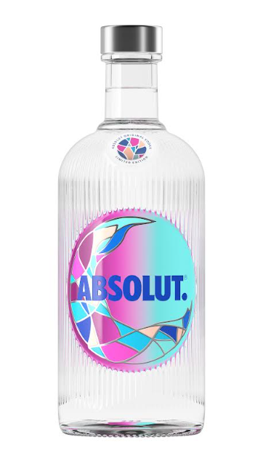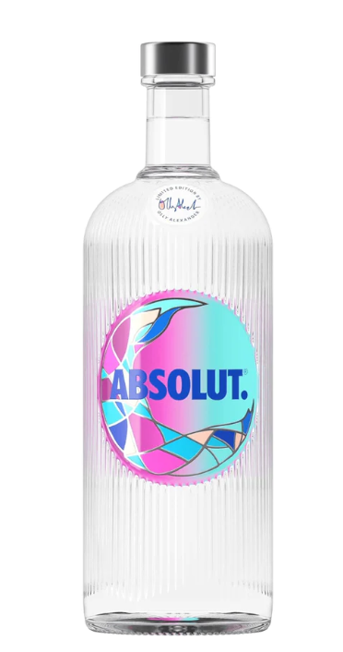
The 70cl and 1 litre Absolut Mosaik limited edition bottles
Notes to the editor
Ardagh Glass Packaging is a leading supplier of sustainable and infinitely recyclable glass packaging. Ardagh Glass Packaging operates 39 production facilities in North America, Europe and Africa and employs approximately 14,000 people and has recorded revenues of $4.6bn.

