

UFLEX LIMITED

EARNINGS RELEASE FOR THE QUARTER ENDED March 31, 2026

BROAD-BASED SURGE POWERS A STRONG Q4 FINISH; POISED FOR THE NEXT PHASE OF GROWTH










Q4 FY26 Q4 FY25 FY26

#Sales volume

166,879 MT
(+10.3% QoQ, +1.0% YoY)

165,147 MT
(+5.2% QoQ, +4.6% YoY)

649,789 MT
(+0.4% YoY)

Sales vol. split
Pkg. films: 76.7%
Packaging: 23.3%
Pkg. films: 76.8%
Packaging: 23.2%
Pkg. films: 76.6%
Packaging: 23.4%

Revenue

Rs. 40,973 Mn.
(+12.8% QoQ, +5.7% YoY)

Rs. 38,767 Mn.
(+2.6% QoQ, +10.9% YoY)

Rs. 155,130 Mn.
(+2.1% YoY)

EBITDA

Rs. 6,265 Mn.
(+36.3% QoQ, +31.8%YoY)

+15.3% Margin
(+260 bps QoQ, +300 bps YoY)

Rs. 4,755 Mn.
(-4.3% QoQ, +9.0%YoY)

+12.3% Margin
(-90 bps QoQ, -20 bps YoY)

Rs. 19,836 Mn.
(+8.1%YoY)

+12.8% Margin
(+70 bps YoY)

*Norm. EBITDA

Rs. 6,109 Mn.
(+39.0% QoQ, +27.0%YoY)

+14.9% Margin
(+280 bps QoQ, +250 bps YoY)

Rs. 4,811 Mn.
(-8.2% QoQ, +5.7%YoY)

+12.4% Margin
(-150 bps QoQ, -60 bps YoY)

Rs. 19,097 Mn.
(-0.4%YoY)

+12.3% Margin
(-30 bps YoY)

**Norm. PAT

Rs. 2,026 Mn.
(+316.9% QoQ, +105.5%YoY)

+4.9% Margin
(+360 bps QoQ, +240 bps YoY)

Rs. 986 Mn.
(-11.3% QoQ, -17.0%YoY)

+2.5% Margin
(-40 bps QoQ, -90 bps YoY)

Rs. 3,362 Mn.
(+5.0%YoY)

+2.2% Margin
(+10 bps YoY)

#,*,**: Please see the footnotes on page 32 for clarification on sales volume, normalized EBITDA and normalized PAT.

UFlex Limited
A – 107 – 108, Sector IV, NOIDA 201301,
UP, India, Tel: +91 120 255 6040 CIN: L74899DL1988PLC032166
Email: investorrelations@uflexltd.com

Q4 FY26 IN Brief (standalone)
- 82,290 MTPA sales volume during the quarter (including third-party PET chips sale vol. of 16,474 MT).

- Net revenue of Rs. 19,896 million.
- EBITDA of Rs. 2,910 million.

- EBITDA margin at 14.6%.

- PAT of Rs. 664 million.

FY26 IN Brief (standalone)

- 351,282 MTPA sales volume during the period (including third-party PET chips sale vol. of 80,416 MT).
- Net revenue of Rs. 78,543 million.

- EBITDA of Rs. 9,360 million.
- EBITDA margin at 11.9%.

- PAT of Rs . 1,480 million.

Broad-Based SURGE Powers a Strong Q4 Finish; Poised for the Next Phase of Growth
NOIDA, India: 1st june , 2026 - UFlex Limited (BSE: 500148, NSE: UFLEX), India’s leading multinational integrated flexible packaging and solutions company reported audited consolidated net revenue of Rs. 40,973 million for the fourth quarter of fiscal 2026 and Rs. 155,130 million for the full fiscal year 2026. EBITDA stood at Rs. 6,265 million for the quarter and Rs. 19,836 million for fiscal 2026, with corresponding EBITDA margins of 15.3% and 12.8%.Net profit was Rs. 1,960 million for the quarter and Rs. 3,171 million for fiscal 2026.

The Board of Directors, in its meeting held on May 30, 2026, has approved and taken on record the audited consolidated financial results of UFlex Limited and its subsidiaries for the quarter and the year ended March 31, 2026.

Strong Volumes and Revenue Growth with Accelerating EBITDA and Margin Expansion UFlex Limited concluded fiscal 2026 with a strong Q4 performance, reflecting steady operations amid a challenging environment. Revenue increased by 12.8% QoQ and 5.7% YoY to Rs. 40,973 million, supported by a 10.3% QoQ and 1.0% YoY increase in sales volume to 166,879 MT.
EBITDA jumped by 33.6% QoQ and 31.8% YoY to Rs. 6,265 million, reflecting improved realization, steady operations and operational excellence. EBITDA margin expanded significantly by 260 basis points QoQ and 300 basis points YoY to 15.3% in Q4 FY26.
Normalized net profit recorded a sharp recovery, rising by 316.9% QoQ and 105.5% YoY to Rs. 2,026 million, compared with Rs. 486 million in Q3 FY26 and Rs. 986 million in Q4 FY25. Normalized Profit After Tax (PAT) excludes exceptional

gains and losses. The reported PAT in Q4 FY26 contains the exceptional provision related to new labour laws to the tune of Rs. 66 million.
The operating environment remained challenging during the quarter amid macroeconomic pressures, tariff-related headwinds, and the ongoing West Asia conflict. Supply chain disruptions arising from constraints in the Strait of Hormuz, a key global energy and petrochemical trade corridor for oil, LNG, LPG, MEG, and polypropylene adversely impacted the packaging films value chain during the period. Despite these challenges, the quarter’s performance underscores the company’s alternate sourcing and execution capabilities in navigating a complex operating environment.

For the full year FY26, consolidated revenue increased by 2.1% year-on-year to Rs. 155,130 million, supported by stable demand. Sales volume remained broadly stable during the year, increasing by 0.4% to 649,789 MT in FY26.
EBITDA strengthened during the year, growing 8.1% year-on-year to Rs. 19,836 million from Rs. 18,343 million in FY25, driven by steady operations, better product mix and enhanced utilization in assets. Accordingly, EBITDA margins expanded by 70 basis points to 12.8% in FY26, compared to 12.1% in the previous fiscal.

The Company reported normalized net profit of Rs. 3,362 million for FY26, compared to Rs. 3,201 million in FY25, marking a 5.0% year-on-year increase and reflecting the company’s resilient operating performance, along with its continued focus on efficiency and profitability improvement.

During the year, demand across the company’s India businesses, including PET chips, packaging films, and packaging segments, was impacted by transition to GST 2.0 leading to destocking and demand disruption across downstream FMCG and beverage segments through Q2 and Q3 along with an unseasonably cool summer in Q1. The resulting slowdown also weighed on demand for intermediary business such as inks, adhesives, coatings, and printing cylinders.

The operating environment became more challenging toward the end of the year, with the onset of the West Asia conflict on February 28, 2026, disrupting crude oil and key petrochemical supply chains. Despite these cumulative headwinds, the Company maintained stable volumes, expanded margins, and improved profitability, underscoring its steady execution and operational adaptability.

Product-wise major sales volume break-up


Q4 FY26 Sales volume (MT)
165,147
151,245
166,879
126,907
114,965
128,037
Q4FY25
Q3FY26
Q4FY26
Packaging Films (Vol’s MT) Packaging (Vol’s MT) Total Sales (Vol’s MT)
Q4 FY26 Sales volume growth rate
11.4%
10.3%
7.1%
0.9%
1.6%
1.0%
Packaging Films Packaging Sales Total Sales Vol's
Sales Vol's Vol's
QoQ YoY
36,280
38,842
38,240

647,499 |  |  | 649,789
144,346 |  |  | 151,755
503,153 |  |  | 498,034



Revenue Mix by Geography

FY26 Sales volume growth rate
5.1%
0.4%
-1.0%
Packaging Films
Sales Vol's
Packaging Sales
Vol's
Total Sales Vol's
Packaging Films Sales Vol's Packaging Sales Vol's Total Sales Vol's
FY26 Sales volume (MT)
FY25
FY26
Packaging Films (Vol’s MT) Packaging (Vol’s MT) Total Sales (Vol’s MT)

FY26 Revenue Mix by Geography (Rs. Mn)
150,361
18.4%
17.3%
15.5%
154,005
18.3%
17.2%
14.6%
46.0%
47.0%
FY25
FY26
India MEA Europe Americas Other
Q4 FY26 Revenue Mix by Geography (Rs. Mn)
38,143
36,120
40,559
Q4 FY25
Q3 FY26
Q4 FY26
India MEA Europe Americas Other

 | 18.1% |  | 18.9% |  | 19.3%
 | 17.4% |  | 17.4% |  | 17.1%
 | 13.9% |  | 15.1% |  | 14.8%
 | 46.9% |  | 46.1% |  | 45.4%

Business Outlook: Near-term demand conditions for the packaging films and packaging businesses in India are expected to remain volatile, as customer procurement patterns may stay cautious amid expectations of potential price corrections. At the same time, elevated freight costs, continued supply chain disruptions, and constrained global trade flows are expected to accelerate localized sourcing trends in overseas markets as customers seek greater supply chain stability. The near-term commissioning of new capacities, including a 12 billion packs aseptic packaging facility in Egypt, an 80-million-unit WPP facility in Mexico, and a 36,000 MTPA rPET chips plant in Noida (Sector 155), remains on track and is expected to contribute to incremental revenues, improved realizations, and higher EBITDA over the medium to long term.

Packaging Business: Flexible Packaging, Aseptic Liquid Packaging, and Holography
In Q4 FY26, the Packaging business segment, comprising Flexible Packaging, Aseptic Liquid Packaging, and Holography, reported sales volume growth of 7.1% QoQ and 1.6% YoY to 38,842 MT. For FY26, sales volumes increased by 5.1% to 151,755, reflecting sustained demand momentum across key packaging categories.

Within the Packaging business segment, the Aseptic Liquid Packaging business witnessed the onset of its seasonal demand cycle, although overall demand remained relatively soft during the quarter compared to the same quarter of the previous fiscal. Sales volumes increased by 15.9% QoQ to 2.08 billion packs in Q4 FY26, while marginally declining by 2.2% YoY, primarily due to weaker domestic food and beverage demand in aseptic-relevant segments, a prolonged winter season in North India, and aggressive pricing by importers from duty-free destinations. For FY26,

sales volumes grew by 2.4% to 7.97 billion packs, reflecting long-term customer relationships and operational agility despite multiple disruptions during the year, including an unseasonably cool summer, the GST 2.0 transition, and supply chain disruptions toward the close of FY26.
Management expects the trend in aseptic demand to remain in line with the Indian F&B market trend in medium term until a healthy and sustained recovery in the food and beverage industry materializes. Nevertheless, the aseptic business remains well positioned to capitalize on strong opportunities in international markets, which are expected to be the primary drivers of future growth.

Looking ahead, the company remains confident in the long-term growth prospects of the overall packaging business, supported by rising income levels, shifting consumer habits, and accelerating urbanization in key markets, which are expected to drive higher consumption of FMCG products and, consequently, related packaging materials. The Company expects FY27 to outperform FY26, driven by operational agility and a sharper focus on volume-led growth, supported by capacity expansion across key strategic geographies.

Virgin PET Chips Business

During the quarter, the virgin PET chips plant at Panipat, India, produced 23,994 MT despite a scheduled transition shutdown, translating into an adjusted utilization of 86% for the effective operating period. Realizations improved meaningfully, supported by a favorable pricing environment due to supply chain disruptions and limited raw materials availability amid the West Asia conflict. This enabled margin expansion including pass though of increased raw material costs of key inputs such as PTA and MEG.

At the Panipat facility, third-party sales constituted 64.9% of total sales volume in Q4 FY26 and 65.3% for fiscal 2026. Third party sales volumes grew by 5.3% YoY in FY26 compared to FY25, reflecting improved market penetration.

India’s virgin PET chips (vPET) business is expected to be influenced by elevated selling price and measured procurement aimed at minimizing potential inventory losses. With the upgrade of the Panipat plant to produce 100% bottle-grade virgin PET chips, compared to 50% earlier, UFlex has enhanced its flexibility to optimize product mix and improve revenue realization in the vPET business.

In Egypt, the packaging film-grade virgin PET chips facility continued its strong ramp-up trajectory following its commissioning at the end of Q4 FY25, operating at 72.3% utilization in Q4 FY26. The business delivered robust sequential growth, with third-party sales volumes increasing by 121.2% to 5,949 MT, reflecting improving traction among external customers.










Geography-wise virgin PET chips Production, Utilization, Sales volume

96,00
96,00
54,00
54,00
42,00 42,00 42,00
Capacity Production Captive Sales Third Party Sales
23994 (57.1%)
8,909
16,474
39025 (72.3%)
33,657
5,949
63019 (65.6%)
42,566
22,423
28464 (67.8%)
10,893
16,589
24455 (45.3%)
31,064
2,690
52919 (55.1%)
41,957
19,279
30601 (72.9%)
9,109
21,498

India | Egypt | Consol | India | Egypt | Consol | India
 | Q4FY26 |  |  | Q3FY26 |  | Q4FY25

Consolidated Packaging Films Business

Global packaging film market witnessed a challenging quarter amid a volatile pricing and demand environment across Europe, CIS, India, and the Gulf region. The prolonged West Asia conflict, along with supply chain constraints around the Strait of Hormuz, further disrupted input availability and logistics.

During the fiscal, the U.S. market was impacted by macroeconomic headwinds and frequent changes in the tariff regime, ranging from ~25%–50% before moderating to ~10–18%. This heightened uncertainty led customers to defer purchasing decisions.
In India, demand was impacted by moderate FMCG growth, followed by GST-related destocking in the subsequent quarters. In Europe, demand remained soft due to subdued CPG consumption, elevated energy costs, and increased low-cost imports, which collectively weighed on overall market conditions.

Against this backdrop, UFlex's overall packaging films capacity utilization stood at 79.3% in Q4 FY26, with consolidated packaging film production of 126,076 MT, reflecting a sequential growth of 6.7% and a marginal decline of 1.3% YoY. For FY26, production volume declined by 4.3% to 492,779 MT, while capacity utilization stood at 77.5%, compared to 83.1% in FY25, primarily due to the first year of operations of the 18,000 MTPA CPP plant in Mexico during FY26 and a one-month maintenance shutdown of the CPP line in Egypt.

Sales volumes witnessed healthy sequential growth of 11.4% during the quarter, increasing to 128,037 MT in Q4 FY26, driven by improved offtake across the Americas, Egypt, and Europe. However, market conditions in other regions remained relatively volatile, resulting in a modest 0.9% YoY growth in sales volumes.
For FY26, sales volumes stood at 498,035 MT compared to 503,153 MT in FY25, reflecting a marginal YoY decline of 1.0%, primarily due to moderate demand across key geographies including the U.S., Europe and Middle East.

Packaging Films Sales Volume Mix by Region

Q4 FY26 P. Films volume growth rate by Geography

23.0%
18.0%
12.9%
11.4%
6.3%
4.6%
1.5%
0.9%
-4.6%
-8.6%
India MEA
Europe Americas Total P. Films
Sales Vol's
QoQ YoY
FY26 Packaging Films Volume Mix by Geography (MT)
503,153
111,787
498,034
110,693
143,363 135,465
138,046 134,096
109,957 117,780
FY25
FY26
India MEA Europe Americas
FY26 P. Films volume growth rate by Geography
7.1%
-1.0%
-1.0%
-2.9%
India
MEA
-5.5%
Europe Americas Total P. Films
Sales Vol's
Q4 FY26 Packaging Films Volume Mix by Geography
(MT)
126,907
114,965
India MEA Europe Americas

 |  |  |  |  | 128,037
 | 27,016 |  |  |  |  | 31,883
 | 27,016 |  | 25,915
 | 37,085 |  | 31,324 |  |  | 35,367
 | 33,383 |  | 32,421 |  |  | 33,899
 | 29,423 |  | 25,305 |  |  | 26,888
Q4 FY25 Q3 FY26 |  |  |  |  | Q4 FY26

Geography-wise contribution to the total Packaging Films Production Volume

Q4 FY26

13%
22%
6%
9%
126,076
MTPQ
5%
10%
21%
8%
6%
Q3 FY26
Q4 FY25
12%
11%
22% 24%
7%
6%
8%
118,147
MTPQ
9%
5%
127,778
MTPQ
6%
9%
11%
20%
10%
7%
19%
7%
7%
India Dubai Egypt Nigeria CIS Poland Hungary USA Mexico

Country-wise Packaging Films Capacity, Production, Utilization (%)

Capacity (MTPQ) | Q4 FY26 |  | Q3 FY26 |  |  | Q4 FY25
41040 | India |  | 27181 (66.2%) |  | 25654 (62.5%) |  | 30279 (73.8%)

10000 | Dubai |  | 6574 (65.7%) |  |  |  | 6399 (64%) |  |  | 7782 (77.8%)
28500 | Egypt |  | 26507 (93%) |  |  |  | 23484 (82.4%) |  |  | 24379 (85.5%)
11250 | Nigeria |  | 7502 (66.7%) |  |  |  | 8950 (79.6%) |  |  | 9277 (82.5%)
12000 | CIS |  | 10534 (87.8%) |  |  |  | 11627 (96.9%) |  |  | 8995 (75%)
18750 | Poland |  | 13006 (69.4%) |  |  |  | 10622 (56.7%) |  |  | 13948 (74.4%)
10500 | Hungary |  | 10794 (102.8%) |  |  |  | 9206 (87.7%) |  |  | 11123 (105.9%)
7500 | USA |  | 7719 (102.9%) |  |  |  | 8208 (109.4%) |  |  | 8005 (106.7%)
19500 | Mexico |  | 16259 (83.4%) |  |  |  | 13997 (71.8%) |  |  | 13990 (84.8%)

India Packaging Film: Strong Sequential Recovery with Improved Realizations
UFlex India’s Packaging Films business operated witnessed and improved capacity utilization of 66.2% in Q4 FY26, a 370-bps improvement over 62.5% in Q3 FY26, supported by a gradual recovery in domestic demand and realizations following a relatively subdued Q3.
Production volumes increased 6.0% QoQ to 27,181 MT in Q4 FY26. Sales volumes also improved sequentially by 6.3% QoQ to 26,888 MT, supported by a gradual recovery in demand and strategic inventory replenishment during the quarter.

Additionally, West Asia conflict-driven cost-push inflation led to a sharp increase in raw material and packaging film prices, impacting industry-wide purchasing activity. Consequently, converters and brand owners adopted a cautious procurement approach, primarily utilizing existing inventory positions and restricting purchases to minimum operational requirements. Incremental procurement activity continued to be deferred amid expectations of more favorable input cost conditions ahead.

For FY26, Packaging Films capacity utilization stood at 72.3%, compared to 74.2% in FY25, resulting in a 2.6% decline in annual production volumes to 118,671 MT from 121,842 MT in the previous fiscal year.
Packaging Films sales volumes increased by 7.1% YoY to 117,780 MT in FY26, primarily driven by strong demand momentum during H1 FY26, when sales volumes grew 24.5% YoY. However, softer market conditions in H2 FY26

resulted in an 8.9% YoY decline in second-half sales volumes, partially moderating the overall growth achieved during the fiscal year.
Looking ahead, UFlex’s domestic packaging films business remains cautiously optimistic over the medium-to-long term. However, near-term demand trends may remain measured following the sharp price increase witnessed in March 2026, as concerns around potential price corrections continue to drive cautious procurement practices among converters and brand owners. This may lead to temporary purchase deferments and calibrated demand in the near term. Against this backdrop, UFlex remains focused on operational efficiency, improving the value-added product mix, disciplined cost management and strengthening customer partnerships to navigate near-term volatility and support long-term growth.

Americas Region (USA & Mexico): Strong Sequential and YoY Volume Recovery in Q4 on Consumption Normalization
In Q4 FY26, sales volumes in the Americas region increased by 23.0% QoQ and 18.0% YoY to 31,883 MT. The growth was driven by a gradual recovery in demand following temporary deferment caused by longest-ever U.S. government shutdown during Q3 FY26, along with inventory replenishment and seasonal restocking after holiday-driven consumption.

For the full year FY26, sales volumes declined marginally by 1.0% YoY to 110,693 MT, primarily due to tariff-related uncertainties, elevated food inflation, weaker consumer sentiment, the government shutdown, and softer CPG sales trends across the US market during the fiscal.
Capacity utilization in the Americas increased by 660 bps QoQ to 88.8% in Q4 FY26, reflecting improved operating performance and stronger demand conditions during the quarter. For FY26, capacity utilization stood at 83.1% versus 97.5% in FY25, primarily attributable to the lower early-stage utilization of the newly commissioned 18,000 MTPA CPP line in Mexico on account of operational stabilization, customer qualification activities.

Looking ahead, near-term demand visibility for the packaging films business in the Americas remains encouraging, supported by the gradual ramp-up of the CPP line in Mexico, the company’s ability to address customer requirements amid ongoing supply chain constraints, and a continued shift in product mix toward higher-margin specialty offerings, including high-barrier and Alox-coated packaging films for premium global consumer brands. However, the operating environment is expected to remain dynamic, with evolving market conditions and broader cost trends likely to influence demand patterns across the value chain during the second half of the fiscal year.

Europe (Hungary, Poland, CIS): Strong Sequential Rebound in Volumes and Utilization
In Q4 FY26, UFlex’s European packaging films production volume increased by 9.2% QoQ and 0.8% YoY to 34,334 MT, supported by improved utilization in Poland and Hungary. Capacity utilization improved by 700 bps QoQ and 60 bps YoY to 83.2%. Sales volumes witnessed strong sequential improvement, increasing 12.9% QoQ to 35,367 MT in Q4 FY26. However, on a YoY basis, volumes remained under pressure due to subdued demand and elevated low-cost imports.

For FY26, production volumes stood at 132,740 MT compared to 134,994 MT in FY25, while sales volumes declined 5.5% to 135,465 MT amid prolonged soft demand, elevated food inflation, cautious consumer spending, and increased inflow of lower-priced imports.

Food and headline inflation remained elevated in FY26 compared to FY25. Consequently, households remained highly price-sensitive, keeping overall CPG demand fragile. In this challenging environment, CPG growth was primarily driven by affordability and value-led offerings rather than broad-based volume expansion. Uneven CPG volume trends

further constrained visibility, leaving demand in the European packaging films business limited and uneven across categories throughout the fiscal year.
Looking ahead, a sustained recovery in European consumer demand for non-durable goods, coupled with improving retail food trade volumes, will be key indicators for the overall demand outlook. Any broad-based improvement in CPG demand is expected to drive higher consumption of primary packaging products and, in turn, support demand for key packaging raw materials, including packaging films.

UFlex continues to strengthen its value-added packaging film portfolio in its array of product offerings. The company is expected to progressively improve its product mix, with greater emphasis on higher realization and margin-accretive packaging film products. In particular, the Hungary plant is expected to witness improved realizations and margins in FY27, supported by increased contribution from value-added packaging films.

MEA Region: Shift Toward Localized Sourcing Helps Sequential Growth
In Q4 FY26, UFlex’s packaging film plants in the MEA (Dubai, Egypt, Nigeria) region operated at 81.6% capacity utilization and production volume stood at 40,583. Sales volume in the MEA region grew by 4.6% QoQ to 33,899 MT compared to 32,421 MT in Q3 FY26 and 1.5% growth on YoY basis from 33,383 MT during the quarter.

The sequential improvement was primarily driven by demand recovery in Egypt and Dubai, with Egypt witnessing particularly strong sales volume growth on both a sequential and YoY basis during the quarter on account of localized sourcing due to West Asia crisis led supply chain disruption. However, on a YoY basis, market conditions in Dubai and Nigeria remained relatively soft in Q4 FY26.
In Nigeria, domestic demand was impacted by elevated imports, while evolving trade and tariff dynamics led export customers to adopt a cautious procurement approach, resulting in deferred order placements during the quarter. Looking ahead, the business outlook is expected to improve from Q2 FY27 onwards, supported by strengthening market conditions and a recovery in domestic and export demand.

For FY26, MEA region plants capacity utilization stood at 76.2%, compared to 84.8% in FY25, with production volumes at 151,589 MT versus 168,743 MT in the prior year, reflecting lingering trade-related headwinds across the region.

Looking ahead, a recovery is expected in FY27, supported by gradual demand improvement across key markets in the region. Additionally, ongoing geopolitical developments and associated supply chain disruptions are expected to reinforce localized production advantages, with domestically produced and consumed volumes remaining relatively insulated from external trade disruptions, thereby creating incremental opportunities for regional operations.

Capital Expenditure: Investing in Tomorrow
During the quarter, the Company incurred capital expenditure of Rs. 7,070 million in Q4 FY26. The expenditure was primarily allocated across four key projects: Rs. 1,009 million (USD 10.7 million) towards the aseptic packaging facility in Egypt; Rs. 480 million (USD 5.1 million) for the WPP bag manufacturing unit in Mexico; Rs. 697 million (USD 7.4 million) for the PCR PET and MLP recycling facility at Noida; and Rs. 110 million (USD 1.2 million) for the new BOPP packaging films manufacturing line at Dharwad, Karnataka.

(Exchange rate: USD 1 = Rs. 94.65 in Q4 FY26, Rs. 89.92 in Q3 FY26, and Rs. 88.79 in Q2 FY26 and Rs. 85.54 in Q1 FY26.)

Egypt: Aseptic Liquid Packaging Facility with 12 billion Carton Packs Annual Capacity
To address the growing demand for aseptic packaging across Egypt, Europe, the Middle East and East Africa, UFlex is setting up a greenfield aseptic liquid packaging facility in Egypt with an annual production capacity of 12 billion cartons packs.

The project entails an estimated capital outlay of approximately USD 126 million (Rs. 11,926 million at Rs. 94.65/USD), of which approximately USD 95.7 million (Rs. 9,059 million) had been incurred as of March 31, 2026. The remaining approximately USD 30.3 million (Rs. 2,868 million) is expected to be invested before the plant’s commissioning.

Mexico: WPP plant with an annual production capacity of 80 million bags
To meet the growing demand for pet food packaging, UFlex Ltd. is setting up a woven polypropylene (WPP) bags manufacturing unit in Mexico. The project had incurred capital expenditure of approximately USD 52 million and is currently undergoing processes of stability testing and validation batches before commissioning the plant.

India: PET, MLP recycling unit with an annual capacity of 39,600 MT
With increasing emphasis on sustainability and supportive regulatory developments, UFlex Ltd. is setting up two recycling units at a new facility at Sector 155, Noida, India. The units will have capacities to produce 36,000 MTPA of recycled PET chips from post-consumer recycled (PCR) PET bottles and 3,600 MTPA of recycled granules from PCR mixed plastic (MLP) waste.

The project entails an estimated capital outlay of Rs. 3,171 million, of which ~Rs. 2,700 million has been incurred as of March 2026. The remaining Rs. 471 million is expected to be invested prior to the scheduled commissioning of the plant.

Dharwad, India: 54,000 MTPA BOPP Manufacturing Line
To meet rising demand for BOPP packaging films in the Indian market, UFlex Ltd. is setting up a new BOPP film manufacturing line with a capacity of 54,000 MTPA at Dharwad, Karnataka. The project involves a total capital expenditure of Rs. 7,154 million (USD 75.6 million), of which approximately Rs. 785 million (USD 8.3 million) has been incurred as of December 2025.
The new line is expected to be commissioned during FY 2027–28 and will further strengthen the Company’s domestic
manufacturing footprint, supporting long-term growth in the packaging films segment.

Mr. Ashok Chaturvedi, Chairman and Managing Director, UFlex Limited, said, “FY26 was a challenging year for the packaging industry, marked by geopolitical tensions and tariff-related uncertainties. Amid these headwinds, UFlex remained steadfast and delivered a strong operational and financial performance in Q4 and a steady performance in FY26.
Our integrated business model and global manufacturing footprint continue to be UFlex’s core strengths, enabling us to navigate volatile conditions with agility and resilience. These core strengths, coupled with our alternate sourcing capabilities globally, helped ensure one of the least disrupted supply chains in the industry during the last few challenging months.

We remain committed to our long-term strategy of manufacturing locally and strengthening relationships with customers and suppliers. Our emphasis on innovation, sustainability, and local production gives us a clear advantage, and as supply and delivery disruptions become more frequent, these priorities further enhance our competitive position.

In early FY27, we commissioned our recycling facilities in Noida with the capacity to recycle nearly 40,000 MTPA of PET and Mixed Flexible Waste, strengthening our ability to provide recycled and alternative materials while supporting brands in meeting their EPR and ESG goals.
During FY26, we also commissioned a brownfield expansion at our aseptic packaging facility in Sanand, Gujarat, increasing capacity from 7 billion to 12 billion packs per annum. Other projects, including a greenfield aseptic packaging plant in Egypt and a WPP bags manufacturing plant in Mexico, are nearing commissioning.
We remain positive about the year ahead and confident that our investments in innovation, recycling, and global capabilities will continue to strengthen long-term value creation and drive sustainable growth across our businesses.”

Mr. Sumeet Kumar, Executive Vice President, Finance, UFlex Group, said, “Q4 FY26 marked a strong finish to the year, with broad-based recovery across both the Packaging Films and Packaging businesses. Consolidated sales volumes increased 10.3% sequentially and 1.0% year-on-year, while revenue grew 12.8% QoQ and 5.7% YoY, supported by improved realizations and a better product mix. Profitability growth was even more pronounced, with EBITDA rising 36.3% QoQ and 31.8% YoY to Rs. 6,265 million, the highest level in the last 14 quarters, while EBITDA margin expanded significantly by 260 bps QoQ and 300 bps YoY to 15.3%, also the highest in 14 quarters.

For FY26, despite a challenging operating environment marked by evolving global trade policies, tax reforms, weather-related demand disruptions, and supply chain volatility, UFlex delivered resilient growth. Consolidated sales volumes increased 0.4% YoY, revenue grew 2.1% YoY, and EBITDA rose 8.1% to Rs. 19,836 million in FY26, underscoring the strength of our integrated business model and diversified global footprint in successfully steering through such challenging conditions.
Looking ahead, we remain confident about the long-term growth prospects of the packaging industry. Gradual normalization of supply chains, stable trade policies, and rising consumption of packaged food and beverages are expected to support demand across the packaging value chain. At the same time, our focus remains on ramping up the utilization of recently commissioned capacities, product mix optimization, and improving asset utilization across key businesses.

We are seeing encouraging traction in third-party bottle-grade PET chip sales, supported by the enhanced flexibility to produce up to 100% bottle-grade PET chips at our 168,000 MTPA facility in Panipat. Additionally, strategic growth projects, including the near-commissioning of the 12-billion-pack aseptic packaging facility in Egypt, the 80 million WPP bags plant in Mexico, and the 39,600 MTPA recycling facilities at Noida Sector 155, are progressing as planned.

These investments, together with our continued focus on operational excellence, value-added products, sustainability, and customer-centric innovation, position UFlex well poised for its next phase of growth and long-term value creation.”

Recycling & Sustainability: Keeping plastic where it belongs – In the Economy
Sustainability remains at the core of UFlex’s strategy as the Company fosters a circular economy. In 12M FY26, UFlex made notable strides in plastic recycling, having processed 586 million PCR PET bottles and 10,237 metric tons of MLP waste.

As per India’s EPR mandate, effective April 1, 2025, requires brand owners to incorporate recycled content in plastic packaging by FY26: 30% in rigid (Category-1), 10% in flexible plastic (Category-2), and 5% in multi-material flexible formats (Category-3).

A key proposed update relates to recycled plastic use in food-contact packaging has been notified by GOI as there have been shortfall in supplying FSSAI-approved food grade recycled plastics since April 2025. Under this change, Producers may carry forward any shortfall in meeting the 2025–26 recycled plastic content requirement for up to three years, in addition to the mandated targets for those years.






PCR PET waste bottle recycled (mn)
586
121
93
Q3FY26
Q4FY26
FY26
MLP waste recycled (MT)
10,237
2,621
2,666
Q3FY26
Q4FY26
FY26

Gross debt and Net debt

As of March 31, 2026, the company’s gross and net debt were Rs 98,526 million and Rs 86,218 million, respectively.

Rs. Million | Mar 31, 2026 | Dec 31, 2025 | Mar 31, 2025
Gross Debt | 98,526 | 94,546 | 81,160
Less: Cash/cash equivalents | 12,308 | 12,737 | 12,728
Net debt | 86,218 | 81,810 | 68,432
Net debt / Norm. EBITDA (annualized) | 4.52x | 4.72x | 3.57x
Net debt / EBITDA (annualized) | 4.35x | 4.52x | 3.73x

Consolidated P&L statement
The exhibit below shows the condensed consolidated statement of operations for UFlex Limited for the quarter ended March 2026 compared to the quarter ended December 2025 and March 2025:

Rs. million | Q4FY26 | Q3FY26 | Q4FY25 | %  change  Q-o-Q | %  change  Y-o-Y | FY26 | FY25 | %  change  Y-o-Y
Revenue from operations | 40,559 | 36,120 | 38,143 | 12.3 | 6.3 | 154,005 | 150,361 | 2.4
Total income | 40,973 | 36,329 | 38,767 | 12.8 | 5.7 | 155,130 | 151,993 | 2.1
Expenditure | 34,708 | 31,733 | 34,012 | 9.4 | 2.0 | 135,294 | 133,649 | 1.2
Normalized EBITDA | 6,109 | 4,395 | 4,811 | 39.0 | 27.0 | 19,097 | 19,179 | (0.4)
Fx currency gain/(loss) and derivative instruments | 156 | 201 | (56) | - | - | 739 | (835) | -
EBITDA | 6,265 | 4,596 | 4,755 | 36.3 | 31.8 | 19,836 | 18,343 | 8.1
Depreciation & Amortization | 2,086 | 2,024 | 1,763 | 3.1 | 18.3 | 7,871 | 6,949 | 13.3
Financial costs | 1,974 | 1,929 | 1,844 | 2.3 | 7.0 | 7,772 | 6,981 | 11.3
Profit / (Loss) before exceptional items and tax | 2,205 | 643 | 1,148 | 243.0 | 92.1 | 4,193 | 4,414 | (5.0)
Exceptional items | 66 | 125 | (700) | - | - | (191) | (1,778) | -
Profit / (Loss) before tax and after  exceptional items | 2,139 | 518 | 1,848 | 312.6 | 15.8 | 4,002 | 2,636 | 51.8
Tax expense:
Current tax | 311 | 372 | 484 | (16.5) | (35.8) | 982 | 1,337 | (26.5)
Deferred tax | (12) | (234) | (281) | - | - | (64) | (237) | -
Short / (Excess) Tax Provision | (130) | (8) | (70) | - | - | (196) | (43) | -
Profit / (Loss) after tax | 1,970 | 389 | 1,715 | 406.8 | 14.9 | 3,280 | 1,579 | 107.8
Share of (Loss) of Associate & JCEs | (9) | (28) | (29) | - | - | (110) | (155) | -
Net Profit / (Loss) after share of (Loss) of Associate & JCEs | 1,960 | 361 | 1,686 | 443.0 | 16.3 | 3,170 | 1,424 | 122.6
Non-controlling interest | 0 | (1) | (0) | - | - | (1) | 0 | -
Net Profit/ (Loss) for  the period | 1,960 | 362 | 1,686 | 442.2 | 16.3 | 3,171 | 1,423 | 122.8
Note: 1) Numbers in the table may not add up due to rounding off.

2) Previous year figures have been regrouped wherever necessary.

Revenue split for the quarter and full year
UFlex’s operating revenue includes packaging films and value-added products. The exhibit below shows each as a percentage of operating revenues:

Rs. million | Quarter ended  Mar.2026 | % of revenue | Quarter ended  Dec 2025 | Quarter ended  Mar.2025 | % of revenue | %  change  Q-o-Q | % change Y-o-Y
Packaging films (incl. chips) | 22,678 | 55.3 | 19,159 | 22,767 | 58.8 | 18.4 | (0.4)
Value added product | 17,881 | 43.6 | 16,961 | 15,376 | 39.7 | 5.4 | 16.3
- Packaging | 14,800 | 36.1 | 13,800 | 11,929 | 30.8 | 7.2 | 24.1
- Engineering | 1,363 | 3.3 | 1,171 | 1,346 | 3.5 | 16.4 | 1.3
- Others VAP | 1,718 | 4.2 | 1,990 | 2,101 | 5.4 | (13.7) | (18.2)
Total revenue from operations | 40,559 | 99.0 | 36,120 | 38,143 | 98.5 | 12.3 | 6.3

Rs. million | Year ended  Mar. 2026 | % of  revenue | Year ended  Mar. 2025 | % of  revenue | % change  Y-o-Y
Packaging films (incl. chips) | 90,930 | 58.6% | 94,641 | 62.3 | (3.9)
Value added product | 63,075 | 40.7% | 55,720 | 36.7 | (13.2)
- Packaging | 50,693 | 32.7% | 4,2945 | 28.3 | 18.0
- Engineering | 4,478 | 2.9% | 4,034 | 2.7 | 11.0
- Others VAP | 7,904 | 5.1% | 8,741 | 5.8 | 9.6
Total revenue from operations | 154,005 | 99.3% | 150,361 | 98.9 | 2.4
Packaging = Flexible packaging, Liquid packaging, and Holography Engineering = Machinery and Printing cylinders
Others value added product (VAP) = Inks & Adhesives and other operating income Revenue from virgin PET chips is included in Packaging Films

Expenditure for the Quarter and Full Year
UFlex’s primary expenses include cost of goods sold (COGS), power & fuel cost, personnel cost and other operating expenses. The exhibit below shows each as a percentage of total revenue:

Rs. million | Quarter ended Mar. 2026 | % of revenue | Quarter ended Dec. 2025 | Quarter ended Mar. 2025 | % of revenue | %  change Q-o-Q | %  change Y-o-Y
COGS | 2,3082 | 56.3 | 20,851 | 23,429 | 60.5 | 10.7 | (1.5)
Power & fuel | 1,889 | 4.6 | 1,804 | 1,642 | 4.2 | 4.7 | 15.0
Personnel cost | 3,996 | 9.8 | 3,827 | 3,538 | 9.1 | 4.4 | 13.0

Other operating expenses | 5,741 | 14.0 | 5,251 | 5,403 | 13.9 | 9.3 | 6.3
Total operating expenses | 34,078 | 84.7 | 31,733 | 34,012 | 87.8 | 9.4 | 2.0

Rs. million | Year ended Mar. 2026 | % of revenue | Year ended Mar. 2025 | % of revenue | % change Y-o-Y
COGS | 90,617 | 58.4 | 92,471 | 60.8 | (2.0)
Power & fuel cost | 7,393 | 4.8 | 6,661 | 4.4 | 11.0
Personnel cost | 15,569 | 10.0 | 13,501 | 8.9 | 15.3
Other operating expenses | 21,714 | 14.0 | 21,017 | 13.8 | 3.3
Total operating expenses | 135,294 | 87.2 | 133,649 | 87.9 | 1.2
Note: 1) Numbers in the table may not add up due to rounding off.
- Previous year figures have been regrouped wherever necessary.
- Other Operating expense includes expenses allocated to self-constructed assets.
- COGS is cost of goods sold.

Consolidated balance sheet statement

Rs. Million | As on March 31, 2026 | As on March 31, 2025
Assets
Non-Current Assets
Fixed Assets
Property, plant &  equipment | 89,379 | 81,664
Capital work-in-progress | 21,692 | 7,117
Investment properties | 129 | 139
Right-to-use assets | 5,776 | 5,460
Intangible assets | 2,547 | 122
Intangible assets under  development | 70 | 134
Financial assets
Investments | 1,165 | 1,448
Long term loans | 565 | 771
Other non-current  financial assets | 2,878 | 1,971
Other non-current assets | 7,631 | 10,957
Total Non-Current Assets | 131,832 | 109,782
Current Assets
Inventories | 24,083 | 25,354

Financial Assets
Trade receivables | 38,608 | 37,510
Cash and cash equivalents | 9,844 | 11,252
Other balances with banks | 874 | 283
Loans | - | -
Other financial assets | 806 | 812
Other current assets | 15,666 | 9,373
Total Current assets | 89,882 | 84,584
Total Assets | 221,714 | 194,365

Equity and Liabilities
Equity
Equity Share Capital | 722 | 722
Other equity | 80,502 | 73,243
Total equity | 81,224 | 73,965
Non-Current Liabilities
Financial Liabilities
Long term borrowings | 58,211 | 48,700
Lease Liabilities | 2,715 | 2,205
Other financial liabilities | 1,454 | 1,357
Long term provisions | 586 | 471
Deferred tax liabilities | 3,371 | 3,054
Total non-current liabilities | 66,336 | 55,787
Current Liabilities
Financial Liabilities
Short term borrowings | 40,315 | 32,460
Lease Liabilities | 282 | 162
Trade payables
a) Total outstanding dues of micro and small  enterprises | 755 | 509
b) Total outstanding dues of creditors other than micro and small  enterprises | 23,840 | 22,399

Other financial liabilities | 5,466 | 5,489
Other current liabilities | 2,621 | 2,969
Short term provisions | 338 | 286
Current tax liabilities | 537 | 339
Total Current liabilities | 74,154 | 64,613
Total Equity and Liabilities | 221,714 | 194,365

Standalone P&L statement
The exhibit below shows the condensed standalone statement of operations for UFlex Limited for the quarter ended March 2026 compared to the quarter ended December 2025 and March 2025:

Rs. million | Q4FY26 | Q3FY26 | Q4FY25 | %  change  Q-o-Q | %  change  Y-o-Y | FY26 | FY25 | %  change  Y-o-Y
Revenue from operations | 19,719 | 18,160 | 19,701 | 8.6 | 0.1 | 77,785 | 77,247 | 0.7
Total income | 19,896 | 18,313 | 20,117 | 8.6 | (1.1) | 78,543 | 78,096 | 0.6
Expenditure | 16,986 | 16,300 | 17,752 | 4.2 | (4.3) | 69,183 | 68,809 | 0.5
EBITDA | 2,910 | 2,014 | 2,365 | 44.5 | 23.1 | 9,360 | 9,287 | 0.8
Depreciation & Amortization | 941 | 914 | 791 | 3.0 | 19.0 | 3,455 | 3,200 | 8.0
Financial costs | 995 | 967 | 796 | 2.9 | 24.9 | 3,780 | 3,348 | 12.9
Profit / (Loss) before exceptional items and  tax | 975 | 133 | 778 | 632.5 | 25.3 | 2,125 | 2,738 | (22.4)
Exceptional items | 66 | 125 | - | - | - | 191 | - | -
Profit / (Loss) before tax after exceptional items | 909 | 9 | 778 | - | - | 1,935 | 2,738 | -
Tax expense:
Current tax | 158 | 201 | 218 | (21.1) | (27.2) | 359 | 739 | (51.4)
Deferred tax | 87 | (207) | (13) | - | - | 162 | (34) | -
Short / (Excess) Tax Provision | 0 | (8) | (139) | - | - | (67) | (111) | -
Profit / (Loss) after tax | 664 | 22 | 712 | 2902.3 | (6.8) | 1,480 | 2,145 | (31.0)
Note: 1) Numbers in the table may not add up due to rounding off.
2) Previous year figures have been regrouped wherever necessary.

Business Highlights: Innovative Pproduct oOfffeerriinnggssaaccrroossssbBuussiinneessssvVeertritcicaalsls
UFlex Limited is at the forefront of innovation in the ever-changing flexible packaging and packaging film landscape. Using sophisticated technologies and design concepts, the Company constantly refines and updates its product offerings to adapt to changing consumer preferences to stay ahead of the industry curve. The company launched a multitude of innovative products across its business verticals during the quarter ended March 31, 2026, as outlined below:

Chemicals (Inks & Adhesives) PU

Development of TMPTA (Tri methylol Tri acrylate) monomer for UV, LED and EB inks and Coatings
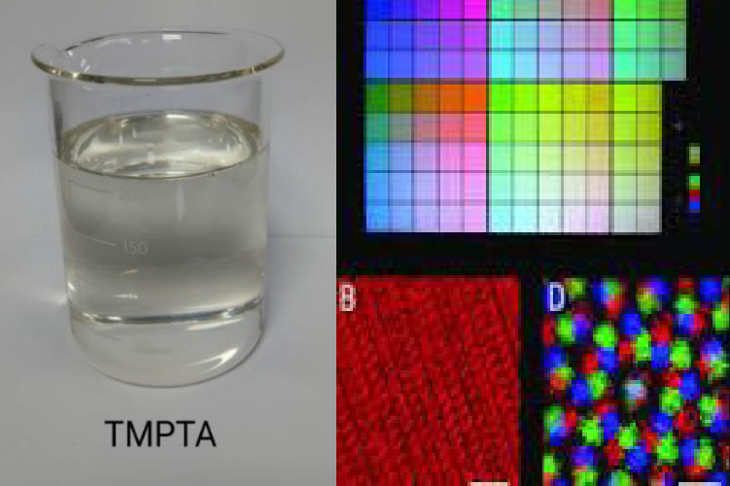
Trimethylolpropane Tri acrylate is a low viscosity trifunctional monomer used as a reactive diluent as well as crosslinking agent in UV, EB and LED curable inks coatings. The development of TMPTA is a backward integration of resins and monomers used in radiation curable products.

Characteristics: -
Low viscosity, light colour, good cure response, high crosslinking density, good solvent and abrasion resistance etc.
Cured films containing TMPTA provide hardness, good solvent and abrasion resistance and high gloss properties.

TMPTA Monomer UV curable inks

Application: - TMPTA is a cost-effective diluent compatible with the wide range of acrylated resins used in radiation curing application. Its ability to enhance reactivity, hardness, gloss and chemical and wear resistance properties. TMPTA is used for making inks like offset, flexo and screen printing. It is also used as coating like metal, glass, plastic, PVC floor, wood and paper coating. Also used as crosslinking agent for free radical polymerization and co-agent for peroxide curing system.

RADCURE

FLEXGREEN LMLO Gloss Coating (NY)
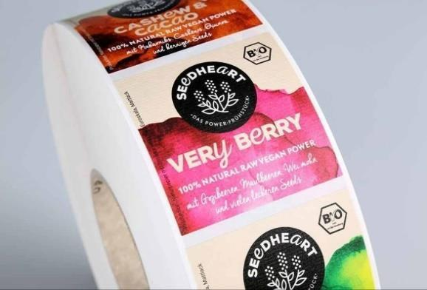
Flexgreen NW UV-LED curable Nestle compliance Low Migration and Low Odour (LMLO) coating especially designed for Nestle compliance sensitive packaging application that required no VoC & LMLO features for printing and packaging industry for food-grade application.

This represents a safe and eco-friendly solution which shows our commitment towards safe packaging for food application and reducing carbon emission by developing low energy curable greener products which will make the significant impact by safe packaging & eliminating Ozone / heat liberation.
This is an innovative & environment friendly solution for safe food packaging. Salient Features:
    - Nestle & Swiss Compliant
    - Low Migration & Low Odour
    - Non-Yellowing feature after curing with LED lamps 385 and 395 nm
    - High Gloss aesthetic
    - Good adhesion properties
    - Very good Flexibilities
    - Very good duct/tray stability during application
    - Suitable for in-direct food application

FLEXCURE SCREEN GLOW-IN-DARK (GID) INKS
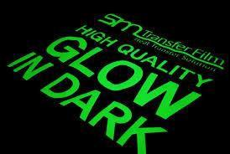
Flexcure Screen Glow-in-the-Dark(phosphorescent) is a plastisol screen printing ink that produces a bright, greenish glow when exposed to light and viewed in a darken area.
This ink is a radiation curable which is especially designed to work with Screen printing or cold peel transfer application with creating luminescent effects in safety signage, packaging, and novelty items.
This ink is especially designed to work on paper & board substrates having excellent glow and printing proprieties.
Salient Features:
    - Brilliant glow in the dark
    - Excellent phosphorescent effect
    - Very good curing capabilities
    - Good printability compatibility with the substrates
    - Good mesh stability

Inks R&D

CI FLEXTONE PE EXTRUSION INK
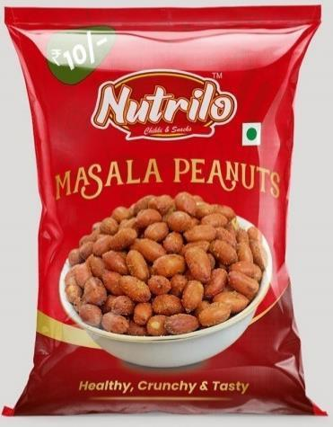
CI FLEXTONE Ink is developed for High Performance CI FLEXO Printing Machine upto 500m/min for PE Extrusion Lamination with High Bond Strength.
This Ink series mainly used for indirect Food and Snack (FMCG) Packaging, Other Flexible Packaging Structure like Detergent, Carry Bag Etc.
This Product gives High HR, High Extrusion Bond Value along with high solvent release for faster printing drying.

This is an innovative & Cost-effective solution engineered to withstand the thermal stress of the extrusion process without losing adhesion or changing color.
Salient Features:
- Excellent Printability
- Adhesion on CCPET, CT PET, BOPP, PE substrate
- Low Migration
- High Extrusion bond Strength
- Suitable for in-direct food application
- Suitable to running speed up to 200-500 m/min

Engineering

Next Generation of High Speed HFFS
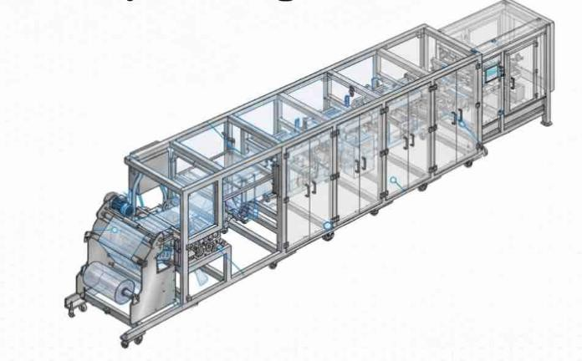
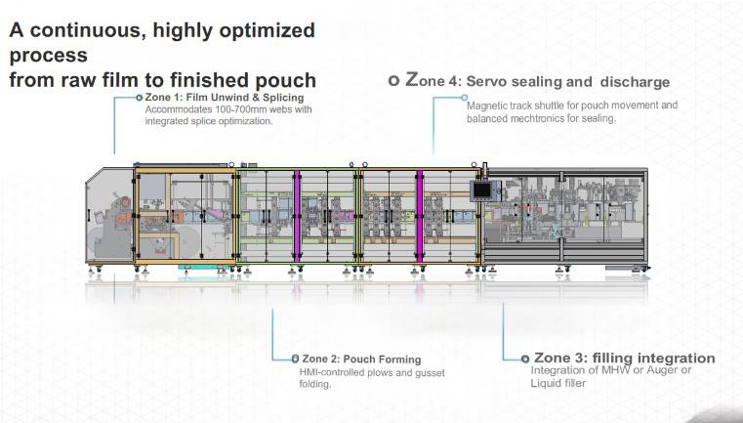

The UF200 has been designed to meet the specific needs of consumer-packaged goods companies in the food and home/ personal care markets.
This new generation machine balances high line-speed with a small footprint and brings the flexibility of being able to process laminate and with ease to offer quick and repeatable changeovers.

New levels of efficiency have been achieved to deliver minimal total cost-of-ownership.

Clean by Design
- Open space frame structure allows easy access for cleaning
- No hollow structure- Either solid or seam welded structural tubes as part of clean design

Chainless Magnetic Track Technology

- Chain less mechanism – reduced wear and tear
- Infinite flexibility for on screen changeover procedure
- Easy to clean system – Easy removal and cleaning process
- High speed motion possibility for improved productivity
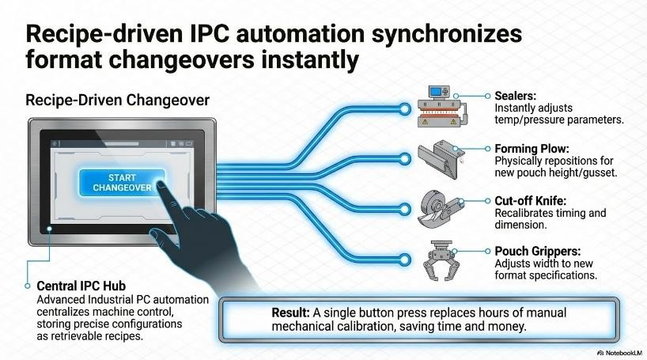

Packaging Films business
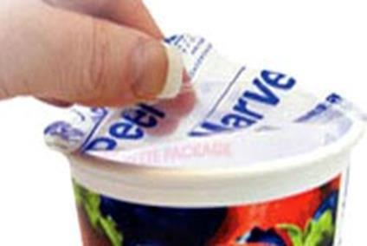
  - F-TPM – Sealable Peelable Metallised Polyester Film This is a Metallised Coated Polyester film with Antifog properties which have special Functional layer to provide good sealing strength to avoid leakage, This Film is best suited for lidding application with A-PET, R-PET, PVC, PP & PS. The other side of the film is available for printing.
Single-layer metallized film can be an excellent packaging solution for dairy products, offering:
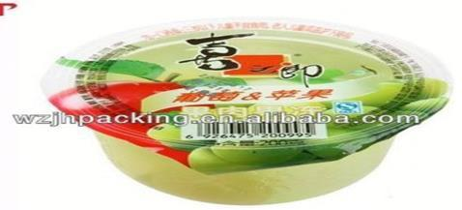
- Barrier properties: Protecting against moisture, oxygen, and light.
- Extended shelf life: Preserving freshness and quality.
- Cost-effective: Compared to traditional laminate films. Some potential dairy products that can benefit from single-layer metallized film packaging include Milk, Yogurt, Cheese, Butter
.

Special Properties:

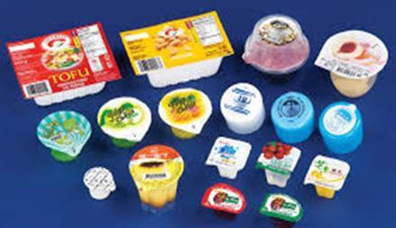
- High Oxygen Barrier (OTR. 0.5 cc/m2/day and WVTR - 0.5 gm/ m2 /day)
- Heat seal strength – 500 gm/25mm
- Good Optics
- Good seal integrity

End Use Application:
- Lidding Food packaging application
- Yoghurt, Fresh vegetable, tablet pack of butter, Water packed in Glass, Packed juice in cup, Jelly Pudding, VAT application (bottle Lid)

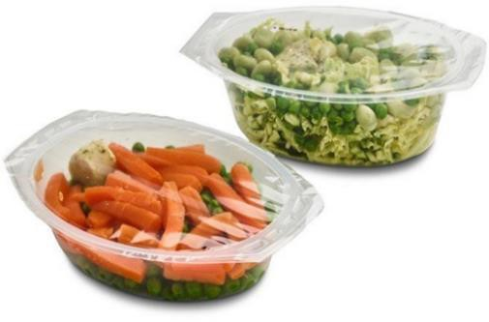
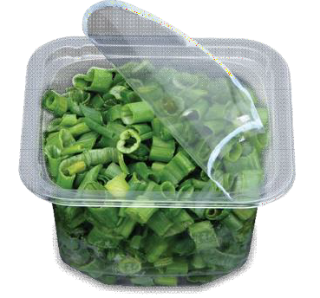
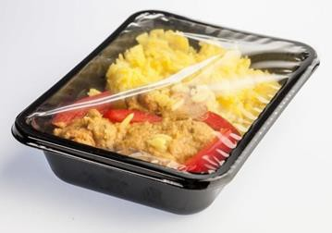
  - F-WSP: Easy Peel Polyester Film

Easy Peel polyester film for A-PET, C-PET, G-PET and PVC. It is having water based The coating can be employed on the surface of BOPP, BOPET films, in which can be achieved antifog with excellent sealable but on CPP films antifog and peel able can be achieved from the coating chemicals.

Special Properties:
    - Seal Peel polyester film with water base coating- a Sustainable approach against solvent base coated product.
    - Optical property - High Clear Peelable lid with 4.5% haze (25 micron) against conventional 10-12% Haze product.
    - Anti-fog property - Instant cold and hot anti-fog property.
    - Substrate - The product is suitable for A-PET/G-PET and C-PET and PVC substrate for lidding
    - Peel Strength- 800 gm/inch for A-PET/G-PET and C-PET and
>1000 gm/inch for PVC substrate

Sealing condition
      - Temperature Range 110- 180°C, Pressure- 40 PSI, D well time 1 sec (One side temperature)

Surface property
      - The coated surface is specially designed to prevent blocking A-B side, Excellent run-ability.

Storage and transportation
      - Store at 25°C, transportation – normal container against conventional products, which requires refrigeration container.

End Use Application:
    - Food Packaging (Lidding): These films are widely used for lidding in various food applications due to their ability to seal through contamination and provide a smooth, easy-open mechanism.
    - Ready-to-Eat/Ready-Meals: Used on CPET/APET trays for microwaveable or ovenable food, often with anti-fog properties for better visibility.

Packaging

Special grade PE for thermoforming film with good transparency for syringe
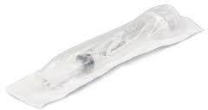
Customer Name: Polymed
Thermoforming 80µ PE Film with Special Grade Material

Customer Requirements
- Thermoforming-compatible film
- Sealable with medical-grade paper
- Resistant to puncture from syringe sharp corners
- High transparency

Solution Provided
- 80µ PE Film with Special Grade Material – Designed with a slippery inner surface to prevent puncture from syringe corner
- Thermoforming Compatibility – Ensures smooth forming and reliable sealing with medical-grade paper
- Enhanced Transparency – Special additives to improve clarity for better product visibility

APET-Based Dip Cup Laminate with Barrier Film and Special Peelable Lid
Dip Cup Bottom
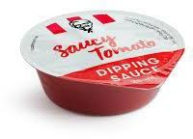
The bottom tray is made with 400µ APET and 50µ EVOH PE, which provides:
- Rigidity – Ensures structural strength and durability.
- High Transparency – Offers clear product visibility.
- Barrier Protection – Extends shelf life and preserves aroma.
- Premium Appearance – Enhances product presentation.

Dip Cup Top

The top film is constructed with 10µ PET + 10µ MET PET + 60µ Topil-based peelable film, designed to deliver:
  - Barrier Performance – MET PET layer ensures protection against moisture and oxygen.
  - Easy Peel Functionality – Prevents spillage and enhances consumer convenience.
  - Customer Delight – Smooth opening even when hands are slippery during eating.
  - Attractive Printing – The PET layer allows high-quality, eye-catching graphics.

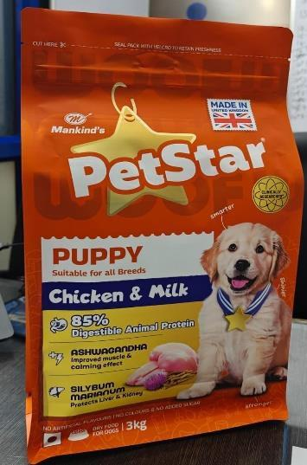
Hook and Loop (Velcro) Zipper 3D pouch for Pet food
Customer Requirements
- Attractive appearance
- 3D pouch for standability and premium appeal
- Easy to open and close
- Strong barrier to retain freshness

Solution Provided
- Matte and gloss printing for enhanced visual appeal
- 3D pouch with special printing effects and Velcro zipper to elevate premium quality
- Velcro zipper ensures ease of opening and closing, while protecting
against dust and pests, maintaining the product’s barrier properties

Holography

Upgrade & Renovation – Advanced Security Coupon Solution

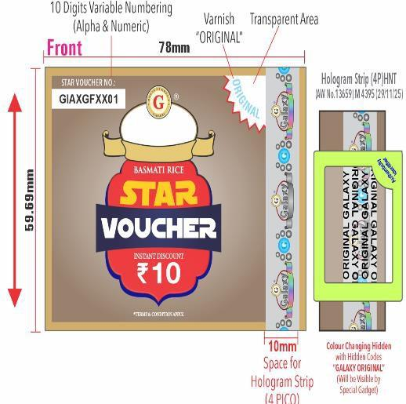
As part of its continuous innovation and product upgradation strategy, the Holography Division introduced an advanced generation of security coupons designed primarily for loyalty and incentive programmes across the trade ecosystem. These coupons are extensively used by the chewing tobacco industry for rewarding retailers, dealers, and distribution partners through redeemable points linked to cash or prize benefits.

The conventional paper-based coupon system faced significant operational and security challenges. Since the coupons pass through multiple levels of handling before final redemption, they often return in mutilated or poor physical condition, making authentication difficult and increasing the risk of duplication and misuse.
To address these challenges, the Division developed a next-generation filmic-based security coupon integrated with upgraded holographic security features, QR code authentication, and variable numbering technology. The new solution offers enhanced durability, superior counterfeit resistance, and improved traceability throughout the redemption cycle, thereby strengthening brand protection and programme reliability.

While the product was initially targeted at the chewing tobacco segment, the enhanced technology platform enabled the Division to successfully expand into new industry verticals including cables & wires, rice, and paints, thereby opening new avenues for growth and diversification.

Introduced in Q4, the product witnessed strong market acceptance with sales reaching approximately 90
lakh coupons, contributing revenue of around ₹1.65 Crore during the year.

Dual Registered Hologram – Next Generation Security Enhancement

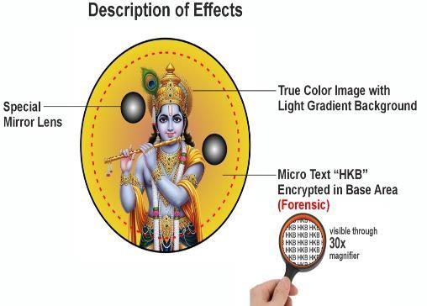
The security packaging industry operates in an environment where continuous innovation is critical, as counterfeiters constantly attempt to replicate existing technologies. In line with its commitment to staying ahead of duplication threats, the Holography Division introduced a highly advanced “Dual Registered Hologram” technology during Q4.


This industry-first innovation incorporates a unique dual registered stamping process that significantly enhances the complexity and security integrity of holographic applications. The technology creates an additional layer of authentication precision, making replication substantially more difficult and thereby strengthening protection against counterfeiting.

The solution has been strategically introduced in the bidi industry, a highly unorganised and counterfeit-prone market segment where brand protection remains a major concern for manufacturers. The innovative holographic security feature provides customers with enhanced assurance of product authenticity while helping brands safeguard market credibility and consumer trust. Sales in Q4 for this product was to the tune of Rs 12 lacs. This has future regular business requirements.
The introduction of this advanced technology further reinforces the Division’s focus on innovation-led growth, customer-centric security solutions, and leadership in the anti-counterfeiting and authentication segment.

Printing Cylinder

Laser Engraving Machine
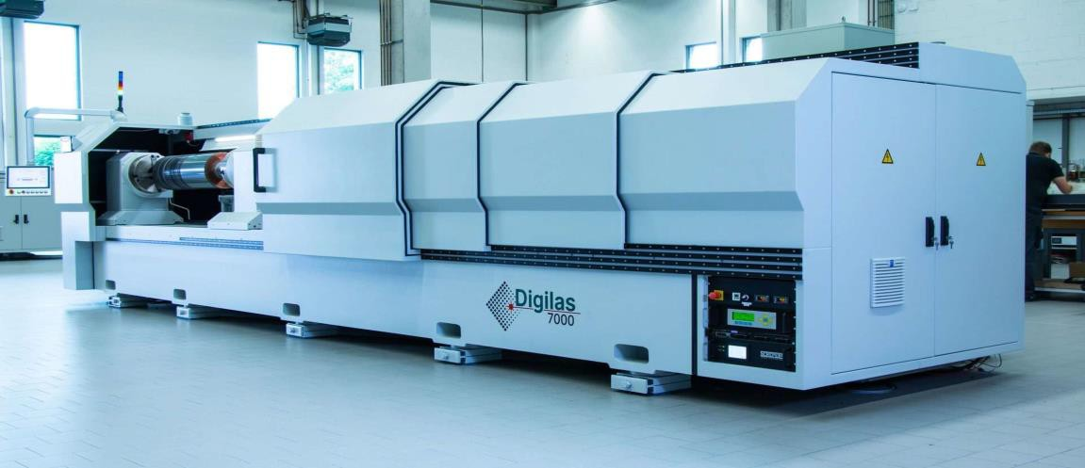

Woven Starburst Pattern achieved on original leather through specialized laser engraving
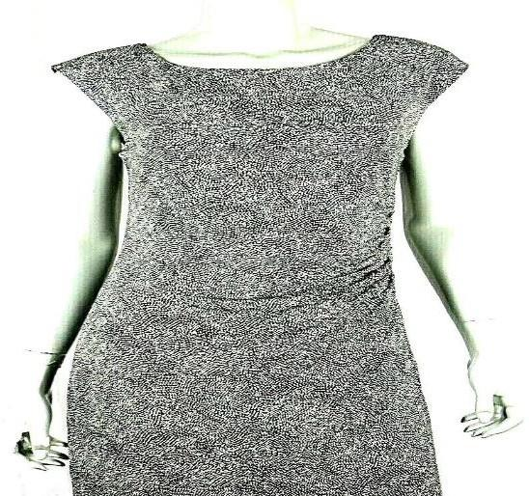
This is an elegant and sophisticated design, featuring a "Woven Starburst" pattern through specialized Laser engraving process on Orignal Leather. The pattern is a hypnotic tessellation of concentric, undulating circles that form interwoven spirals. Its monochromatic palette emphasizes a dynamic, three-dimensional texture, creating a high-end aesthetic. This versatile pattern is suitable for luxury apparel like dresses and jackets, as well as for accessories such as handbags, footwear, and belts. Its durable nature also makes it ideal for modern upholstery and interior decor

Application
    - Fashion: A popular choice for luxury apparel, including blazers and skirts, adding a chic touch
    - Accessories: Featured in high-end bags, footwear, belts, and small accessories, it symbolizes affluence and craftsmanship
    - Interior G Automotive: The pattern's durability makes it an ideal choice for modern upholstery, premium car interiors, and other decor, creating an exclusive and luxurious feel

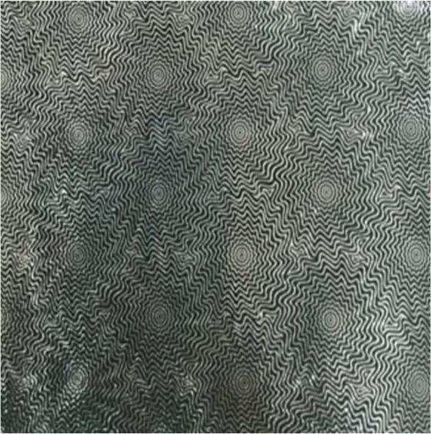
Business Advantage
    - Precision and Quality: Specialised laser-engraved cylinders ensure consistent, high-quality patterns, making the fabric more appealing to luxury brands.
    - Customization Capabilities: Laser technology allows for detailed and bespoke pattern creation, offering unique designs to fashion houses.
    - Revenue: It has helped our total revenue grow by another 0.25%.
    - Scalability: Specialized laser engraving offers efficient production, enabling large-scale manufacturing without compromising on the intricate detailing.
    - Market Differentiation: Exclusive access to advanced laser engraving techniques helps the provider stand out from competitors in the luxury fabric market.

Pebble Stone Pattern achieved on Artificial Leather through Laser Embossing


The design features a tactile, interlocking grid of small, square-shaped blocks with rounded edges. These blocks resemble river pebbles’ stones, creating a "woven" effect where they appear to pass over and under each other. This textured, organic pattern is commonly used for non-slip surfaces, flooring, or as a decorative element on materials like plastic, rubber, or leather

Application
    - Footwear: Enhances grip on shoe soles and adds a distinctive look to the outer material of shoes and sandals.
    - Automotive Interiors: Improves grip and durability on car floor mats, dashboards, and steering wheel covers.

    - Handbags & Accessories: Provides an elegant, high-end finish to items like handbags, wallets, and belts.
    - Flooring: Serves as an anti-slip or decorative texture for mats and various types of flooring.
    - Consumer Electronics: Offers better grip and scratch protection on phone cases and other accessories.
    - Packaging: Conveys a sense of luxury and quality on high-end product boxes and labels.
    - Furniture: Used for decorative upholstery or as a detail on furniture surfaces.

Business Advantage
    - Precision and Quality: Our specialized laser-embossed cylinders ensure a consistently high-quality pebble stone pattern, elevating the material's appeal to luxury brands.
    - Customization Capabilities: Laser technology enables the creation of detailed and bespoke pebble stone patterns, offering unique designs to discerning clients and designers.
    - Revenue: This advanced process has contributed to our total revenue, helping it grow by an additional 0.20%.
    - Scalability: The specialized laser embossing process allows for efficient, large-scale manufacturing of the intricate pebble stone designs without sacrificing quality.
    - Market Differentiation: Having exclusive access to this advanced laser embossing technique sets us apart from competitors in the luxury market, particularly for our exquisite pebble stone designs.


  - Aluminum Composite Panels through Laser Engraved Rollers Various effects like wood, cloud, flower and marble etc. are created on aluminium sheets using Laser Engraved Rollers to manufacture Aluminium Composite Panels (ACPs). ACP comprises of two aluminium sheets bonded to a polyethylene (PE) or fire-retardant (FR) core, coated with PVDF or polyester paint for durability and color retention. This sandwich structure ensures strength, rigidity, and a smooth finish.

Application


    - ACP is a versatile material widely used in architecture, interiors, signage, and metro or lift décor. It is known for effective thermal and sound insulation, weather and corrosion resistance, cost-effectiveness, light weight, and durability.
    - ACP offers an attractive alternative to conventional materials like concrete, paint, and solid aluminium sheets.
    - ACPs have become a cornerstone of modern architecture, blending aesthetics with sustainability.

Business Advantages
    - Precision and Quality: Our specialized laser-engraved rollers produce consistently high-quality wood, cloud, flower, and marble patterns, enhancing the appeal and demand for Aluminium Composite Panels

across construction, home décor, architecture, interiors, signage, and metro or lift wall applications.
    - Customization Capabilities: Laser technology enables the creation of various patterns on ACPs, offering unique designs to various industries.
    - Revenue: This advanced process has contributed to our total revenue, helping it grow by an additional 0.25%. With technological advancements and local roller manufacturing, production is set for strong growth in India and the UAE markets.
    - Scalability: The specialised laser-engraving process allows for efficient, large-scale manufacturing of ACPs through specialized laser-engraved rollers.
    - Market Differentiation: Having exclusive access to this advanced laser engraving technique, sets us apart from competitors in the ACP market, particularly for our various special designs.
    - Earlier, customers used to import these costly rollers from China with long lead times. We have now entered this market and secured orders from India and the UAE, where demand for Aluminium Composite Panels is rising. exponentially.
Further Coating rollers are used to create wooden pattern on Aluminium sheets to manufacture Aluminium Composite Panels (ACP) which are widely used in out of home properties, home décor, metro and lift wall decorations etc. Currently, customers are buying these rollers at premium price from China. However, we have entered the market with these rollers and are able to get orders from customers within India and outside India.

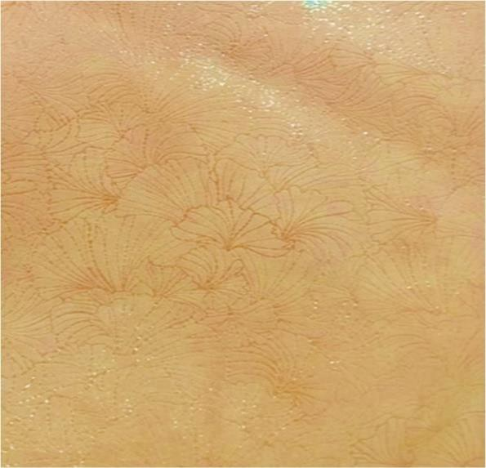
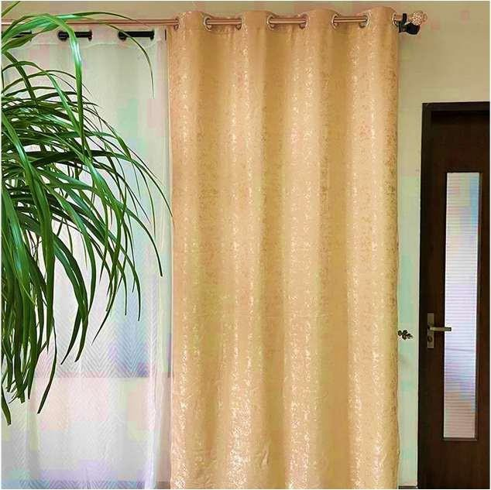
Ginkgo leaves pattern achieved on original leather through specialized laser engraving

The pattern is composed of overlapping, fan-shaped motifs resembling ginkgo leaves. These motifs are created with fine, radiating lines on a light, neutral base, possibly off-white or beige. The lines are slightly darker, contrasting shade, like pale gold. A key feature is the glossy finish with a shimmering effect, which adds a luxurious feel. The overall style is elegant, decorative, and contemporary.

Application
This design is commonly used for a variety of applications due to its versatile and sophisticated aesthetic. Some of the most probable uses include:
    - Wallpaper for adding a subtle yet luxurious touch to interior spaces.
    - Fabric for upholstery, curtains, or other textiles.
    - Decorative panelling for a high-end finish on walls or furniture.
    - Stationery for a premium, decorative pattern on special items.

Business Advantage
    - Precision and Quality: Our specialized laser-engraved cylinders ensure a consistently high-quality ginkgo leaf pattern, elevating the fabric's appeal to luxury brands.
    - Customization Capabilities: Laser technology enables the creation of detailed and bespoke ginkgo leaf patterns, offering unique designs to discerning fashion houses.
    - Revenue: This advanced process has contributed to our total revenue, helping us to grow by an additional 0.25%
    - Scalability: The specialized laser engraving process allows for efficient, large-scale manufacturing of the intricate ginkgo leaf designs without sacrificing quality.
    - Market Differentiation: Having exclusive access to this advanced laser engraving technique sets us apart from competitors in the luxury fabric market, particularly for our exquisite ginkgo leaf designs

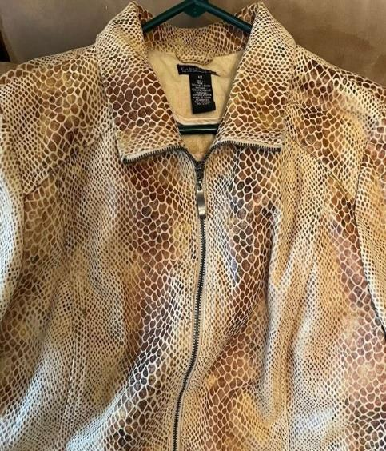
Golden Python Glaze Pattern Achieved on Original Leather Through Specialized Laser Engraving
This sophisticated design is an engraved, glossy golden python skin imitation. The faux snakeskin features a luxurious, three-dimensional texture with raised, interlocking scales in a light yellow-gold. Its high-gloss finish creates a striking, wet-look appearance, making it a popular choice for high-end fashion and home décor

Application
    - Fashion Industry: Used in high-fashion garments like blazers and skirts, adding a chic, luxurious touch to wardrobes.
    - Footwear: Common in high-end shoes, boots, and heels, symbolizing affluence and craftsmanship.
    - Purses and Handbags: Featured in designer bags from luxury brands like Hermes and Gucci for added prestige.
    - Accessories: Applied in belts, wallets, and phone cases for a premium, refined look.
    - HomeDécor G Automotive: Used in furniture upholstery and premium car interiors for an exclusive, luxurious feel

Business Advantage
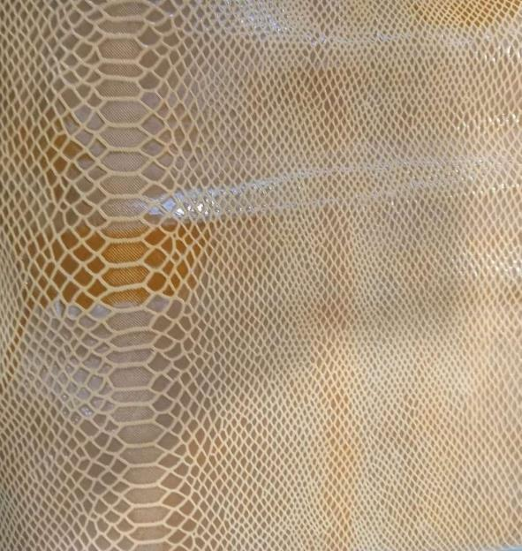
    - Precision and Quality: Laser-engraved cylinders ensure consistent, high-quality patterns, making the fabric more appealing to luxury brands.
    - Customization Capabilities: Laser technology allows for detailed and bespoke pattern creation, offering unique designs to fashion houses.
    - Revenue: It has helped our total revenue grow by another 0.30%.
    - Scalability: Laser engraving offers efficient production, enabling large-scale manufacturing without compromising on the intricate detailing.

Cruelty-Free Golden Python Glaze Replication on Original Leather
    - Exclusive access to advanced laser engraving techniques helps the provider stand out from competitors in the luxury fabric market.

Awards and Accreditations
- 3 Products for UFlex Packaging films awarded by National Award with Global Recognition by SIES SOP STAR AWARDS 2025- SIES School of Packaging, Mumbai for excellence in Packaging in Packaging Materials & Components category-

  - C-CGB-M - Outstanding barrier metallized CPP film with water-based coating for flexible packaging applications
  - F-HAS - High seal strength in polyester film with antifog properties for Lidding as food packaging applications.
  - B-THU-M - Outstanding barrier and robust-seal metallized BOPP film for milk powder, tea, and coffee packaging applications.
- In the financial year 2025-26, we received 3 SIES SOP & 4 IFCA Awards:

SIES SOP Awards

  - Pebble stone pattern on artificial leather through laser-embossed cylinders
  - Ginkgo Leaves pattern on original leather through specialized laser engraving
  - Aluminum composite panels through laser-engraved rollers

IFCA Awards
- Ginkgo leaves pattern on original leather through specialized laser-engraving cylinders
- Golden python glaze pattern on original leather through specialized laser-engraving cylinders
- Pebble stone pattern on artificial leather through laser-embossed cylinders
- Woven starburst pattern on original leather through specialized laser-engraving cylinders

Footnotes:

This Earnings Release contains consolidated audited results that are prepared as per Indian Accounting Standards (Ind-AS).
# Total sales volume excludes virgin PET chips sales volumes.

*Q4 FY26, the Normalized EBITDA stood at Rs. 6,109 million, with a corresponding normalized EBITDA margin of 14.9%. The normalized EBITDA was derived with adjustments of Rs 156 million due to the impact of foreign currency gains/(losses) in derivative instruments. FY26, Normalized EBITDA was at Rs. 19,097 million and similar adjustment was Rs. 739 million.
The calculated Normalized EBITDA margin is determined by dividing the Normalized EBITDA by the total revenues.

** Normalized PAT excludes exceptional currency devaluation and new labour law impact: Rs. 66 million in Q4 FY26 vs Rs. 125 million in Q3 FY26 and Rs. 700 million losses in Q4 FY25. Similarly, Rs. 191 million in FY26 vs. Rs. 1,778 million in FY25. One-time employee benefit provisions of Rs 125 million and Rs 66 million were recognized as exceptional items in Q3 and Q4 FY26.

***The average USD/INR exchange rate was Rs. 91.71 in Q4 FY26, Rs. 89.18 in Q3 FY26, Rs. 87.52 in Q2 FY26, Rs. 85.37 in Q1 FY26.
##NAFTA: North American Free Trade Agreement

Caution Concerning Forward-Looking Statements:

This document includes certain forward-looking statements. Such forward-looking statements involve known and unknown risks, uncertainties and other factors which may cause UFlex’s actual results, performance or achievements, or industry results, to be materially different from any future results, performance or achievements expressed or implied by such forward-looking statements. Such forward-looking statements are based on numerous assumptions regarding UFlex’s present & future business strategies and the environment in which UFlex Limited will operate in the future. Among the important factors that could cause UFlex’s actual results, performance or achievements to differ materially from those in the forward-looking statements include, among others, the condition of and changes in India’s political and economic status, government policies, applicable laws, the Indian packaging sectors, and international and domestic events having a bearing on UFlex’s business, particularly in regard to the progress of changes in sectors’ regulatory regimes, and such other factors beyond UFlex’s control. UFlex Limited is under no obligation to and expressly disclaims any such obligation to, update or alter its forward-looking statements, whether as a result of new information, future events, or otherwise.

About UFlex Limited:
UFlex is India’s largest multinational flexible packaging and solutions company. Since its inception in 1985, UFlex has grown from strength to strength and has built a strong presence across all verticals of the packaging value chain — packaging films, chemicals, aseptic liquid packaging, holography, flexible packaging, printing cylinders, and engineering.

With a 12,000+ strong multicultural workforce across global regions that work toward developing innovative, value-added, and sustainable packaging solutions, the company has earned an irreproachable reputation for defining the contours of the ‘Packaging Industry’ in India and overseas. It provides end-to-end solutions to numerous Fortune 500 clients across various sectors such as FMCG, consumer product goods, pharmaceuticals, building materials, automobiles, and more, in more than 150 countries. Headquartered in Noida, the National Capital Region, India, UFlex enjoys a global reach with advanced manufacturing facilities in India, UAE, Mexico, Egypt, USA, Poland, CIS, Nigeria, and Hungary.

A winner of various marquee global awards for product excellence, innovation, and sustainability, UFlex is the first company in the world to earn recognition at the Davos Recycle Forum in 1995 for conceptualizing the recycling of mixed plastic waste. For more details, please visit: www.UFlexltd.com

