PRESS RELEASE

Mondi strengthens corrugated solutions operations in Germany through targeted site upgrades

- Targeted upgrades at the Greven and Ebersdorf plants enhance efficiency, quality and customer service.
- Operational improvements, including process optimisation and pallet-free production, strengthen long-term competitiveness.
- Raised health and safety standards support employee wellbeing and stable operations.

1 June 2026 – Mondi, a global leader in sustainable packaging and paper, is strengthening its corrugated solutions operations in Germany through targeted upgrades at its plants in Greven, North Rhine-Westphalia, and Ebersdorf near Coburg, Bavaria. The measures focus on enhancing operational performance, aligning both sites with Mondi’s global safety standards and reinforcing their long-term competitiveness, while creating added value for customers and employees.

At both sites, Mondi has implemented production-related upgrades aimed at improving efficiency, quality and reliability. These include enhancements to existing production equipment and the optimisation of internal processes. At the Ebersdorf plant, the continued development of pallet-free production plays a key role, reducing handling steps, improving product quality consistency and supporting more resource-efficient operations. In Greven, increased automation further stabilises processes, reduces waste and strengthens overall product quality. In addition, Mondi has established a dedicated onsite sales team at the Greven plant, enabling closer customer collaboration, faster response times and more tailored packaging solutions.

Health and safety remains a clear priority at both locations. Mondi has aligned safety standards at the Greven and Ebersdorf plants with its global benchmarks through improvements to the working environment and dedicated safety training programmes. These measures reinforce safety as a fundamental part of daily operations and contribute to stable, reliable performance.

“Together, the upgrades at Greven and Ebersdorf strengthen our ability to deliver consistently high product quality, reliable delivery performance and more sustainable production processes for our customers. At the same time, they reinforce Mondi’s corrugated solutions footprint in Germany and support long-term, reliable partnerships with our customers,” says Paulus Goëss, COO Corrugated Solutions at Mondi.

Mondi has integrated the Greven and Ebersdorf plants following the acquisition of Schumacher Packaging´s Western European assets, strengthening its footprint in Germany. Since the acquisition, Mondi has systematically embedded its operational excellence approach and global health and safety standards across both plants, further enhancing performance, consistency and reliability while unlocking additional potential for long-term value creation.

/ends

About Mondi
Mondi is a global leader in packaging and paper, contributing to a better world by producing products that are sustainable by design. We employ 24,000 people in more than 30 countries and operate an integrated business with expertise spanning the entire value chain, enabling us to offer our customers a broad range of innovative solutions for consumer and industrial end-use applications. Sustainability is at the centre of our strategy, with our ambitious commitments to 2030 focused on circular driven solutions, created by empowered people, taking action on climate.

In 2025, Mondi had revenues of €7.7 billion and underlying EBITDA of €1.0 billion. Mondi is listed on the London Stock Exchange in the ESCC category (MNDI), where the Group is a FTSE100 constituent. It also has a secondary listing on the JSE Limited (MNP).

www.mondigroup.com

Contact:
Anika Köstinger
Senior Communication Manager, Mondi
anika.koestinger@mondigroup.com

Kim Lommaert
EMG
Tel: +31 164 317 021
Email: klommaert@emg-marcom.com

Photos:
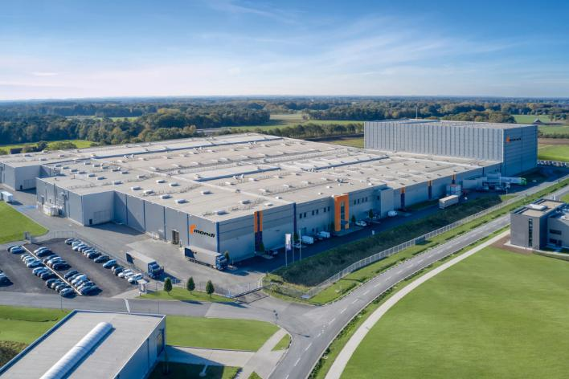

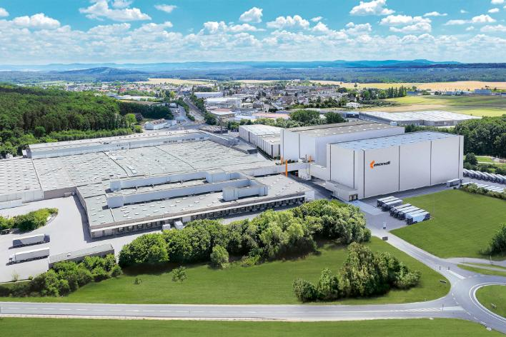

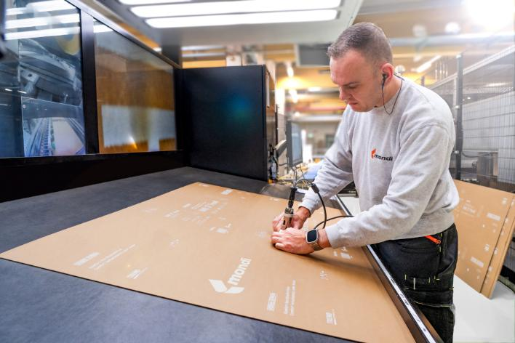

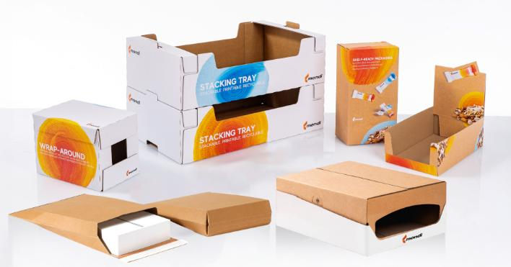
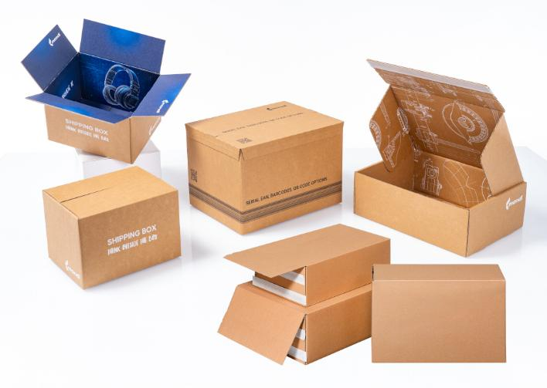
Mondi strengthens corrugated solutions operations in Germany through targeted site upgrades. (Photos: Mondi, PR371)

This press release and relevant photography can be downloaded from
www.PressReleaseFinder.com.
Alternatively for very high resolution pictures please contact Kim Lommaert (klommaert@emg-marcom.com, +31 164 317 021).

