PRESS RELEASE

Mondi expands paper bags business in Southeast Asia through new joint venture

- Joint venture with Indocement strengthens Mondi's paper bags footprint in a structurally growing Southeast Asian market.
- Establishes a majority-owned local paper bags production platform, with long-term anchor customer Indocement.
- Combines strong local market presence with Mondi's global operational and safety standards.

16 April 2026 – Mondi, a global leader in sustainable packaging and paper, is expanding its paper bags business in Southeast Asia through a joint venture with PT Indocement Tunggal Prakarsa Tbk (“Indocement”), one of the largest cement producers in Indonesia.

The joint venture, PT Mondi Indo Prakarsa Kemasan, will be located at Indocement’s CementFactory Complex in Citeureup, West Java, Indonesia and will initially produce paper bags for Indocement, serving the growing local market demand for paper bags in Southeast Asia. Mondi will own a 60% stake, with Indocement owning the remaining 40%. Indocement will act as the anchor customer of the joint venture, providing long-term volume stability.

Southeast Asia is characterised by sustained construction demand, making it an attractive long-term growth market for paper bags. The joint venture reflects Mondi’s strategy to expand its paper bags footprint and build scalable platforms in structurally growing markets such as Southeast Asia, where market fundaments remain attractive. Through this new joint venture, Mondi establishes a majority-owned local production platform in Indonesia, strengthening its regional presence while benefiting from Indocement’s strong local market position and customer base.

“This joint venture is an excellent strategic fit for our paper bags business. It allows us to establish a strong local platform in a structurally growing market, underpinned by a reliable long-term customer. At the same time, it provides a clear pathway for scalable growth while applying Mondi’s high standards in operational excellence, safety and quality,” says Claudio Fedalto, Chief Operating Officer Paper Bags at Mondi.

Co-location at the Citeureup Cement Factory Complex enables close operational integration, efficiency gains and reliable execution. Mondi will install an additional paper bags production line alongside the existing one to further support efficient operations and create a strong base to expand activities in Southeast Asia adding over 200 million paper bags to Mondi’s global production footprint. The joint venture is expected to be operational towards the end of 2026, subject to the completion of all commercial, operational and legal preparations.

/ends

About Mondi
Mondi is a global leader in packaging and paper, contributing to a better world by producing products that are sustainable by design. We employ 24,000 people in more than 30 countries and operate an integrated business with expertise spanning the entire value chain, enabling us to offer our customers a broad range of innovative solutions for consumer and industrial end-use applications. Sustainability is at the centre of our strategy, with our ambitious commitments to 2030 focused on circular driven solutions, created by empowered people, taking action on climate.

In 2025, Mondi had revenues of €7.7 billion and underlying EBITDA of €1.0 billion. Mondi is listed on the London Stock Exchange in the ESCC category (MNDI), where the Group is a FTSE100 constituent. It also has a secondary listing on the JSE Limited (MNP).

www.mondigroup.com

About Indocement
PT Indocement Tunggal Prakarsa Tbk. (“Indocement”) is one of the largest cement producers in Indonesia, manufacturing well-known brands such as Semen Tiga Roda, Semen Rajawali, Mortar Tiga Roda, and Semen Grobogan. Indocement and its subsidiaries are engaged in several business lines, including the production and sale of cement (as its core business), ready-mix concrete, and the mining of aggregates and trass, with approximately 4,100 employees.

Indocement operates 14 owned plants, as well as two plants and one grinding mill under lease arrangements, with a total annual production capacity of 33.5 million tons of cement. Ten plants are located at the Citeureup Plant Complex in Bogor, West Java; two plants at the Cirebon Plant Complex in Cirebon, West Java; one plant at the Tarjun Plant Complex in Kotabaru, South Kalimantan; one plant in Grobogan, Central Java; two plants in Maros, South Sulawesi; and one grinding mill in Banyuwangi, East Java.

In 2022, Indocement commenced operations of the Maros plant following the signing of an asset lease agreement with PT Semen Bosowa Maros and PT Bosowa Corporindo. Heidelberg Materials AG has been the majority shareholder of Indocement since 2001.

Contact:
Anika Köstinger
Senior Communication Manager, Mondi Group
Tel: +43 664 41 62 546
Email: anika.koestinger@mondigroup.com

Kim Lommaert
EMG
Tel: +31 164 317 021
Email: klommaert@emg-marcom.com

Photos:
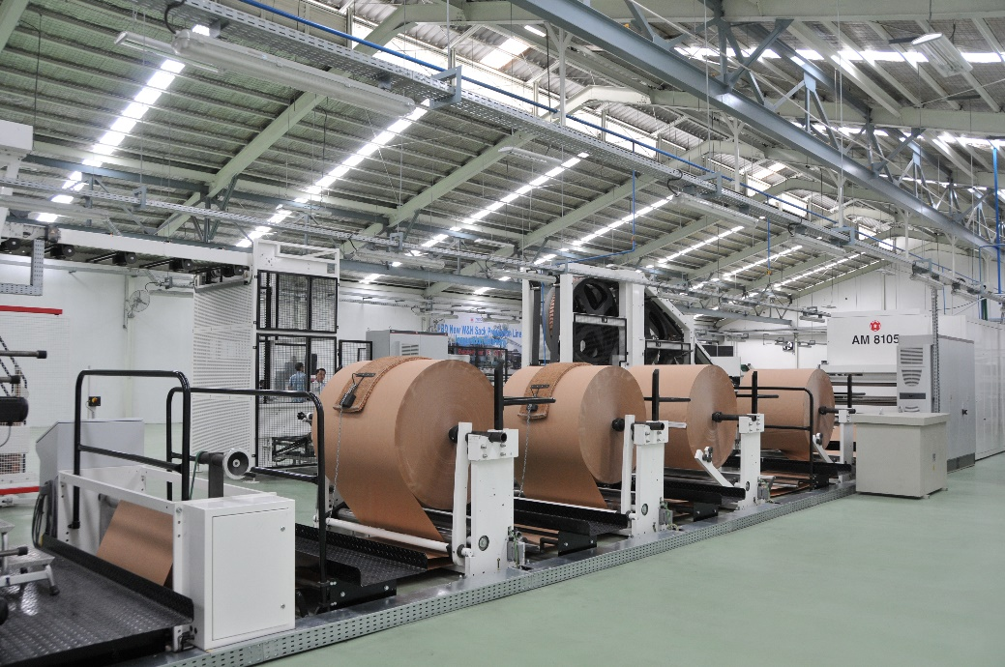
Mondi expands paper bags business in Southeast Asia through new joint venture.
(Photo: Mondi, PR361)

This press release and relevant photography can be downloaded from
www.PressReleaseFinder.com.
Alternatively for very high resolution pictures please contact Kim Lommaert (klommaert@emg-marcom.com, +31 164 317 021).

