
Editorial Contact: Ana Juraga ana.juraga@ecocortec.hr
Cortec® Europe Advertising Agency +385 91 270 5018

Company Contact: Ivana Radic Borsic iborsic@cortecvci.com
Cortec® Corporation: +385 1 48 54 486

Attention: Editor
January 29, 2026
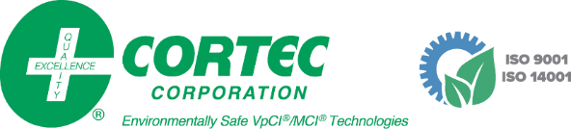
PRESS RELEASE

Solving the 2027 Recycled Content Mandate: How Cortec® is Closing the Loop on Plastic Waste

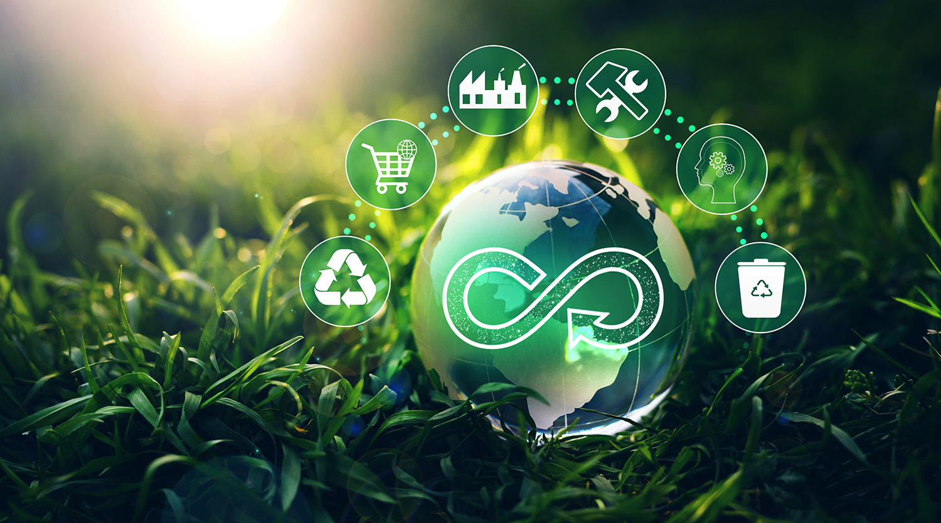
With India mandating 20% recycled content in flexible plastic packaging by 2027, and many other “circular economy” initiatives arising around the globe, it is more important than ever for manufacturers to have a plastic recycling strategy. Cortec® makes that process easier for users of anticorrosion packaging by offering a variety of traceable recycled content options and opening a profitable recycling waste stream to qualified customers.

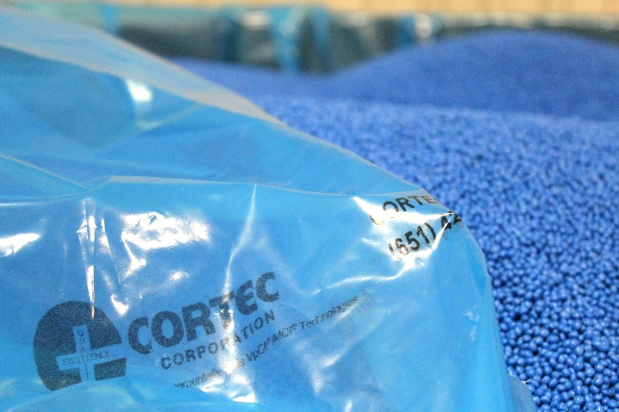
VCI Film with Recycled Content
Cortec® has been a leader in VCI (vapor corrosion inhibitor) film recycling options since the 1990s, when it patented the use of recycled resin in VCI film. Today, Cortec® makes VpCI®-126 with a minimum of 10% recycled content and custom variations of up to 30% PCR (post-consumer recycled content). This provides much needed, trackable options for international manufacturers like one who regularly ships metal components

to India and has already adopted 20% recycled content in all its VpCI®-126 films and bags.

Cortec® Recycling Opportunities

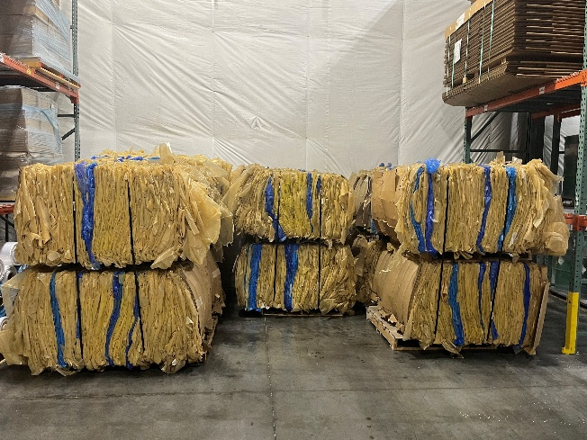
Another way Cortec® and its European sister facility EcoCortec® exhibit Extended Producer Responsibility (EPR) is by receiving clean used VpCI® films from qualified customer recycling partners and incorporating them into their recycled content stream, conducting rigorous testing to assure satisfactory film quality. In Europe, this recycling program has led to a sustainable packaging award for Jakob Schober, an EcoCortec® recycling partner who purchases VpCI® film with 30% PCR and sends unused scrap back to EcoCortec® for reprocessing. In the US, it resulted in the reclamation of 33,000 pounds (14,969 kg) of plastic for recycling from a chiller manufacturer. This reprocessing program is especially ideal for large organizations in certain regions that can request their suppliers to use VpCI® film, which, if clean and dry, can be sent back to Cortec® for recycling, providing corporations with a systematic approach to eliminating plastic waste.


Go ‘Circular’ with Cortec® Packaging
India’s mandate is just one example of evolving recycling standards around the world. Whether voluntarily or by mandate, manufacturers should be on the lookout for ways to reduce their plastic packaging footprint by making wise recycling choices. Contact Cortec® to learn more about recycled content and recycling options.

Keywords: recycling, circular economy, Cortec, India recycled content mandate, plastic recycling, VCI film with recycled content, Cortec recycling program, EcoCortec, recycling mandates, extended producer responsibility

Need a High-Resolution Photo? Visit: www.cortecadvertising.com.
Cortec® Corporation is the global leader in innovative, environmentally responsible VpCI® and MCI® corrosion control technologies for packaging, metalworking, construction, electronics, water treatment, oil & gas, and other industries. Our relentless dedication to sustainability, quality, service, and support is unmatched in the industry. Headquartered in St. Paul, Minnesota, Cortec® manufactures over 400 products distributed worldwide. ISO 9001:2015 and ISO 14001:2015 certified. Cortec® website: http://www.cortecvci.com. Phone: 1-800-426-7832. FAX: (651) 429-1122.

