Press Note

UFlex Unveils CERUFLEX 500 High-Speed Gravure Printing Machine at PLASTINDIA 2026
New Delhi, February 5, 2026: UFlex Limited, India’s largest multinational flexible packaging and solutions company, unveiled the CERUFLEX 500, its next-generation high-speed gravure printing machine, at PLASTINDIA 2026.
This machine has been developed through a collaboration between Gravtech Srl, Italy, and UFlex Limited, India. Gravtech designed a completely new and innovative rotogravure model, while UFlex built the machine by leveraging its engineering expertise and deep market understanding. Gravtech also drew upon the expertise of Dr. Giancarlo Cerutti and a technical team of mechanical and electronic engineers with long-standing and proven experience in the sector. This close collaboration between Italian design excellence and UFlex’s manufacturing capabilities offers the printing market a product that is better suited to the increasingly demanding needs of end users.
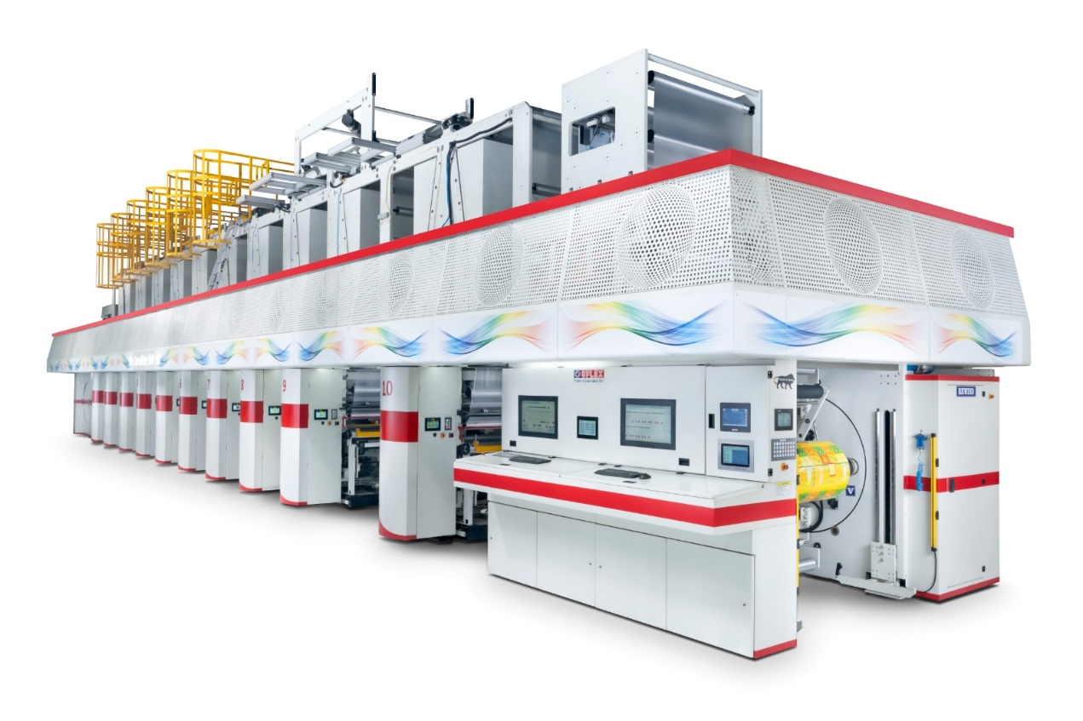
CERUFLEX 500 delivers printing speeds of up to 500 metres per minute. It features a shaftless cylinder system with chucking and a furnishing roller, ensuring accurate ink application and high print quality. The machine is equipped with a trolley-based system for faster job changeovers, allowing flexible swapping of printing cylinders and inking systems, along with semi-automatic operations that reduce downtime and free operators for critical tasks such as doctor blade setting and colour matching.

CERUFLEX 500 also offers automatic register alignment, advanced servo mechanisms for repeatability, and an intelligent inking system capable of handling a wide range of ink and solvent combinations without compromising speed or consistency, making it suitable for both short and long production runs.
Designed with sustainability at its core, the CERUFLEX 500 incorporates high-performance drying hoods to reduce thermal energy consumption, integrated viscosity control with cooling to minimise ink and solvent usage, and remote monitoring capabilities via mobile and tablet devices.
Commenting on the unveiling, a spokesperson from UFlex Limited said, “This innovation represents a significant milestone in UFlex’s engineering journey and underscores our long-term vision of building an intelligent, future-ready manufacturing ecosystem for the packaging industry. As converters face increasing pressure to deliver higher productivity, consistent quality, and lower environmental impact, we believe innovation must go beyond incremental improvements. This new machine has been developed by combining deep process expertise with advanced automation and smart controls, enabling customers to drive operational excellence, reduce waste, and align manufacturing performance with evolving sustainability and energy-efficiency expectations.”
“Our goal is to design a completely new rotogravure press capable of eliminating traditional bottlenecks in gravure printing,” added Dr. Giancarlo Cerutti, an industry veteran. “Its trolley system, auto-register, and smart inking deliver unmatched flexibility and waste reduction, making high-speed printing more accessible and sustainable for flexible packaging leaders worldwide.”
UFlex has an exclusive licence from Gravtech to build and sell this machine model (CERUFLEX 500) in India and other countries across the world, as per the agreements defined between the two companies.
Visit UFlex at B2, Hall 12, Bharat Mandapam, New Delhi, from February 5–10, 2026, to learn more about the machine and its capabilities.
For queries: corpcomm@uflexltd.com
About UFlex Limited:
UFlex is India’s largest multinational flexible packaging and solutions company. Since its inception in 1985, UFlex has grown from strength to strength and has built a strong presence across all verticals of the packaging value chain - packaging films, flexible packaging, aseptic packaging, chemicals, holography, engineering, and printing cylinders.
With a 15,000+ strong multicultural workforce across global regions that works toward developing innovative, value-added, and sustainable packaging solutions, the company has earned an irreproachable reputation for defining the contours of the ‘Packaging Industry’ in India and overseas. It provides end-to-end solutions to numerous Fortune 500 clients across various sectors such as FMCG, consumer product goods, pharmaceuticals, building materials, automobiles, and more, in more
than 150 countries. Headquartered in Noida, the National Capital Region, India, UFlex enjoys a global reach with advanced manufacturing facilities in India, UAE, Mexico, Egypt, USA, Poland, CIS, Nigeria, and Hungary.
A winner of various marquee global awards for product excellence, innovation, and sustainability, UFlex is the first company in the world to earn recognition at the Davos Recycle Forum in 1995 for conceptualizing the recycling of mixed plastic waste. For more details, please visit: www.uflexltd.com

