
Sabert launches PULPUltra™, a game-changer in food packaging

“We are pioneering PULPUltra™, a game changing next-generation, no-intentionally-added-PFAS formulation that meets both legislative standards and customers’ expectations for superior strength and heat resistance.”

Already introduced in Ireland with bespoke childrens’ meal packaging and in France with the Gastronorme range, Sabert Corporation Europe is now launching its latest innovation, PULPUltra™, across Europe and the UK & Ireland.

“Over a decade ago, Sabert was the first to bring quality, functional bagasse pulp packaging solutions to the European market,” says Alex Noake, Senior Vice President and Managing Director for Sabert Europe. “Now, we are pioneering PULPUltra™, a game changing next-generation, no-intentionally-added-PFAS formulation that meets both legislative standards and customers’ expectations for superior strength and heat resistance.”

PULPUltra™ – free from intentionally added PFAS

PULPUltra™ combines performance and versatility and is an ideal packaging solution for fresh, ready-to-eat dishes and hot foods. Made from over 95% bagasse fibres and treated with a barrier spray coating of <5%, PULPUltra™ delivers outstanding Oil and Grease Resistance (OGR) permeation in direct contact, hot food applications. It outperforms existing market alternatives, including laminated products, and is fully compliant with legislation.

PULPUltra™ is freezer-safe and able to retain frozen goods integrity, perishable goods freshness, and keep factory conditioned items intact. It is safe for use in microwaves, conventional ovens, and MerryChef applications, and is suitable for single PET sealing or multi-welding. In terms of sustainability, it is recyclable (green in the UK’s Recycling Assessment Methodology (RAM), compliant with the European Packaging and Packaging Waste Regulation (PPWR) and certified as Compostable TÜV OK Compost Industrial. Home compostable certification will also soon be announced.

Putting food safety first

“Every product we make is rigorously tested to comply with food safety standards,” says Sabert Quality Environment, Health & Safety Manager Isabelle Ernotte.

“From 12 August 2026, Regulation (EU) No 40/2025 on PPWR introduces new measures, including Article 5(5) paragraph 5, of Regulation (EU) No 40/2025 which restricts and introduces limits on the presence of per- and polyfluoroalkyl substances (PFAS), often referred to as ‘forever chemicals’ due to their persistence in the environment and the human body.

“Sabert’s PULPUltra™ will help customers to stay ahead of these changes with products that already meet the next generation of sustainability standards.”

Award winning innovation

At launch, PULPUltra™ won the Green Apple Awards’ National Silver in the Paper & Packaging category, from The Green Organisation.

“This award recognises our commitment to innovation and compliance with evolving European standards,” concludes Alex Noake. “To align with new regulatory requirements, Sabert has evolved its entire pulp portfolio into the HC (home compostable) range, and we are proud to be launching PULPUltra across Europe.

“The launch of PULPUltra™ is proof that Sabert continues to reinvent food packaging to nourish and protect our world, and always makes food look great!”

www.sabert.eu
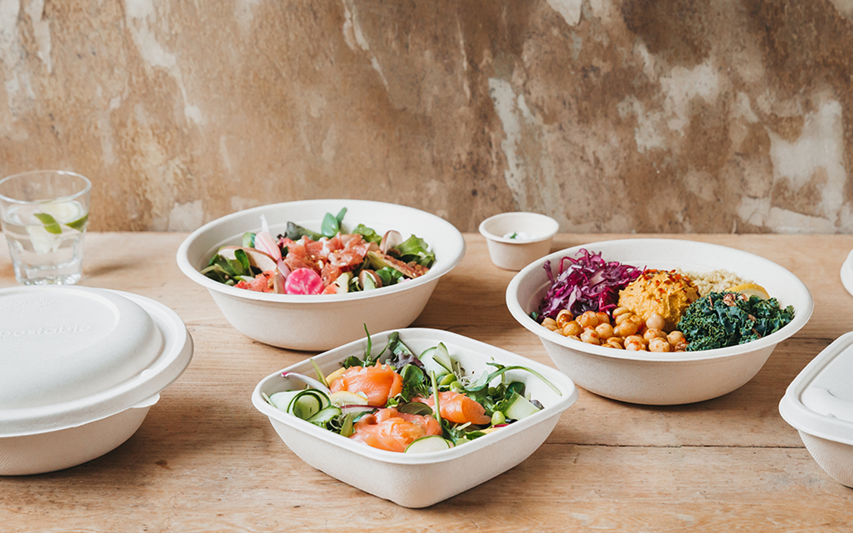
PULPUltra™, from Sabert Corporation Europe is a game changing next-generation, no-intentionally-added-PFAS foodservice packaging solution.
__

For further information, please contact:
Bill Bruce,
Suzanne Howe Communications
Tel: +44 (0)2034 680923
Email: bill@suzannehowe.com
Web: www.suzannehowe.com

Or visit: www.sabert.eu

About Sabert

Sabert is specialised in manufacturing and marketing food packaging, disposable high-quality tableware and compostable food packaging and tableware. Through various partnerships established with some of its customers, Sabert Corporation Europe commits to develop its products and its production’s processes in a sustainable way. With 40 years of experience, Sabert provides innovative, value-added products to the highest quality standards supported by outstanding customer service. We have given ourselves the mission to offer our clients the best guarantees in terms of quality, safety and service. Today, our product solutions fulfil this vision and have earned the trust and loyalty of customers around the globe. As our employees and clients agree, Sabert makes food look great!

In July 2025, Sabert acquired Colpac Limited, a leading UK-based manufacturer of sustainable paperboard packaging solutions for the food-to-go foodservice and industrial markets.

Sabert Corporation Europe is a founding member of the Alliance for Fibre-Based Packaging.

Please note:
Suzanne Howe Communications (SHC) has supported the Copyright Licensing Association (CLA) and the National Licencing Association (NLA) for many years. We are aware of the great work they do in the world of journalism and publishing. We see our licences as a way of giving back and therefore they form part of our Sustainable and ESG commitment as a business. We would like to take this opportunity to thank you for the coverage you might give our client. We might wish to use the coverage on our social channels to promote our clients but also to thank you. If you would prefer that we didn’t share your coverage online, please make this known to SHC. Thank you very much.

