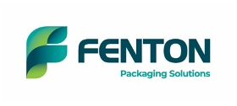

Fenton Packaging Solutions’ investment in digital transformation delivers major customer benefits
“The new infrastructure significantly reduces the administrative burden across the company, allowing teams to focus on serving customers rather than moving paperwork between systems.”

Over the past year, Fenton Packaging Solutions has undergone a major digital transformation, backed by an investment of close to £250,000.
“The goal was simple: make the organisation faster, smarter, more accurate, and future-proof,” says General Manager Ryan Banks. “The shift to a modern cloud-based ERP has completely changed how the business operates.
“The investment includes the implementation of Access ERP, integration with Salesforce, the introduction of Asset Hub, and a full upgrade of warehouse operations through handheld scanning and real-time tracking. Together, these systems replace an ageing on-premise platform and manual, paper-based processes with a fully connected, cloud-based infrastructure.
“Perhaps the biggest gain is time back for the business itself,” Ryan adds. “Teams now spend far less time moving paper and reconciling data – and far more time selling, planning, supporting customers and adding value.
“A salesperson can now sit with a customer and see live stock-levels, pricing, order history and even pick an order there and then – knowing it will be in the loading bay within hours, rather than a day later. Warehouse teams track every pallet, every movement, every scan. Customer service staff no longer chase information through emails or paper trails; everything they need is in one place and with AI streamlining admin, teams have hours each week returned to them to focus on what matters: customers.
“The business now understands its customers better than ever — who buys what, when, how and why. It can spot patterns, analyse markets, negotiate better with suppliers, and reduce stockouts before they happen.”
A more efficient, future-ready partner
“The new infrastructure significantly reduces the administrative burden across the company, allowing teams to focus on serving customers rather than moving paperwork between systems,” says Managing Partner Sharon Dakin. “With live data replacing overnight updates and manual reporting, customers will receive quicker decisions, more accurate information, and a service that is responsive to real-world conditions.
“Ultimately, this transformation gives our customers something incredibly valuable: time, accuracy and reliability. It allows us to be faster, better informed, and more proactive – exactly what our customers need from a modern supply-chain partner.
“This investment positions Fenton Packaging Solutions for continued growth and establishes a scalable platform for further innovation over the coming years.
“We have also continued to invest in people. In September we were pleased to announce two new senior appointments, further strengthening our sales team, and supporting our growth plans as a consultative packaging solutions provider. Mark Woods joined the company as Business Development Manager, and Alex Breeze as Internal Sales & Customer Service Manager.”

A Great Place to Work
Fenton Packaging Solutions has achieved a Great Place to Work accreditation, scoring 87% – with the success criteria being 65%. The statement: “Overall, I consider Fenton Packaging a great place to work”, scored an impressive 94%.
“To score over and above the success criteria is a testament to Fenton’s commitment in delivering a good working culture,” says Internal Sales & Customer Service Manager Alex Breeze. “Having joined Fenton Packaging only three months ago, I’m absolutely delighted to see the business achieve the Great Place to Work accreditation, which is a powerful reflection of the energy, dedication and pride our people bring to work every single day.
“It is clear that our culture is built on genuine teamwork, respect, and a shared commitment to doing things the right way. Even in a short time, I have seen first-hand how invested our teams are in supporting each other and driving the business forward. This achievement belongs to them, and it reinforces our ambition to continue building a workplace where everyone can thrive and feel proud of what we accomplish together.”

https://www.fentonpackaging.co.uk
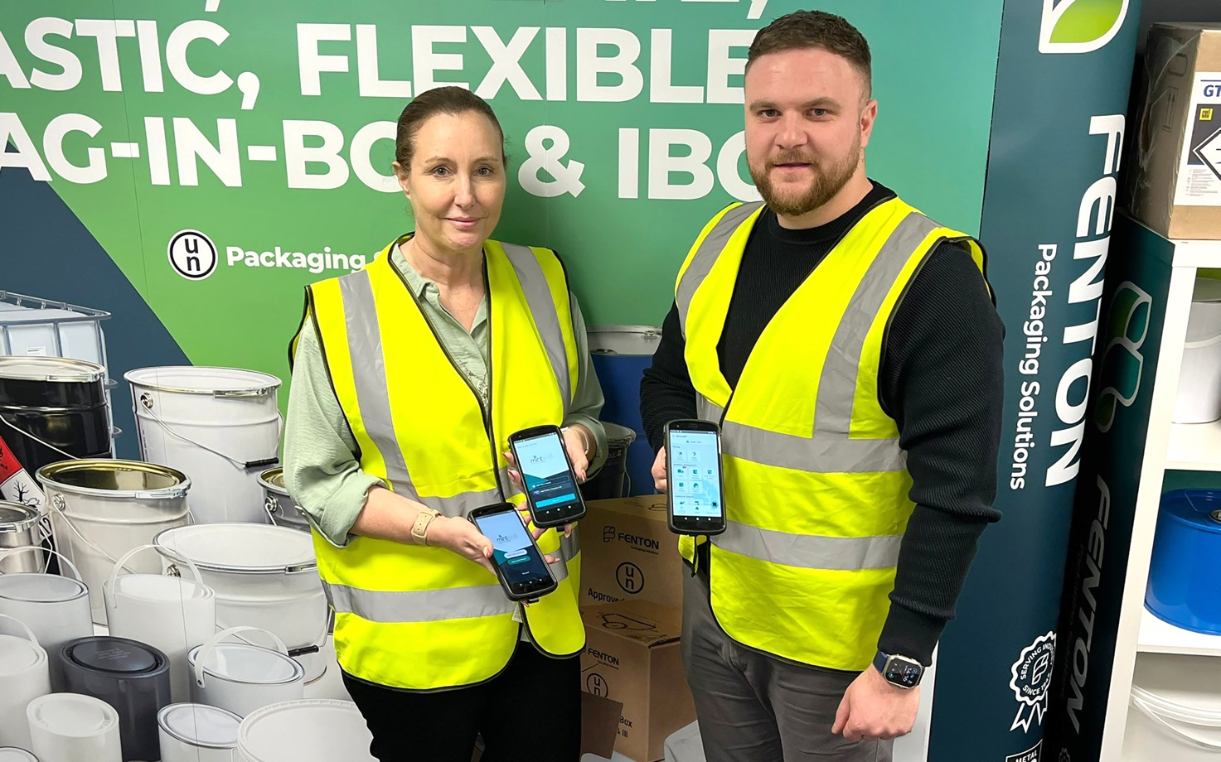

Sharon Dakin - Managing Partner Finance & Technology, and Ryan Banks - General Manager.
.

___

For further information, please contact:
Bill Bruce
Suzanne Howe Communications
Tel: +44 (0)2034 680923
Email: bill@suzannehowe.com
Web: www.suzannehowe.com

Notes for editors:

About Fenton Packaging Solutions

Fenton Packaging Solutions specialises in stocking and distributing a wide range of containers for powders, granules, pastes and liquids, for industry sectors including food, dairy, beverage, pharmaceuticals, chemicals, detergents, paints, inks, resins and adhesives.

Fenton Packaging Solutions is a member of leading trade associations, including the British Coatings Federation.

Please note:
Suzanne Howe Communications (SHC) has supported the Copyright Licensing Association (CLA) and the National Licencing Association (NLA) for many years. We are aware of the great work they do in the world of journalism and publishing. We see our licences as a way of giving back and therefore they form part of our Sustainable and ESG commitment as a business. We would like to take this opportunity to thank you for the coverage you might give our client. We might wish to use the coverage on our social channels to promote our clients but also to thank you. If you would prefer that we didn’t share your coverage online, please make this known to SHC. Thank you very much.

