
Editorial Contact: Ana Juraga ana.juraga@ecocortec.hr
Cortec® Europe Advertising Agency +385 91 270 5018

Company Contact: Ivana Radic Borsic iborsic@cortecvci.com
Cortec® Corporation: +385 1 48 54 486

Attention: Editor
January 23, 2026
PRESS RELEASE


Cortec® Steps Into the Future with
Biobased Acrylic Anticorrosion Coating

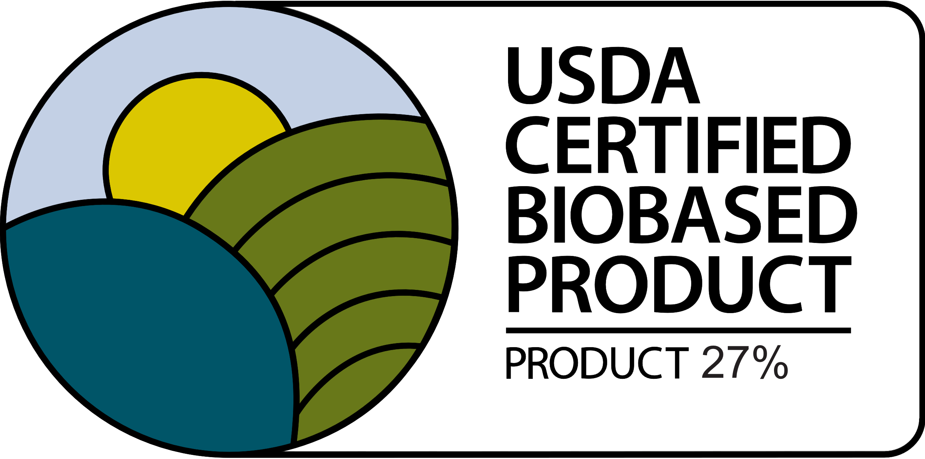
Cortec® is announcing a major step forward in the development of biobased anticorrosion coatings for metal with the release of EcoLine® 3860, Cortec’s first water-based acrylic coating to incorporate renewably-sourced resins. EcoLine® 3860 contains 27% USDA certified biobased content and is designed for industrial users who want to increase their use of renewable content. It is an important move toward expanding sustainable options in the specialty field of corrosion inhibiting paints.


EcoLine® 3860 is an extension of Cortec’s line of VpCI®-386 anticorrosion coatings, which have become flagship products in the Cortec® portfolio of corrosion solutions. VpCI®-386 represents the journey from solvent-based technologies that once dominated the market to water-based paints that can effectively protect metals from corrosion while reducing VOCs and introducing other user benefits. Over the last several decades, VpCI®-386 has become a mainstay of Cortec® coatings, demonstrating the potential for preservation with reduced environmental impact.

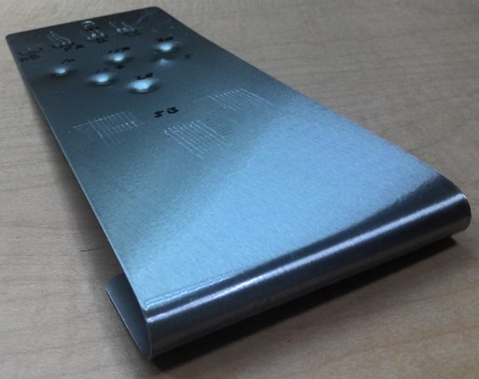
With the release of EcoLine® 3860, Cortec® is poised to follow this pattern in the field of biobased paints for corrosion inhibition. Once again, acrylic paints provide a good starting point for metals protection because of their flexibility, good adhesion, and UV resistance. As typical for Cortec® coatings, EcoLine® 3860 remains well within Green Seal and EPA guidelines for low VOC coatings, registering at 0.6 lbs/gal (72 g/L). Applied clear or matched to a range of custom colors at a DFT (dry film thickness) of 1.5-3.0 mils (38-76 µm), EcoLine® 3860 offers an unobtrusive way to add corrosion protection to metal parts, equipment and structures while introducing renewable content.

As Cortec’s first biobased acrylic anticorrosion paint, EcoLine® 3860 represents an important milestone in the use of biobased resins, setting the stage for the development of more advanced biobased anticorrosion coatings in the future. Contact Cortec® to learn more about EcoLine® 3860, and stay tuned for future biobased coatings developments from Cortec® R&D.

Keywords: Cortec, biobased coatings, anticorrosion coatings, acrylic coatings, EcoLine, EcoLine 3860, low VOC coatings, corrosion control, metal coatings, biobased resins

Need a High-Resolution Photo? Visit: www.cortecadvertising.com.
Cortec® Corporation is the global leader in innovative, environmentally responsible VpCI® and MCI® corrosion control technologies for packaging, metalworking, construction, electronics, water treatment, oil & gas, and other industries. Our relentless dedication to sustainability, quality, service, and support is unmatched in the industry. Headquartered in St. Paul, Minnesota, Cortec® manufactures over 400 products distributed worldwide. ISO 9001:2015 and ISO 14001:2015 certified. Cortec® website: http://www.cortecvci.com. Phone: 1-800-426-7832. FAX: (651) 429-1122.

