UK Government Minister inaugurates Greenback and Amcor advanced recycling technology

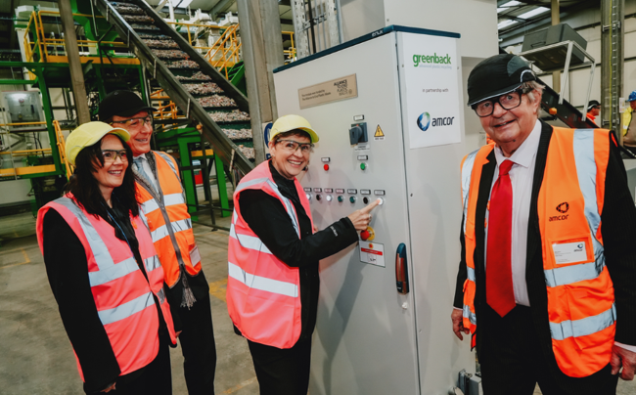

HEANOR, U.K., 13 January, 2026 — Greenback Recycling Technologies (“Greenback”) and Amcor (NYSE: AMCR, ASX: AMC) a global leader in developing and producing responsible packaging solutions, welcomed Mary Creagh CBE MP, Nature and Circular Economy Minister, on the 15th of December 2025 to Amcor’s Heanor facility for the official commissioning of the first UK deployment of Greenback’s Enval® advanced recycling module.

Her visit highlighted the importance of the work on circular plastics being done by both Amcor and Greenback, in association with the Alliance to End Plastic Waste (AEPW), to trial this innovative new technology which can recycle post-consumer flexible plastics into food-grade circular plastics feedstock.

The advanced recycling process under trial at the Heanor facility is evaluated by eco₂Veritas™ traceability platform, which uses AI and IoT devices to capture data from the receipt of waste through to the production of pyrolytic oil. The oil carries a digital certificate of provenance, providing crucial data for mass-balance allocation as the oil is then converted into recycled plastics.

This step marked the completion of Greenback’s Enval module installation and is the first time the company’s modular advanced recycling technology is hosted by a global packaging leader in Europe. The collaboration with Amcor aims to showcase the potential for co-locating modular recycling units within existing industrial infrastructure and, following successful trials, has the potential to bring the circular economy closer to reality.

The Heanor site was selected because of its expertise in the use of recycling technologies. The facility already plays a vital role in converting post-consumer and industrial flexible plastic waste, via mechanical recycling, into high-quality recycled polymers. These are then used in Amcor’s flexible packaging applications across multiple markets.

Adding the Enval advanced recycling process creates new opportunities to recycle post-consumer flexible plastics.

Nature and Circular Economy Minister Mary Creagh said: “This is an exciting example of how shared action between government and the private sector can tackle the world’s plastic waste mountain through innovation, infrastructure investment and collaboration. This commissioning reflects the government’s broader ambition to build a resilient, circular economy by reusing the plastics which already exist.”

“This commissioning demonstrated how collaboration and innovation can accelerate scalable circular solutions,” said Philippe G. von Stauffenberg, Founder and CEO of Greenback. “We are proud to work with Amcor and government stakeholders to scale technologies that keep plastics in the economy and out of the environment. We also want to thank the Alliance to AEPW for their support in reaching this milestone.”

Andrew Green, Vice President, Amcor Flexibles EMEA, added: “The trial of this pioneering technology at Heanor reinforces our commitment to improving circularity for flexible packaging and supporting UK policy objectives for a more sustainable future.”

The commissioning of Greenback’s module at Amcor’s Heanor facility marks a pivotal step toward achieving a circular economy in the UK. By combining cutting-edge technology, industry collaboration, and government support, this initiative demonstrates how innovation can transform plastic waste into valuable resources.

Media Contact:
Julie Liedtke, Amcor – julie.liedtke@amcor.com
Lorena de la Canal, Greenback Recycling Technologies – Lorena.delaCanal@greenback.earth
Nielsen McAllister Public Relations Ltd - amcor@nmpr.co.uk

About Amcor
Amcor is the global leader in developing and producing responsible consumer packaging and dispensing solutions across a variety of materials for nutrition, health, beauty and wellness categories. Our global product innovation and sustainability expertise enables us to solve packaging challenges around the world every day, producing a range of flexible packaging, rigid packaging, cartons and closures that are more sustainable, functional and appealing for our customers and their consumers. We are guided by our purpose of elevating customers, shaping lives and protecting the future. Supported by a commitment to safety, over 75,000 people generate $23 billion in annualized sales from operations that span over 400 locations in more than 40 countries. NYSE: AMCR; ASX: AMC www.amcor.com | LinkedIn | YouTube

About Greenback Recycling Technologies
Greenback is a UK-based advanced recycling company founded in 2018 to bring an immediate solution for the global plastic pollution. Greenback is building a global network of advanced recycling systems to close the loop on flexible plastic waste. Greenback’s patented Enval™ microwave induced recycling process turns flexible, multilaminate plastics into π-Oil® feedstock for circular plastics. By developing modular, scalable technology Greenback ensures that post-consumer plastics are recycled and transformed back into verified high-quality raw materials. www.greenback.earth| LinkedIn | YouTube

About the Alliance to End Plastic Waste
The Alliance to End Plastic Waste is an independent global non-profit organisation with the purpose to end plastic waste entering the environment and to create circular systems that keep materials and products in use for as long as possible. We go beyond connecting existing solutions to building unique and impactful circular solutions. The Alliance convenes companies across the plastic value chain, governments, local communities, civil society groups, intergovernmental organisations, academia, and civil society. The expertise, knowledge, experience, and resources of this network enable our work to help end plastic waste and pollution. Together, we work towards economically viable, environmentally beneficial, and socially responsible solutions. Find out more: endplasticwaste.org

