
Editorial Contact: Ana Juraga ana.juraga@ecocortec.hr
Cortec® Europe Advertising Agency +385 91 2705018

Company Contact: Ivana Radic Borsic iborsic@cortecvci.com
Cortec® Corporation: +385 1 48 54 486

Attention: Editor
December 03, 2025
PRESS RELEASE


EcoCortec® Pioneers the Future of Sustainable
VCI Packaging for the Circular Economy

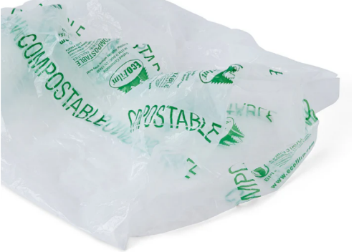
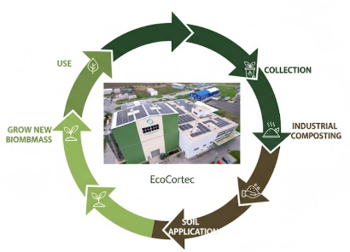
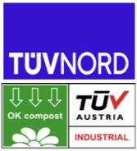
The global landscape is moving decisively towards a model where performance and environmental responsibility are inseparable. While effective material protection remains essential, industry leaders now recognize that true value lies in solutions that embrace the entire product lifecycle. It is no longer enough to simply protect goods from corrosion and damage, packaging must also align with the highest sustainability standards and circular economy principles. This commitment is amplified by regulatory drivers like the forthcoming EU PPWR Regulation, which champions materials that simplify end-of-life management. As the European subsidiary of Cortec® Corporation, EcoCortec® plant located in Croatia is dedicated to developing materials that support this transition such as certified biodegradable and compostable solutions and advanced PCR packaging. This commitment to innovation enables manufacturers to achieve zero-compromise performance on corrosion protection while gaining an environmentally friendly solutions. EcoCortec’s green portfolio of films and bags is designed not just for corrosion protection, but engineered to safely return to the earth at its end-of-life, securing a cleaner and more responsible future for industry. Through continuous investment in R&D, EcoCortec® has pioneered a portfolio of film technologies designed to contribute to the circular economy, ensuring their clients receive full corrosion protection without the waste burden:

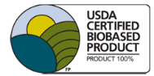
EcoWorks® patented films and bags can be used for checkout bags, lawn and leaf bags, organic waste diversion, and other industrial and commercial uses. When placed in a typical commercial composting environment, they fully biodegrade within months. Eco Works® is made from resin certified by BPI (international Biodegradable Products Institute, Inc.) to be compostable in municipal and industrial composting facilities according to ASTM D 6400 (BPI certificate #890974-6).
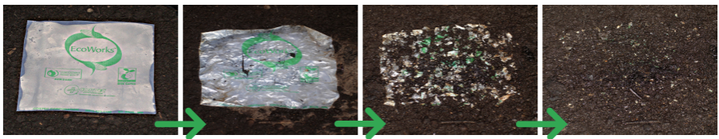

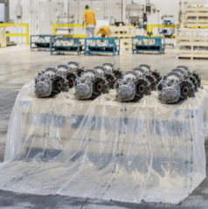
Eco-Corr Film® ESD biodegradable and compostable high performance anti-static, corrosion inhibiting film and bags for use in the protection of static sensitive multi-metal items such as electronics. They contain permanent anti-static properties to immediately reduce or eliminate static buildup as long as the films or bags are in use, independent of the presence of humidity.

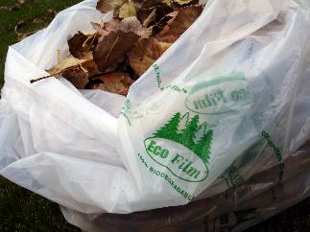
EcoFilm® is a certified commercially compostable film designed to replace traditional polyethylene films. The film is shelf and curb stable, meaning it retains its integrity until properly disposed of in commercial composting facilities, making it an ideal choice for large-scale organic waste programs.

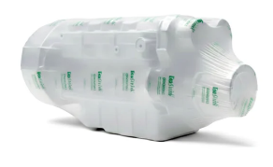
EcoShrink™ designed for use in standard heat-shrinking applications and also certified to major compostability standards. It breaks down into non-toxic substances H₂O I CO₂ and biomass, leaving no microplastic residue. After use, it can be disposed of in a commercial composting environment to reduce the amount of plastic packaging that normally ends up in a landfill.

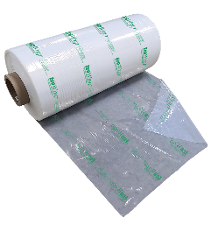
Eco Wrap® is a specialty compostable wrapping film made with certified compostable resin plus a tackifier additive. It is designed to run on existing stretch film equipment by simply adjusting the tension setting. Most applications requiring three wraps of standard film can use two wraps of Eco Wrap® without sacrificing strength or protection. Eco Wrap® is commercially certified compostable and avoids tariffs, and fines in areas where polyethylene is restricted.

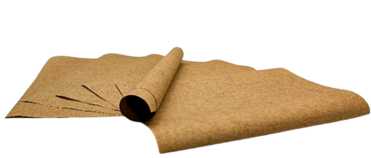
EcoBio™ Barrier Paper is new premium recyclable, repulpable, biodegradable barrier paper aimed for a variety of short-term packaging applications where moisture or grease is a concern. It starts the product life cycle as 100% recycled paper stock coated with a biobased (90-100% renewable organic carbon per ASTM D6866) and biodegradable (per OECD 301) barrier coating. It has no intentionally added plastics (or PFAS or fluorochemicals) to hinder recycling or biodegradation. EcoBio™ Barrier Paper can be recycled through normal paper recycling streams instead of ending up in the landfill. However, this paper goes a step further with its biodegradable, biobased coating that has the potential to open even more sustainable end of life options depending on local regulations. Most importantly, EcoBio™ Barrier Paper tackles moisture and grease resistance without the risk of plastic or foil pollution.

“The move toward genuinely sustainable packaging is not just an economic and environmental imperative. Products like EcoBio™ Barrier Paper are vital because they allow industries to maintain product integrity and safety without sacrificing the planet. Its features make it incredibly appealing as a direct replacement for conventional plastic packaging, especially when we consider its potential to carry specialized features like superior barrier, anticorrosion, and ESD properties," says Boris Miksic, CEO of Cortec Corporation. "Our certified sustainable VCI/VpCI packaging line delivers uncompromised corrosion protection while guaranteeing a plastic-free end-of-life, whether through recycling, composability, or biodegradation," he concludes.

- The complete EcoCortec packaging assortment is detailed in our company brochures, which you can explore here: https://ecocortec.hr/eng/brochures
Keywords: corrosion protection, packaging, VpCI, VCI, cortec corporation, ecocortec packaging innovations, recycling, regranulation, circular economy, sustainability, PPWR

Need a high-resolution photo? Visit: www.cortecadvertising.com.
Cortec® Corporation is the global leader in innovative, environmentally responsible VpCI® and MCI® corrosion control technologies for packaging, metalworking, construction, electronics, water treatment, oil & gas, and other industries. Our relentless dedication to sustainability, quality, service, and support is unmatched in the industry. Headquartered in St. Paul, Minnesota, Cortec® manufactures over 400 products distributed worldwide. ISO 9001:2015, ISO 14001:2015, & ISO/IEC 17025:2017 certified. Cortec® website: http://www.cortecvci.com. Phone: 1-800-426-7832. FAX: (651) 429-1122.

