Press Release
FOR IMMEDIATE RELEASE

Title: Zeus Group Appoints Brian O’Kelly and Paul Hogan as Non-Executive Directors

Image:
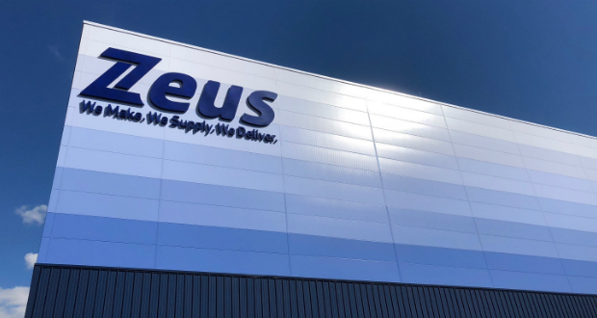

Text:

Zeus Group, a global provider of innovative packaging solutions, today announces the appointments of Brian O’Kelly and Paul Hogan as Non-Executive Directors of its Board. The additions strengthen the company’s governance and strategic capability as Zeus pursues ambitious growth, M&A and sustainability objectives.
Brian O’Kelly brings extensive experience in investment banking, corporate finance and company strategy having advised many of Ireland’s leading public and private companies on major M&A and capital markets transactions throughout his career. Brian has a deep knowledge of financial markets having spent 24 years at Goodbody Stockbrokers where he was Co-Head of Investment Banking having previously been Managing Director of Goodbody Corporate Finance and during which time he was a Board member for many years.
He is currently Chairman of Bellingham Capital, a private equity firm specialising in the food sector and is a Non-Executive Director of H&K International, a global kitchen equipment supplier. Brian is also Chairman of EIIS Management Limited, a joint venture between Goodbody and Azets, specialising in providing EIIS capital to SME’s across Ireland. Brian was previously the Chairman of Gresham House Ireland Investment Management and was the Senior Independent Director of Irish Continental Group plc.
He began his career qualifying as a Chartered Accountant with KPMG following which he joined ABN AMRO Corporate Finance gaining deep analytical and financial expertise.
Brian will bring to Zeus a strong focus on strategy, financial oversight and board-level advisory, supporting long-term growth and value creation.
Brian O’Kelly commented: "I am delighted to join the Zeus Board at an exciting time in the company’s development. I look forward to applying my experience in corporate finance and strategic governance to support the board and management in delivering sustainable growth and long-term shareholder value."
Paul Hogan — Non-Executive Director Paul Hogan is a seasoned finance executive and board member with more than 30 years’ experience in global packaging, corporate development, M&A and financial leadership. He began his career at Price Waterhouse and spent 24 years at Clondalkin Group, rising to Chief Financial Officer and leading global corporate development and M&A activity across flexible, specialty and healthcare packaging. In 2014 he became CFO of Nelipak Healthcare Packaging Corporation, overseeing North American finance across multi-site healthcare operations in a private equity-backed environment, and in 2020 he was appointed CFO of Brook & Whittle Holdings.
Paul has been recognised for his financial leadership, including Plastics News “CFO of the Year” (2016). He also serves as Senior Independent Non-Executive Director of Uniphar plc (since June 2019), where he chairs the Nominations Committee and contributes to governance, risk and sustainability oversight.
Paul will bring to Zeus deep sector knowledge, proven M&A and growth strategy experience, and strong financial stewardship and board governance capabilities.
Paul Hogan commented: "I am excited to join the Zeus Board and to contribute my experience in finance, M&A and governance as the company grows and pursues new market opportunities."
Comment from Brian O’Sullivan, Founder & Owner, Zeus "We are delighted to welcome Brian O’Kelly and Paul Hogan to the Zeus Board. Their combined strengths in strategic governance, corporate finance and the packaging sector will be instrumental as we scale our business, execute on M&A opportunities and continue to build sustainable value for our customers and shareholders."

For media inquiries or further information, please contact:

Pip Gorringe
Director of Marketing
Zeus Packaging
Pip.Gorringe@zeuspackaging.co.uk
07809737871

About Zeus Packaging
Zeus Packaging is a leading provider of sustainable packaging solutions, committed to innovation and excellence in serving a diverse range of industries. With a focus on sustainability and customer satisfaction, Zeus Packaging delivers high-quality, eco-friendly packaging products to clients worldwide. Serving in 38 countries and with 61 locations, Zeus truly is a global packaging solutions provider.

End of Release

