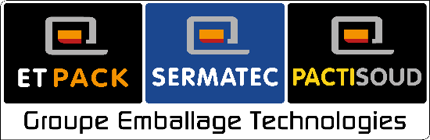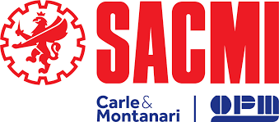

SACMI acquires majority stake in Groupe Emballage Technologies
This operation strengthens and expands SACMI's reach in the food packaging sector. President Paolo Mongardi states: “In line with our strategic vision, this acquisition further strengthens our presence in France and other countries.”

SACMI has gained a majority share in the French group Emballage Technologies, which comprises Etpack, Sermatec, and Pactisoud. Made official on Friday 19th December 2025, this acquisition sees SACMI gain a 65% share. The operation was completed via the subsidiary SACMI Packaging & Chocolate SpA, the SACMI Group Business Unit that operates in the food packaging sector.
SACMI has been working with Etpack since 2019 through its Poland-based subsidiary. The basis for this transaction - of considerable commercial and industrial value - is, then, the strong relationship between the two industrial groups and their shared strategic vision.
SACMI Packaging & Chocolate thus expands and completes its range of secondary packaging solutions by integrating specific technologies, with the resulting expansion of the offering allowing the company to reach into additional industries and market segments. This synergy also extends to the construction and assembly of the flowpack ranges and the low- and medium-speed vertical packaging machines - designed by SACMI and assembled in Sermatec - thus boosting the ability to respond to market dynamics.
Groupe Emballage Technologies is a renowned name in France, and SACMI is confident that it will be a major growth driver on this market, in keeping with the goal of achieving a strong local presence via a network of production and sales facilities. Note also that this operation aligns with SACMI Packaging & Chocolate’s broader business strategy: indeed, the company is already present internationally in Poland, the DACH countries and the United States.
“Strengthening our food packaging operations is a key SACMI goal,” notes the President of SACMI, Paolo Mongardi. “The skills and far-reaching presence of Groupe Emballage Technologies on the French market will bolster our growth there, which is extremely important to us. The complementary nature of our primary and secondary packaging solutions completes SACMI's technological proposal,” adds Paolo Mongardi, “opening up new market opportunities via the full involvement of our Global Network.”
“Groupe Emballage Technologies will retain its managerial autonomy: a crucial aspect, in light of the excellent work done in recent years,” comments Pierrick Doux, who has been at the Group’s helm since 2007. “Closer teamwork will facilitate the pursuit of shared strategic goals, helping to boost growth both in France and abroad.”
The first official market event will be the CFIA trade fair in Rennes in March 2026.

