Ardagh Glass Packaging creates Absolut Haring

artist-edition bottle
Luxembourg (11 December, 2025) – Ardagh Glass Packaging-Europe (AGP-Europe), an operating business of Ardagh Group, has partnered with The Absolut Company International to create Absolut Haring, the latest artist-edition bottle, inspired by Keith Haring’s iconic 1986 artwork featuring the Absolut vodka bottle.
Developed with design agency Pearlfisher, and produced exclusively at Ardagh Glass Packaging’s facility in Limmared, Sweden, the bottle brings Haring’s style to life through intricately debossed dancing figures and a screen-printed vibrant yellow panel that, when viewed through the clear glass, creates an illusion via reflection that the entire bottle is yellow.
“The Absolut Haring artist-edition bottle perfectly demonstrates how design, technology and art can come together in glass,” said John Oczabruk, Product Designer, Ardagh Glass Packaging-Europe. “Reproducing Keith Haring’s artwork through debossing demanded extreme accuracy, to maintain uniform depth and width around the bottle. Aligning the debossing precisely with the screen printing ensured a flawless, visually stunning result.”
Each bottle was made with over 60%* recycled glass cullet, reflecting both companies’ shared commitment to sustainability.
Launched exclusively in Travel Retail and then rolled out in global markets from September onwards, the Absolut Haring artist-edition bottle continues The Absolut Company International’s tradition of partnering with visionary artists to celebrate creativity and connection.

*Total recycled cullet level

Further information
Marketing & Communications at Ardagh Glass Packaging-Europe Sharon.todd@ardaghgroup.com
Download Image
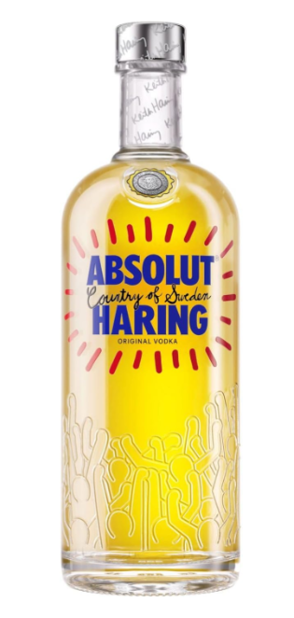
Notes to the editor
Ardagh Glass Packaging (AGP) is a leading supplier of sustainable and infinitely recyclable glass packaging. Ardagh Glass Packaging operates 37 production facilities in North America, Europe and Africa and employs approximately 13,000 people and has recorded revenues of $4.2 billion in 2024.

